Sl No | Equipment | Name of the equipment | Make & Model | Contact details | I-STEM registration id | Brochure | Booking Link
1 | 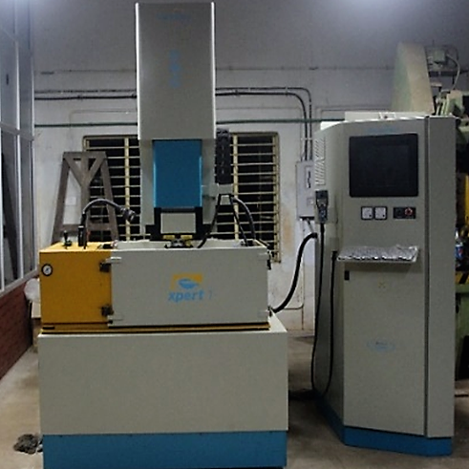 | CNC Die Sinking EDM | Electronica | Faculty In-charge:  Dr. Vikash Kumar  vikash@nitc.ac.in  +91-8638366093  Technical Staff:  Sanal PR (TA SG I)  sanal@nitc.ac.in  0495-2286450 | 3224899 |  | https://www.istem.gov.in/
2 | 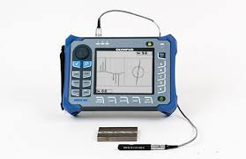 | Eddy Current Flaw Detector | Olympus Corporation, Tokyo- Japan NORTEC600 | Faculty In-charge:  Dr. Murali KP  kpmurali@nitc.ac.in  0495-2286414  Technical Staff:  Sanal PR (TA SG I)  sanal@nitc.ac.in  0495-2286450 | 3224878 |  | https://www.istem.gov.in/
3 | 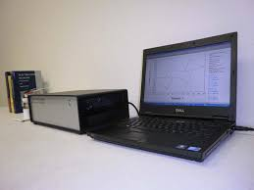 | Electrochemical Corrosion Analyzer | CH Instruments Inc., USA CHI608E Potentiostat/Galvanostat | Faculty In-charge:  Dr. Murali KP  kpmurali@nitc.ac.in  0495-2286414  Technical Staff:  Sanal PR (TA SG I)  sanal@nitc.ac.in  0495-2286450 | 3224881 |  | https://www.istem.gov.in/
4 | 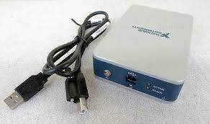 | High speed temperature data acquisition system | National Instruments,USA NI CDAQ 9212 | Faculty In-charge:  Dr. Murali KP  kpmurali@nitc.ac.in  0495-2286414  Technical Staff:  Sanal PR (TA SG I)  sanal@nitc.ac.in  0495-2286450 |  |  | https://www.istem.gov.in/
5 | 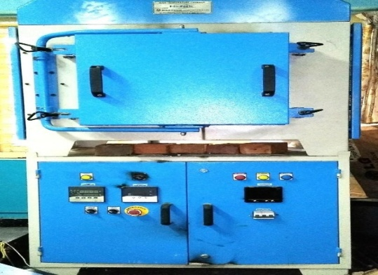 | HIGH TEMPERATURE FURNACE | Heatcon Instruments pvt. Ltd, HENIX | Faculty In-charge:  Dr. Murali KP  kpmurali@nitc.ac.in  0495-2286414  Technical Staff:  Sanal PR (TA SG I)  sanal@nitc.ac.in  0495-2286450 | 3224879 |  | https://www.istem.gov.in/
6 | 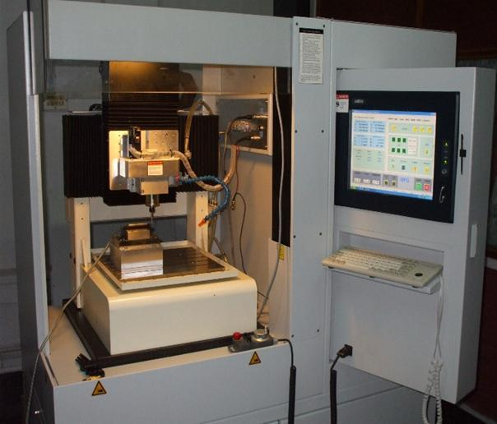 | MICRO MACHINING CENTRE AND ACCESSORIES | MIKROTOOLS Pte Ltd, DT-110 LE-311 | Faculty In-charge:  Dr. Basil Kuriachen  bk@nitc.ac.in  +91-9947187133  Technical Staff:  Sanal PR (TA SG I)  sanal@nitc.ac.in  0495-2286450 | 3224890 |  | https://www.istem.gov.in/
7 | 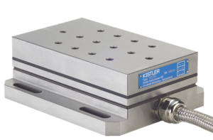 | MULTICOMPONENT DYNAMOMETER (KISTLER – 9257B) | KISTLER, DYNAMOMETER(9257B) | Faculty In-charge:  Dr. Basil Kuriachen  bk@nitc.ac.in  +91-9947187133  Technical Staff:  Sanal PR (TA SG I)  sanal@nitc.ac.in  0495-2286450 | 3224888 |  | https://www.istem.gov.in/
8 |  | MULTICOMPONENT DYNAMOMETER (KISTLER 9256C2) | KISTLER,9256C2 | Faculty In-charge:  Dr. Basil Kuriachen  bk@nitc.ac.in  +91-9947187133  Technical Staff:  Sanal PR (TA SG I)  sanal@nitc.ac.in  0495-2286450 | 3224887 |  | https://www.istem.gov.in/
9 | 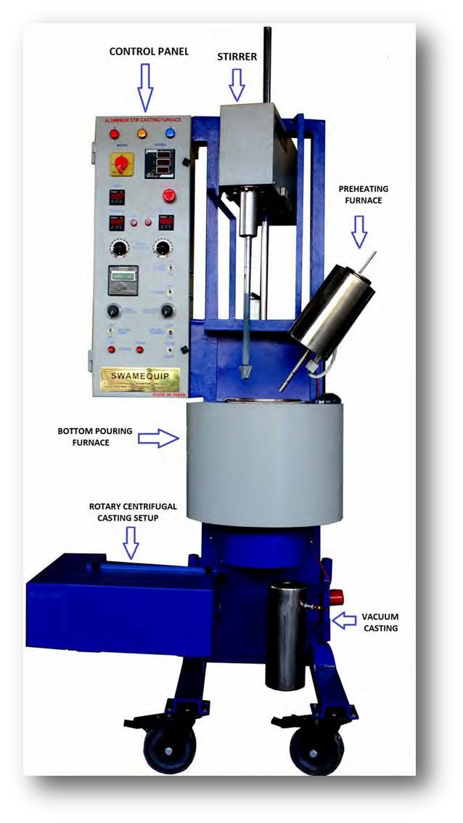  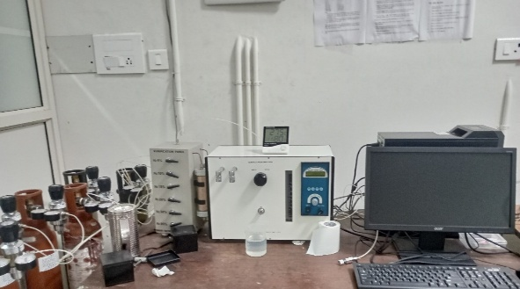 | Computerized Magnesium & Aluminium MMC Casting | Swam Equip, India | Faculty In-charge:  Dr. Murali KP  kpmurali@nitc.ac.in  0495-2286414  Technical Staff:  Sanal PR (TA SG I)  sanal@nitc.ac.in  0495-2286450 | 3224874 |  | https://www.istem.gov.in/
10 |  | Multi-point BET Surface area Analyzer | Smart SORB-93 | Faculty In-charge:  Dr. Muhammed Rashad K  rashad@nitc.ac.in  Technical Staff:  Sanal PR (TA SG I)  sanal@nitc.ac.in  0495-2286450 | 3224875 |  | https://www.istem.gov.in/
11 | 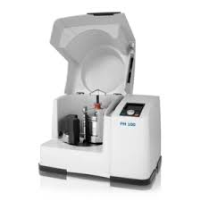 | Planetary Ball Mill | Retsch, Germany PM 100 | Faculty In-charge:  Dr. Murali KP  kpmurali@nitc.ac.in  0495-2286414  Technical Staff:  Sanal PR (TA SG I)  sanal@nitc.ac.in  0495-2286450 | 3224880 |  | https://www.istem.gov.in/
12 |  | RAPID PROTOTYPING MACHINE | STRATASYS F170 | Faculty In-charge:  Dr. Basil Kuriachen  bk@nitc.ac.in  +91-9947187133  Technical Staff:  Sanal PR (TA SG I)  sanal@nitc.ac.in  0495-2286450 | 3224891 |  | https://www.istem.gov.in/
13 | 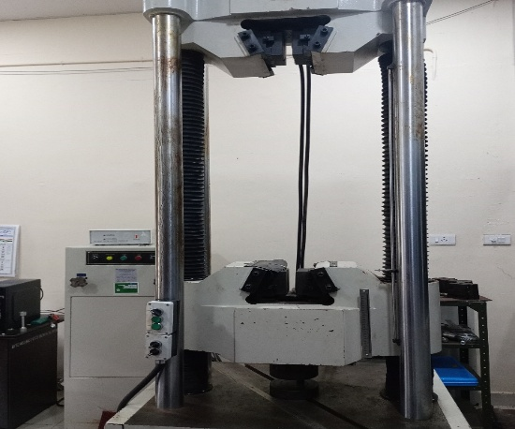 | Computer controlled Hydraulic Servo 1000KN Universal Testing Machine | JINAN WAW1000E | Faculty In-charge:  Dr. Murali KP  kpmurali@nitc.ac.in  0495-2286414  Technical Staff:  Sanal PR (TA SG I)  sanal@nitc.ac.in  0495-2286450 | 3224877 |  | https://www.istem.gov.in/
14 | 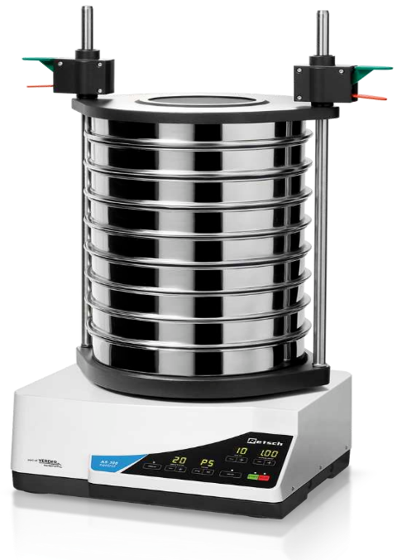  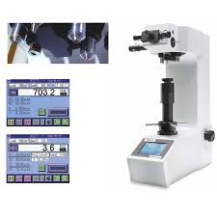 | Vibratory Sieve Shaker | Retsch, Germany AS 300 CONTROL | Faculty In-charge:  Dr. Murali KP  kpmurali@nitc.ac.in  0495-2286414  Technical Staff:  Sanal PR (TA SG I)  sanal@nitc.ac.in  0495-2286450 |  |  | https://www.istem.gov.in/
15 |  | Vickers Hardness Tester-Digital type | Matsuzawa Co. Ltd, Japan VMT X7S | Faculty In-charge:  Dr. Murali KP  kpmurali@nitc.ac.in  0495-2286414  Technical Staff:  Sanal PR (TA SG I)  sanal@nitc.ac.in  0495-2286450 | 3224876 |  | https://www.istem.gov.in/
16 | 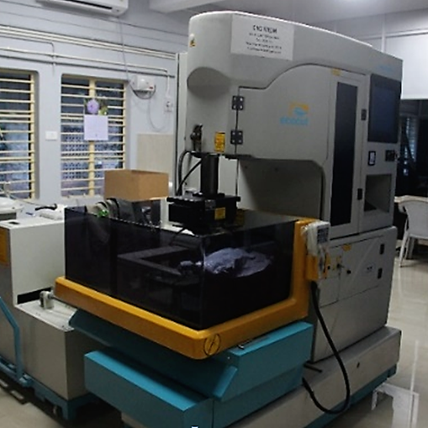 | Wire Electric Discharge Machine | Electronica, ECOCUT-11 | Faculty In-charge:  Dr. Vikash Kumar  vikash@nitc.ac.in  +91-8638366093  Technical Staff:  Sanal PR (TA SG I)  sanal@nitc.ac.in  0495-2286450 | 3224894 |  | https://www.istem.gov.in/
17 | 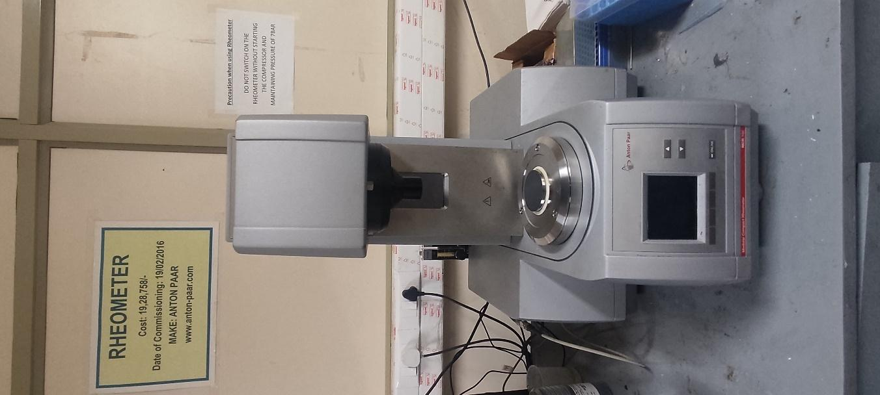 | Rheometer | Anton Paar & MCR 102 & MRD170/T | Faculty In-charge:  Dr.Amit Kumar Singh  amitsingh@nitc.ac.in  +91-8949362395  Technical Staff:  Shibin (Senior Technician)  shibinr@nitc.ac.in  0495-2286485 | 3224914 |  | https://www.istem.gov.in/
18 | 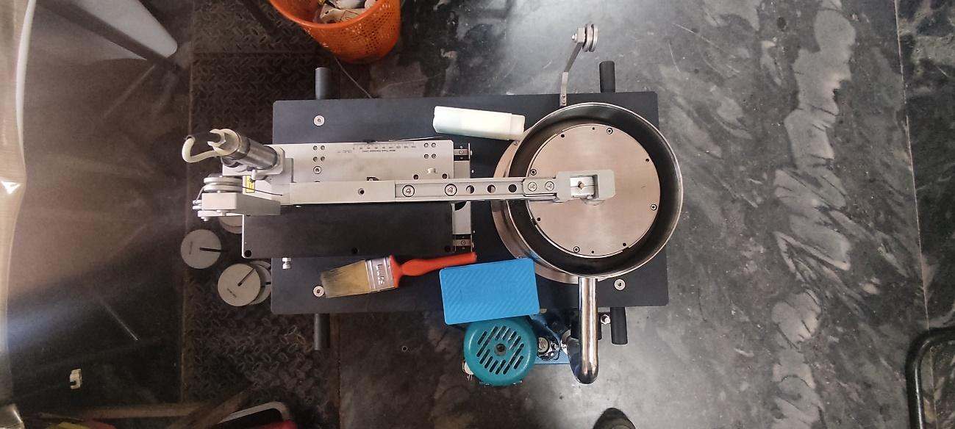 | Pin-On-Disc Tribometer | DUCOM & TR 20 NEO SERIES 1420 | Faculty In-charge:  Dr.Amit Kumar Singh  amitsingh@nitc.ac.in  +91-8949362395  Technical Staff:  Shibin (Senior Technician)  shibinr@nitc.ac.in  0495-2286485 | 3245822 |  | https://www.istem.gov.in/
19 | 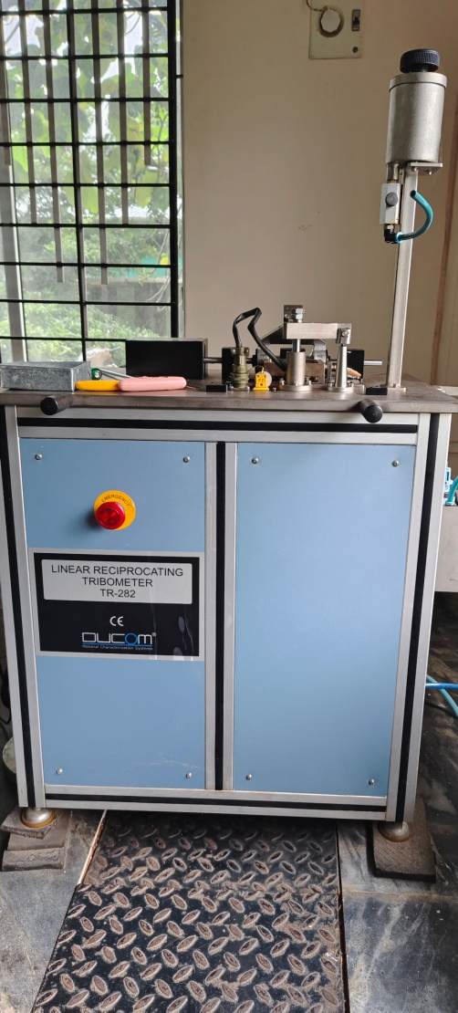 | Linear Reciprocating Tribometer | Ducom TR 282 | Faculty In-charge:  Dr.Amit Kumar Singh  amitsingh@nitc.ac.in  +91-8949362395  Technical Staff:  Shibin (Senior Technician)  shibinr@nitc.ac.in  0495-2286485 | 3224926 |  | https://www.istem.gov.in/
20 | 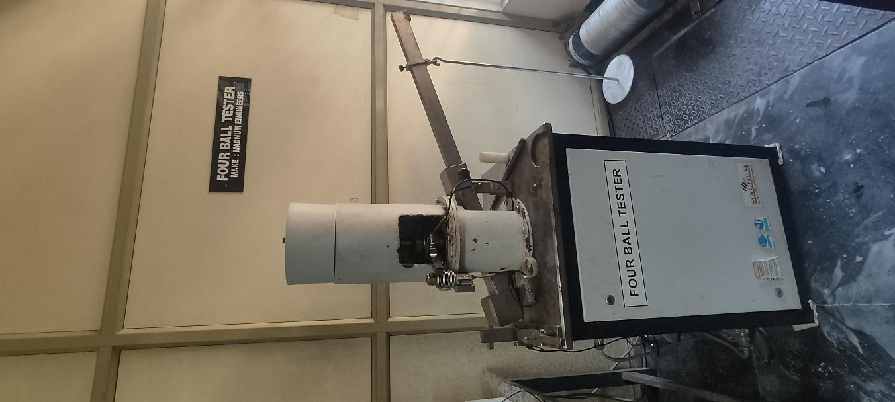 | Four Ball Tester | Magnum & TE-4B-L 144/2014 | Faculty In-charge:  Dr.Amit Kumar Singh  amitsingh@nitc.ac.in  +91-8949362395  Technical Staff:  Eldho P Varghese (TA SG II)  epv@nitc.ac.in  0495-2286485 | 3224913 |  | https://www.istem.gov.in/
21 | 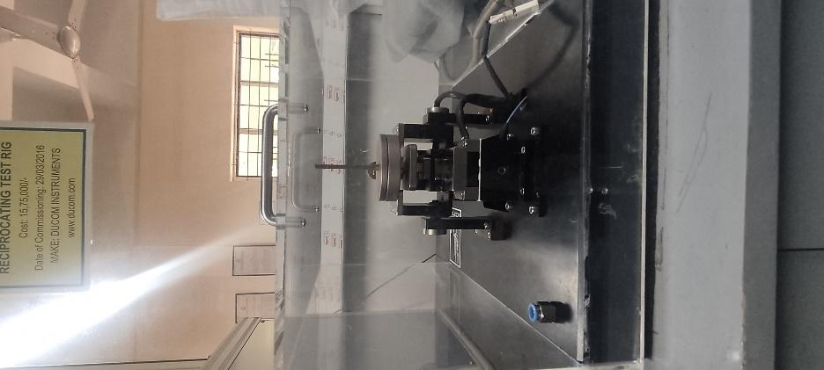 | High Frequency Reciprocating Rig | DUCOM & TR-282 | Faculty In-charge:  Dr.Amit Kumar Singh  amitsingh@nitc.ac.in  +91-8949362395  Technical Staff:  Shibin (Senior Technician)  shibinr@nitc.ac.in  0495-2286485 | 3224915 |  | https://www.istem.gov.in/
22 | 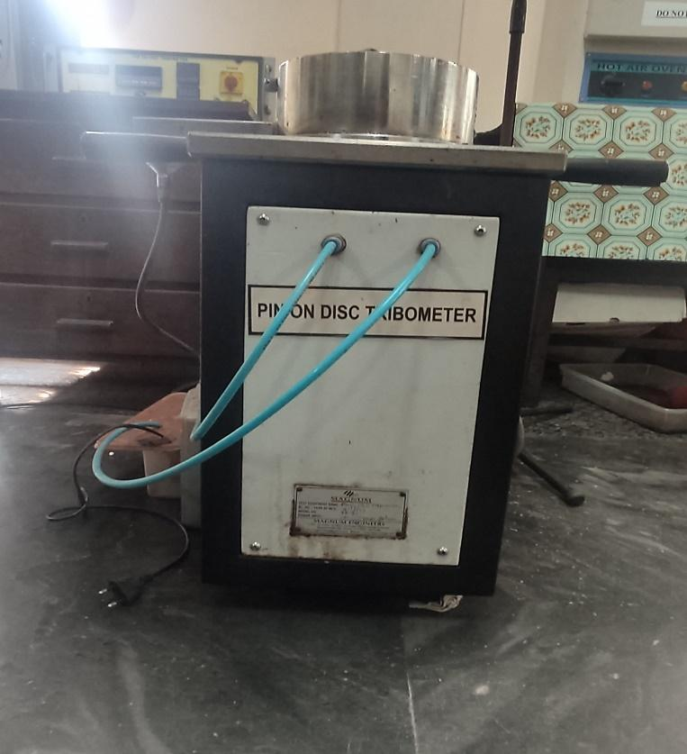 | Pin On Disc Tribotester | Magnum & TE-165 143/2014 | Faculty In-charge:  Dr.Amit Kumar Singh  amitsingh@nitc.ac.in  +91-8949362395  Technical Staff:  Shibin (Senior Technician)  shibinr@nitc.ac.in  0495-2286485 | 3224913 |  | https://www.istem.gov.in/
23 | 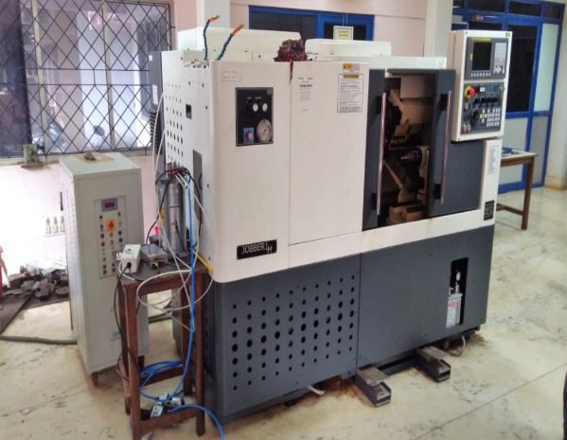 | CNC TURNING CENTER | Ace Micromatics- Jober LM | Faculty In-charge:  Dr. Basil Kuriachen  bk@nitc.ac.in  +91-9947187133  Technical Staff:  Unni Krishnan(TA )  kishan@nitc.ac.in  0495 228 6476 | 3224893 |  | https://www.istem.gov.in/
24 | 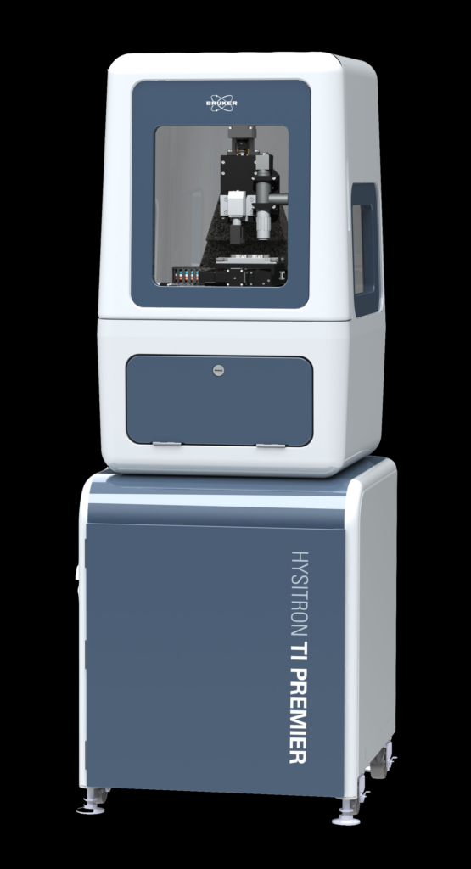 | NANO INDENTER | Hysitron TI Premier | Faculty In-charge:  Dr. Basil Kuriachen  bk@nitc.ac.in  +91-9947187133  Technical Staff:  Harikrishnan K (TE)  harikrishnank@nitc.ac.in  0495 228 6476 | 3229300 |  | https://www.istem.gov.in/
25 | 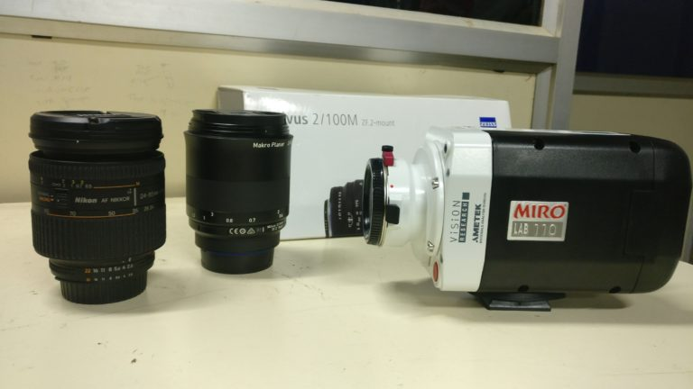 | HIGH-SPEED CAMERA | PHANTOM- MIRO LAB110 | Faculty In-charge:  Dr. Basil Kuriachen  bk@nitc.ac.in  +91-9947187133  Technical Staff:  Unni Krishnan(TA )  kishan@nitc.ac.in  0495 228 6476 | 3224896 |  | https://www.istem.gov.in/
26 | 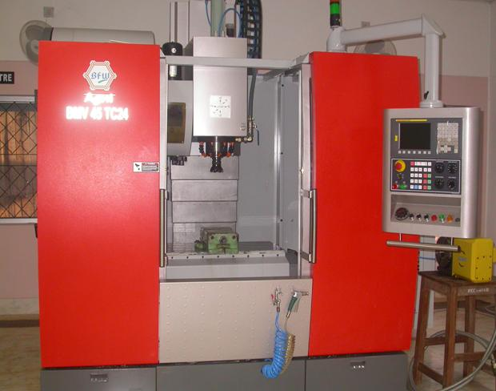 | CNC VERTICAL MACHINING CENTER | Agni BMV45 TC24 4-axis vertical machining centre | Faculty In-charge:  Dr. Basil Kuriachen  bk@nitc.ac.in  +91-9947187133  Technical Staff:  Unni Krishnan(TA )  kishan@nitc.ac.in  0495 228 6476 | 3224889 |  | https://www.istem.gov.in/
27 | 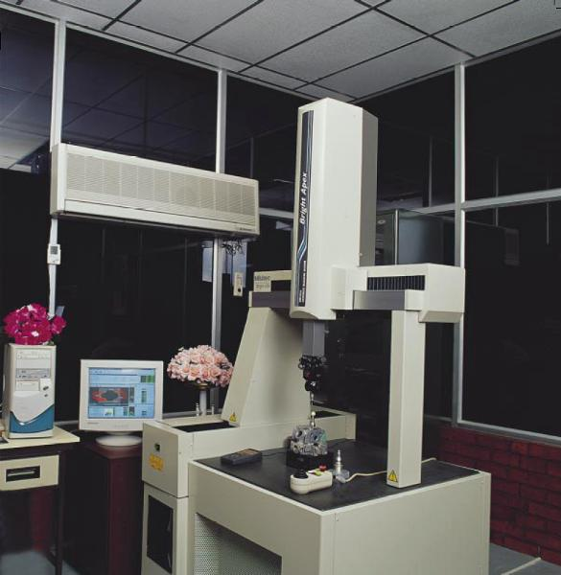 | 5 AXIS CNC COORDINATE MEASURING MACHINE | Mitutoyo- Bright A 504 | Faculty In-charge:  Dr Jos Mathew  josmat@nitc.ac.in  0495 2286405  Technical Staff:  Unni Krishnan(TA )  kishan@nitc.ac.in  0495 228 6476 | 3224852 |  | https://www.istem.gov.in/
28 | 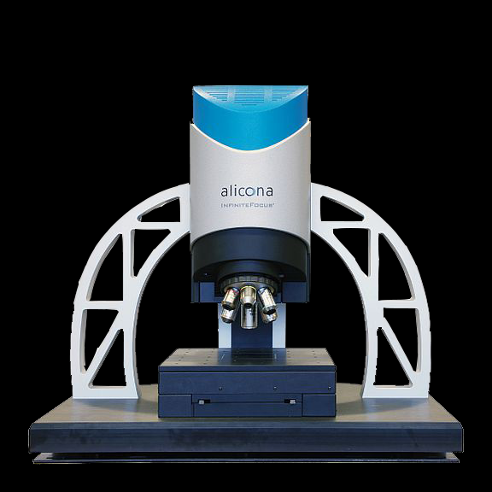 | 3D OPTICAL PROFILOMETER | ALICONA Model- Infinite Focus G5 | Faculty In-charge:  Dr. Basil Kuriachen  bk@nitc.ac.in  +91-9947187133  Technical Staff:  Harikrishnan K (TE)  harikrishnank@nitc.ac.in  0495 228 6476 | 3224898 |  | https://www.istem.gov.in/
29 | 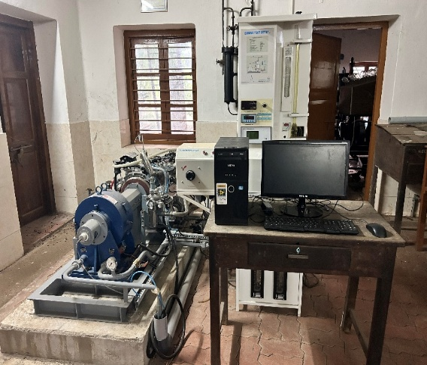 | Automotive CRDI Diesel Engine Test Rig | Mahindra, Jeeto (Engine No -UGN3H00251) | Faculty In-charge:  Dr. Saleel Ismail  saleel@nitc.ac.in  9884691904  Technical Staff:  Pradeep Kumar K K  kkp69@nitc.ac.in  04952286456 |  |  | https://www.istem.gov.in/
30 | 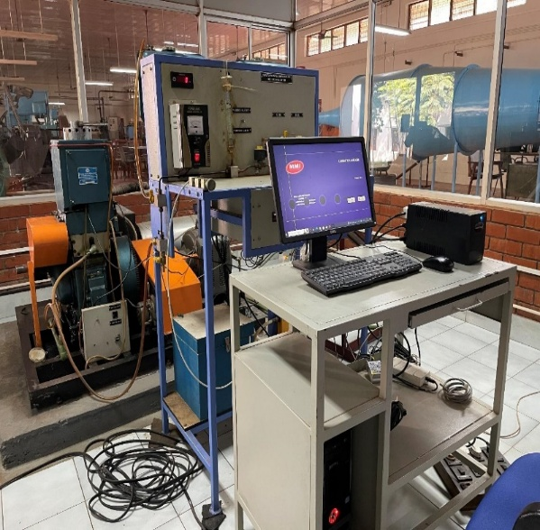 | Variable compression ratio multifuel engine test rig | Kirloskar, Engine No. 18.1324/1300209 | Faculty In-charge:  Dr. Saleel Ismail  saleel@nitc.ac.in  9884691904  Technical Staff:  Pradeep Kumar K K  kkp69@nitc.ac.in  04952286456 | 3224886 |  | https://www.istem.gov.in/
31 | 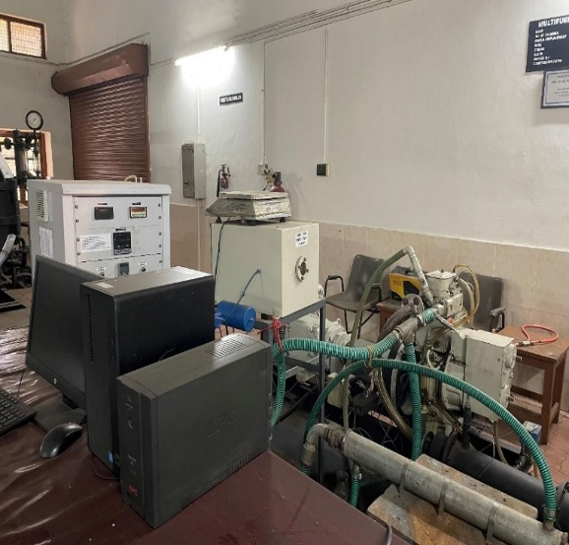 | Computerized Variable Compression Ratio Multifuel Engine Test Rig | Kirloskar, Tv1 (SR No- VE019) | Faculty In-charge:  Dr. Saleel Ismail  saleel@nitc.ac.in  9884691904  Technical Staff:  Pradeep Kumar K K  kkp69@nitc.ac.in  04952286456 |  |  | https://www.istem.gov.in/
32 | 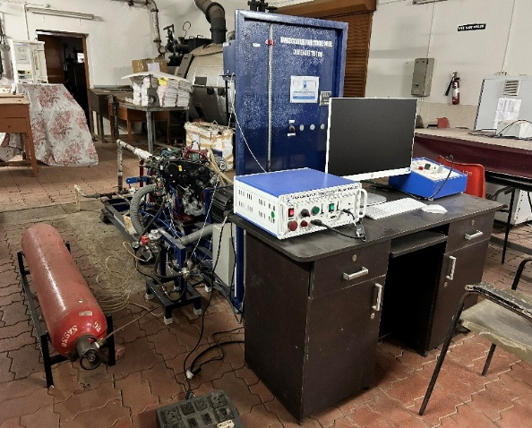 | Single cylinder automotive hybrid research engine with dual fuel setup and open ECU system | Mahindra, Jeeto (Engine No - UAK3A17253) | Faculty In-charge:  Dr. Saleel Ismail  saleel@nitc.ac.in  9884691904  Technical Staff:  Pradeep Kumar K K  kkp69@nitc.ac.in  04952286456 |  |  | https://www.istem.gov.in/
33 | 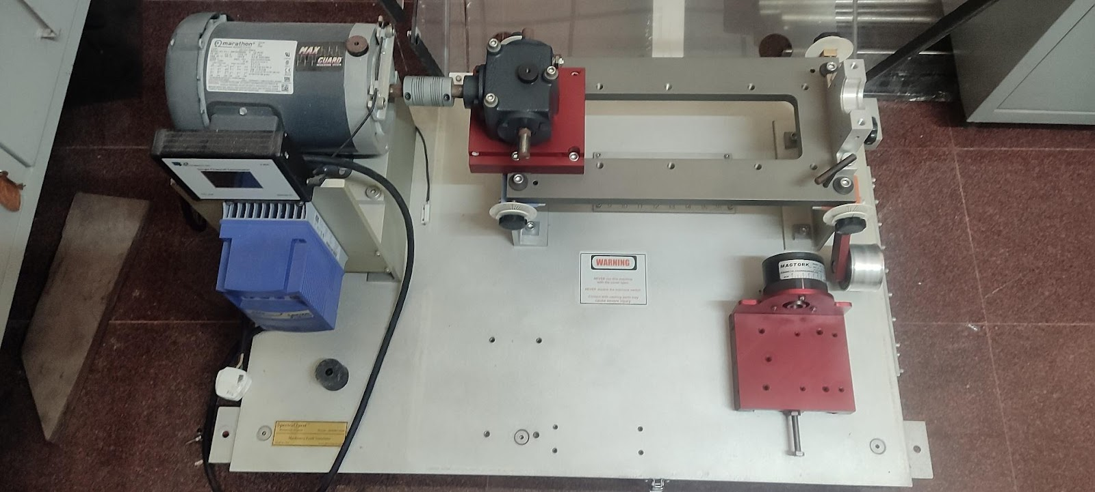 | Machinery Fault Simulator | Spectra Quest Inc USA & MFSS2010 | Faculty In-charge:  Dr.Ashesh Saha  ashesh@nitc.ac.in  +91-9451545350  Technical Staff:  Shibin (Senior Technician)  shibinr@nitc.ac.in | 3236735 |  | https://www.istem.gov.in/
34 | 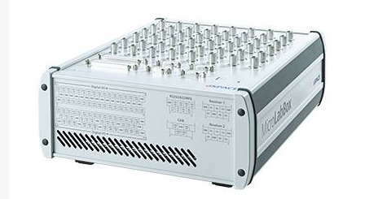 | MicroLab Box DSpace | DynaFusion Technologies & ACE_MLBX_1302T | Faculty In-charge:  Dr.Ashesh Saha  ashesh@nitc.ac.in  +91-9451545350  Technical Staff:  Shibin (Senior Technician)  shibinr@nitc.ac.in | 3236736 |  | https://www.istem.gov.in/
35 | 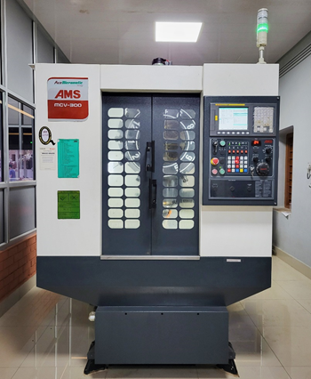 | CNC Lathe Machine | Ace Micromatic, Bangalore& LT-16 300LM, | Faculty In-charge:  Dr. Muhammed Rashad  rashad@nitc.ac.in  +91-9744899126  Technical Staff:  Manoj K.G  manoj@nitc.ac.in  0495 2286440 | 3224872 |  | https://www.istem.gov.in/
36 |  | CNC Vertical Machining Center | Ace Micromatic, Bangalore& MCV-300 | Faculty In-charge:  Dr. Muhammed Rashad  rashad@nitc.ac.in  +91-9744899126  Technical Staff:  Manoj K.G  manoj@nitc.ac.in  0495 2286440 | 3224873 |  | https://www.istem.gov.in/
37 | 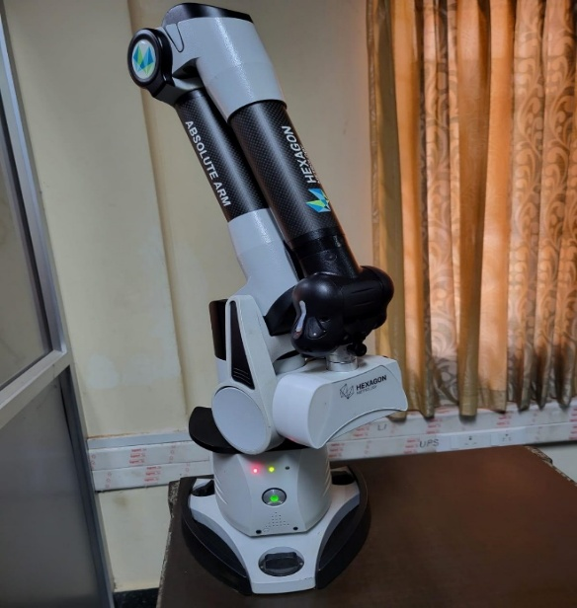 | Laser Scanner | Hexagon Metrology USA; HP-L-8.9 | Faculty In-charge:  Dr. P. B. Dhanish  dhanish@nitc.ac.in  +91-9207024889  Technical Staff:  Ishan Chandra (TA)  ishanchandra@nitc.ac.in | 3224864 |  | https://www.istem.gov.in/
38 | 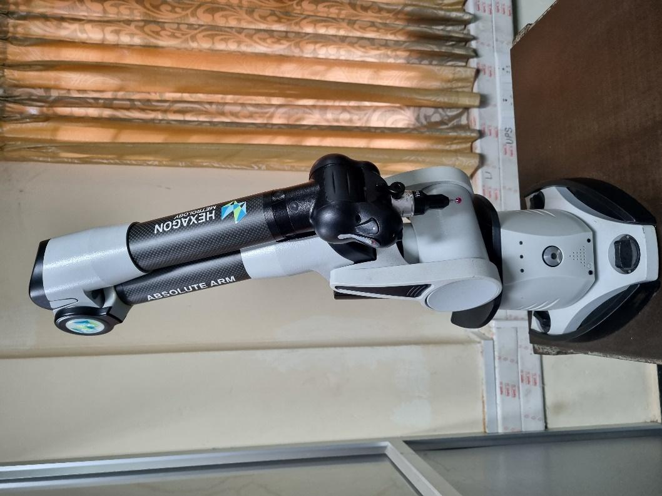 | Portable Measuring Arm | Hexagon Metrology USA; RA-7312-4 | Faculty In-charge:  Dr. P. B. Dhanish  dhanish@nitc.ac.in  +91-9207024889  Technical Staff:  Ishan Chandra (TA)  ishanchandra@nitc.ac.in | 3224863 |  | https://www.istem.gov.in/
39 | 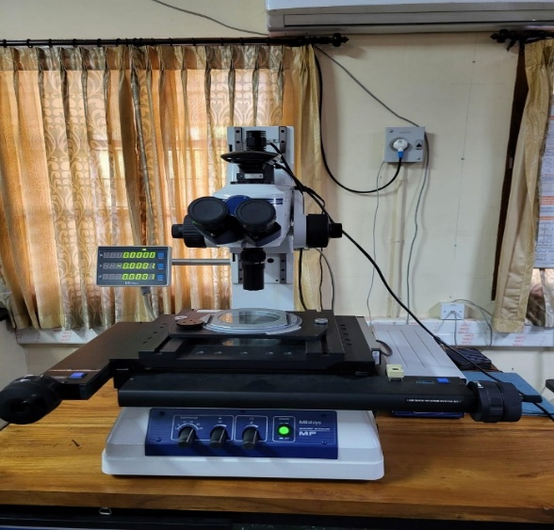 | Measuring Microscope | Mitutoyo; MF-B2010D | Faculty In-charge:  Dr. P. B. Dhanish  dhanish@nitc.ac.in  +91-9207024889  Technical Staff:  Ishan Chandra (TA)  ishanchandra@nitc.ac.in | 3224862 |  | https://www.istem.gov.in/
40 | 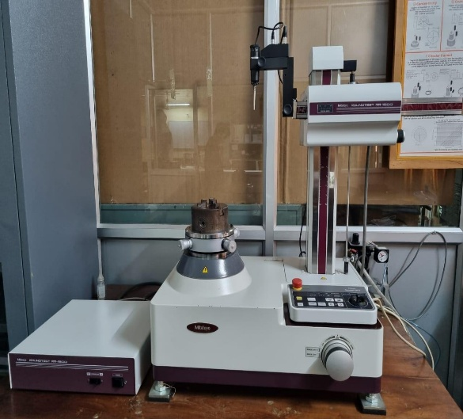 | Roundness Tester | Mitutoyo; RA-1600M | Faculty In-charge:  Dr. P. B. Dhanish  dhanish@nitc.ac.in  +91-9207024889  Technical Staff:  Ishan Chandra (TA)  ishanchandra@nitc.ac.in | 3224861 |  | https://www.istem.gov.in/
41 | 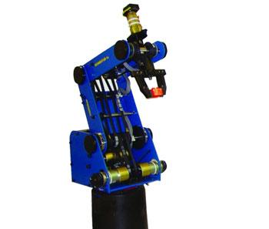 | SCORBOT ER-4U ROBOT | INTELITEK, ER-4U & 160146421-006 | Faculty In-charge:  Dr. Sudheer A P  apsudheer@nitc.ac.in  +91-9961450987  Technical Staff:  Sasi K K  kksasi@nitc.ac.in  9447635438 | 3224930 |  | https://www.istem.gov.in/
42 | 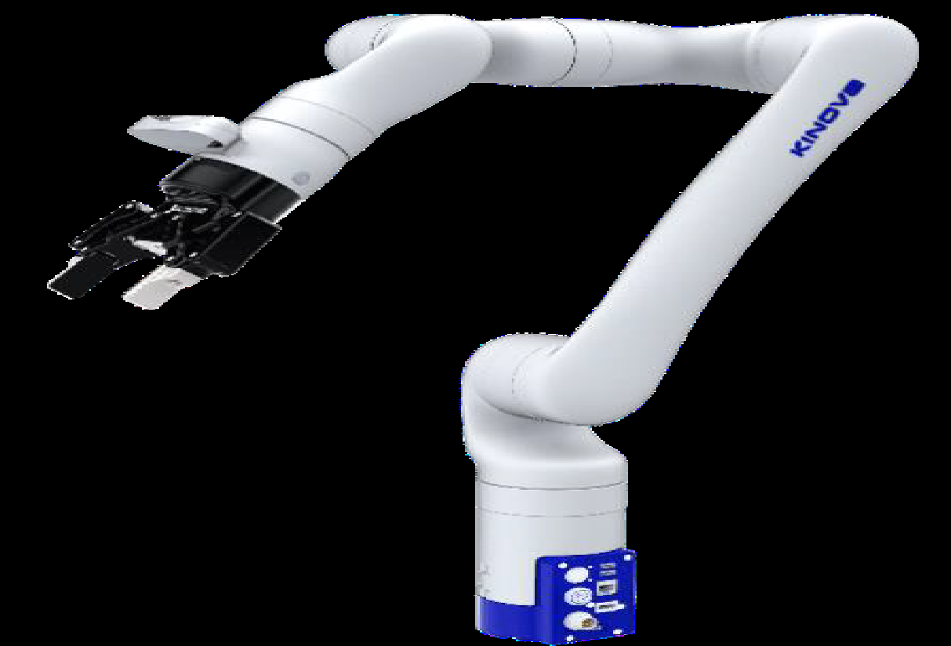 | KINOVA GEN3 ROBOT | KINOVA , CANADA GEN 3 & C-45652 | Faculty In-charge:  Dr. Sudheer A P  apsudheer@nitc.ac.in  +91-9961450987  Technical Staff:  Sasi K K  kksasi@nitc.ac.in  9447635438 | 3236734 |  | https://www.istem.gov.in/
43 | 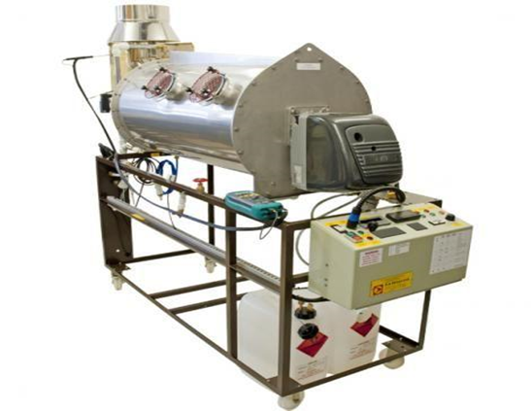 | Combustion Laboratory Unit with oil Burner | PA HILTON, UK & C492 & c492B | Faculty In-charge:  Dr. T. J. Sarvoththama Jothi  tjsjothi@nitc.ac.in  0495 228 6419  Technical Staff:  Abhilash A  abhilasha@nitc.ac.in  0495-2286449 | 3224911 |  | https://www.istem.gov.in/
44 | 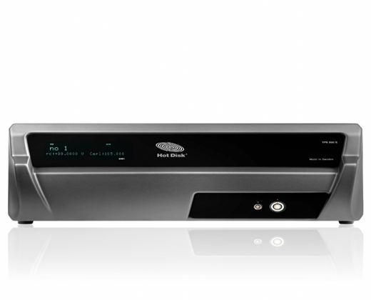 | Thermal Constant Analyzer | Sven Hultins gata 9A & Hot Disk TPS 500 S | Faculty In-charge:  Dr. T. J. Sarvoththama Jothi  tjsjothi@nitc.ac.in  0495 228 6419  Technical Staff:  Abhilash A  abhilasha@nitc.ac.in  0495-2286449 | 3224904 |  | https://www.istem.gov.in/
45 | 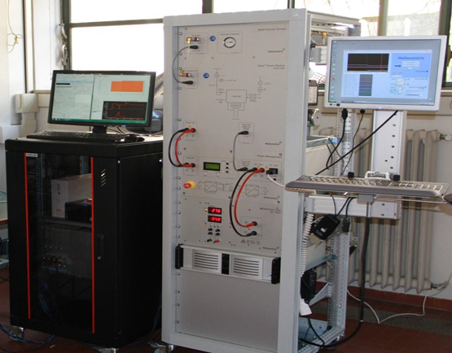 | Fuel Cell Experiment Test Rig | Heliocentris & EL 1500, Nexa® | Faculty In-charge:  Dr. Vinod Kumar Sharma  vinodks@nitc.ac.in  9981263331  Technical Staff:  Abhilash A  abhilasha@nitc.ac.in  0495-2286449 | 3224910 |  | https://www.istem.gov.in/
46 | 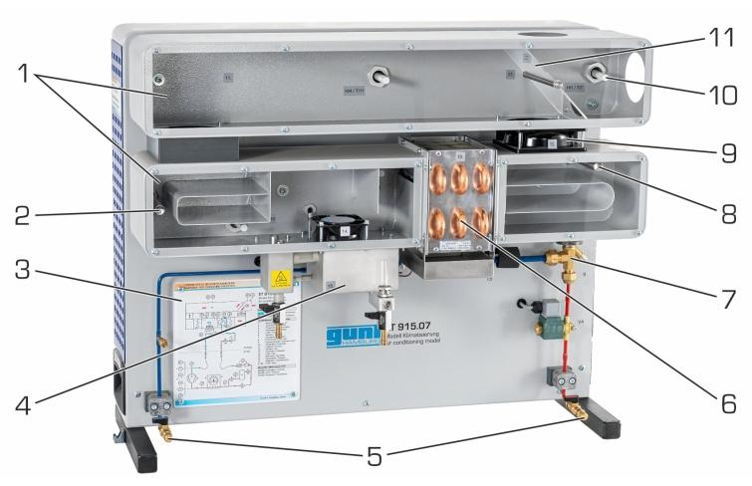 | AC Test Rig | Gunt Hamburg & ET 915 ET915.07 | Faculty In-charge:  Dr. T. J. Sarvoththama Jothi  tjsjothi@nitc.ac.in  0495 228 6419  Technical Staff:  Abhilash A  abhilasha@nitc.ac.in  0495-2286449 | 3224900 |  | https://www.istem.gov.in/
47 | 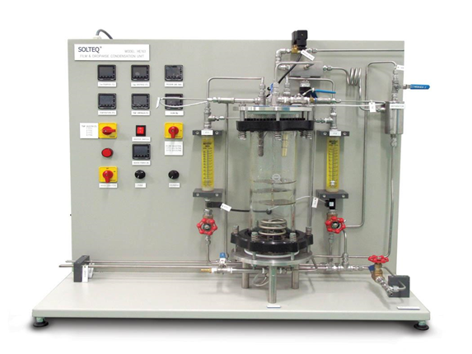 | Film and Dropwise condensation unit | SolTeq Solution & Sdn.BHD, HE 178® | Faculty In-charge:  Dr. Sujith Kumar C S  sujithcs@nitc.ac.in  0495 228 6416  Technical Staff:  Abhilash A  abhilasha@nitc.ac.in  0495-2286449 | 3224903 |  | https://www.istem.gov.in/

