|  |  |  |  |  |  |  |
| --- | --- | --- | --- | --- | --- | --- |
|  | | | **MULTIPLE CASTING MACHINES**  **Name of the equipment:**  Computerized Magnesium & Aluminium MMC Casting  **Make & Model:**  Swam Equip, India  **I-Stem Registration ID-**  **3224874**  **Category of Instrument**  Metallurgical Processing Equipment  **Types of Analysis / Testing**  Composite material fabrication  **Application:**  Production of Aluminium/Magnesium metal matrix composites (MMCs) by incorporating reinforcements into molten metal  **Description of Instrument**  The Bottom Pouring Stir Casting unit enables uniform mixing of reinforcements into molten metal with controlled stirring and clean pouring from the bottom to minimize impurities and segregation. This machine facilitates reinforcement mixing via stir rod or ultrasonic vibration. It is also designed to perform diverse casting methods such as gravity, vacuum, squeeze, and centrifugal casting. | | | |
| **Book through I-STEM:**  <https://www.istem.gov.in/>  **Slot Booking Link**  [I-STEM Slot Booking link for External User](https://www.istem.gov.in/equipment-info/24874/Multiple-Casting-Machine) | | | **Booking Details**  **Booking available for**  Internal and External Both  **Requisition form for**  Internal  External  **Contact Details** | |
| **Faculty In-charge:**  Dr. Murali KP  **Email ID:**  [kpmurali@nitc.ac.in](mailto:kpmurali@nitc.ac.in)  **Phone number:**  0495-2286414 | | **Technical Staff:**  Sanal PR (TA SG I)  [sanal@nitc.ac.in](mailto:sanal@nitc.ac.in)  Jithin Krishna M (TA)  [jithinkrishnam@nitc.ac.in](mailto:jithinkrishnam@nitc.ac.in)  Jijeesh k (ST)  [jijeeshk@nitc.ac.in](mailto:jijeeshk@nitc.ac.in) | | | **Department-** MED  **Office Email ID**  [medoffice@nitc.ac.in](mailto:medoffice@nitc.ac.in)  **Location**  Material Science Lab Production Block  **Lab Phone No**  0495-2286450 | | |

**Features, Working Principle and Specifications**

**Bottom pouring type stir casting machine**

• Supports Aluminium and Magnesium stir casting processes.

• Partial Argon atmosphere control for Al, full SF6 + Ar control for Mg.

• Motorized stirrer with variable speed up to 1500 RPM and interchangeable blades.

• Max furnace temperature of 1000°C with capacities of 2, 5, 10, and 50 kg.

• PID-based temperature control with ±2°C accuracy and dual thermocouples.

• Gas-shielded bottom pouring prevents oxidation during Mg casting.

• Pre-heating furnace for nano/alloy particles up to 800°C (Al) and 500°C (Mg).

• Integrated control panel and gas mixing chamber (for Mg models).

• Fully assembled on a mobile frame with safety and convenience features.

**Vacuum casting**

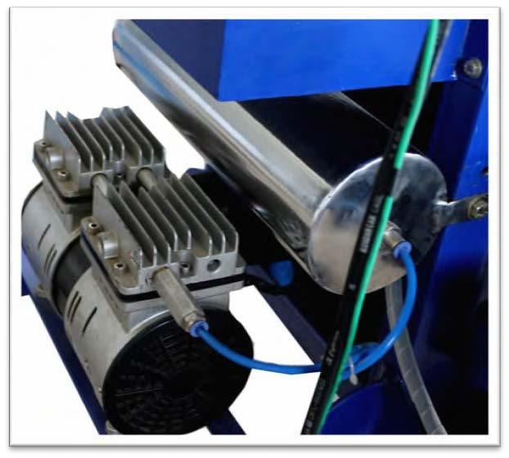

* Pump: single or two stage pump
* Gauge: Analog dial type
* Control: Using electric solenoid valve
* Max. Vacuum: 760 mmHg

**Squeeze Casting**

* A machine with a blue and green machine

  AI-generated content may be incorrect.Maximum pressure of hydraulic power pack: 100 tons
* Maximum load that can be applied on the die: 50 tons
* Control: Digital indication & control
* Pathway heater max. temp: 450 0C
* Pathway heater temp. control: PID based ON/ OFF controller with K type sensor
* Die: Mild steel (water cooled die available under additional cost)
* Safe load conditions: 40 tons for Aluminium and 10 tons for Magnesium

**Type of Sample Required for Analysis / Testing (Quantity, Pre-Preparation, State etc.) Guidelines for Sample Submission – User Instructions**

|  |
| --- |
| * Sample Type: Al and Mg alloys * Type of Samples to be Analysed - Metallic * Maximum No. of Samples Accepted at a Time- 1 * Minimum No of Days Required for Analysis – 2 Days |

**User Charges Rs. (GST Extra)**

|  |  |  |  |
| --- | --- | --- | --- |
| **Internal** | **External Academic Institutes** | **National R&D Lab** | **Industry** |
| 1000/- per sample | 2000/- per sample + GST | 2000/- per sample + GST | 2000/- per sample + GST |