MULTICOMPONENT DYNAMOMETER (KISTLER 9256C2)

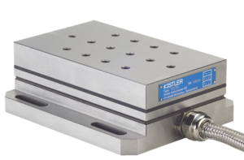 |  | Name of the equipment:  MULTICOMPONENT DYNAMOMETER (KISTLER 9256C2)  Make & Model:  KISTLER,9256C2  I-Stem Registration ID-  3224887  Category of Instrument  Advance Manufacturing Centre  Application:  Cutting force and cutting moment (6 components) measurements.  Description of Instrument:  Multicomponent Dynamometer for force and moment measurement during machining  Booking Details
Book through I-STEM:  https://www.istem.gov.in/  Slot Booking Link  I-STEM Slot Booking link for External User | Booking available for  Internal and External Both  Requisition form for  Internal  External
Contact Details

Faculty In-charge:  Dr. Basil Kuriachen  Email ID:  bk@nitc.ac.in  Phone number:  +91-9947187133 | Technical Staff:  Sanal PR (TA SG I)  sanal@nitc.ac.in  Jithin Krishna M (TA)  jithinkrishnam@nitc.ac.in  Jijeesh k (ST)  jijeeshk@nitc.ac.in | Department  MED  Office Email ID  medoffice@nitc.ac.in  Location  Advance Manufacturing Centre  Production Block  Lab Phone No  0495-2286450

Features, Working Principle and Specifications

Instrument Technical Description and Major Specifications:
Measuring range (Fx, Fy, Fz): -250 – 250 N,
Measuring range (Mx, Mz):-11 – 11 Nm
Sensitivity (Fx, Fz): ~ -26 pC/N;
Sensitivity (Fy): ~ -13 pC/N
Type of sample Required: Metallic/composite/alloys etc.
Maximum size usually limited 75mm x 35mm
User Charges Rs. (GST Extra)

Internal | External Academic Institutes | National R&D Lab | Industry
250/- per hour | 250/- per hour + GST | 250/- per hour + GST | 250/- per hour + GST

