MICRO MACHINING CENTRE AND ACCESSORIES

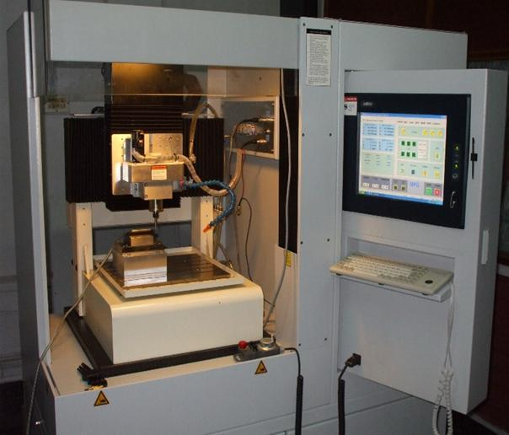  Booking Details |  | Name of the equipment:  MICRO MACHINING CENTRE AND ACCESSORIES  Make & Model:  MIKROTOOLS Pte Ltd, DT-110 LE-311  I-Stem Registration ID-  3224890  Category of Instrument  Advance Manufacturing Centre  Types of Analysis / Testing  Micro Machining  Application:  Micro Turning, Micro Milling, Micro Drilling  Description of Instrument:  The major facilities available in the micro machining centre are Micro Turning, Micro Milling, Micro Drilling in which spindle speed varies from 10000 rpm -60000rpm
Book through I-STEM:  https://www.istem.gov.in/  Slot Booking Link  I-STEM Slot Booking link for External User | Booking available for  Internal and External Both  Requisition form for  Internal  External
Contact Details

Faculty In-charge:  Dr. Basil Kuriachen  Email ID:  bk@nitc.ac.in  Phone number:  +91-9947187133 | Technical Staff:  Sanal PR (TA SG I)  sanal@nitc.ac.in  Jithin Krishna M (TA)  jithinkrishnam@nitc.ac.in  Jijeesh k (ST)  jijeeshk@nitc.ac.in | Department  MED  Office Email ID  medoffice@nitc.ac.in  Location  Advance Manufacturing Centre  Production Block  Lab Phone No  0495-2286450

Features, Working Principle and Specifications

Instrument Technical Description and Major Specifications:
Rotational Speed 10000-60000rpm
Frequency variation 167-1000Hz
Maximum Power-1.3kW
Tool holding dia. Limited up to 100mm
Type of sample Required: Metals and alloys
Maximum size usually limited 100mm x 100mm
User Charges Rs. (GST Extra)

Internal | External Academic Institutes | National R&D Lab | Industry
200/- per hour | 200/- per hour + GST | 200/- per hour + GST | 200/- per hour + GST

