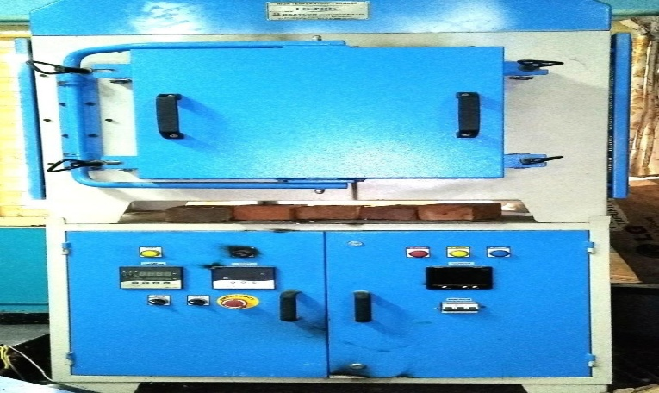  HIGH TEMPERATURE FURNACE | Name of the equipment:  HIGH TEMPERATURE FURNACE  Make & Model:  Heatcon Instruments pvt. Ltd, HENIX  I-Stem Registration ID-  3224879  Category of Instrument  Material Science  Types of Analysis / Testing  Heat Treatment  Application:  Heat treatment, metallurgy, ceramic production  Description of Instrument  Specialized equipment designed to generate and maintain extremely high temperatures, typically ranging from 1000°C to over 1500°C, for industrial processes like material testing, heat treatment, metallurgy, and ceramic production.
Booking Details

Book through I-STEM:  https://www.istem.gov.in/  Slot Booking Link  I-STEM Slot Booking link for External User | Booking available for  Internal and External Both  Requisition form for  Internal  External
Contact Details

Faculty In-charge:  Dr. Murali.K.P  Email ID:  kpmurali@nitc.ac.in  Phone number:  +914952286414 | Technical Staff:  Sanal PR (TA SG I)  sanal@nitc.ac.in  Jithin Krishna M (TA)  jithinkrishnam@nitc.ac.in  Jijeesh k (ST)  jijeeshk@nitc.ac.in | Department  MED  Office Email ID  medoffice@nitc.ac.in  Location  Production Engineering Lab  Production Block  Lab Phone No  0495-2286450

Features, Working Principle and Specifications

Instrument Technical Description and Major Specifications:
Size: Height 12” x Width 12” x Depth 12’’
Power rating: 12KW
Max. Temp: 1800o C
Insulation: Ceramic fibre
Heating Element: Molebdenum Di-Silicate
Control panel: PID controller, Thyristor power controller, indication lamp, Transformer
Type of sample Required: To be discussed case by case

User Charges Rs. (GST Extra)

Internal | External Academic Institutes | National R&D Lab | Industry
100/- per hour | 300/- per hour + GST | 300/- per hour + GST | 300/ per hour + GST

