Film and Dropwise condensation unit
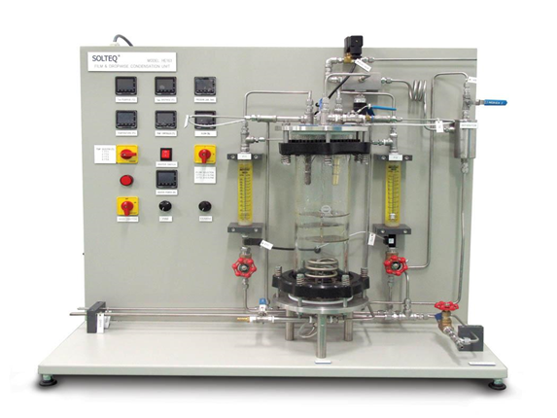 | Name of the equipment:  Film and Dropwise condensation unit  Make & Model:  SolTeq Solution & Sdn.BHD, HE 178®  I-Stem Registration ID-  3224903  Category of Instrument  Educational training system  Types of Analysis / Testing  Heat Transfer Coefficient Determination  Effect of Surface Coatings  Impact of Operating Conditions  Application:  Educational Demonstrations  Applied to improve the design of condensers in power plants and refrigeration system  Description of Instrument  The SolTeq HE 178 Filmwise and Dropwise Condensation Unit is an educational apparatus designed to demonstrate and analyse the two primary modes of steam condensation: Filmwise and dropwise.
Booking Details
Contact Details
Book through I-STEM:  https://www.istem.gov.in/  Slot Booking Link  I-STEM Slot Booking link for External User | Booking available for  Internal and External Both  Requisition form for  Internal  External

Faculty In-charge:  Dr. Sujith Kumar C S  Email ID:  sujithcs@nitc.ac.in  Phone number:  0495 228 6416 | Technical Staff:  Abhilash A  abhilasha@nitc.ac.in  Dhaneesh D C  dhaneeshdc@nitc.ac.in  Athulkrishna K R athulkrishnakr@nitc.ac.in | Department: MED  Office Email ID  medoffice@nitc.ac.in  Location  Thermal Science Laboratory, Department of Mechanical Engineering  Lab Phone No  0495-2286449
Features, Working Principle and Specifications
Contact Details
Features of the equipment  - Dual Condenser Design  - High-Quality Construction of condensers  - Integrated Instrumentation | Unique features/Measurement capabilities, if any  - Dual Condenser Design for Comparative studies  - Integrated Temperature and Flow Measurement
Instrument Technical Description and Major Specifications (This Specifications Limited to Major 5)  - Steam Chamber made of Borosilicate Glass cylinder  - Condenser Diameter: 12.7mm; Length:120mm  - Coiled heater with thermal protection, Power:3kW  - Air Extraction System: Includes air cooler, separator, and water jet vacuum pump.  - Pressure Switch to turn off the heater when chamber pressure exceeds 1.20 abs bar | Measurement/Sample specifications:  - To measure the pressure within the steam chamber  - Typically, distilled water is used to generate steam for the condensation process
Type of Sample Required for Analysis / Testing (Quantity, Pre-Preparation, State etc.) Guidelines for Sample Submission – User Instructions

User Charges Rs. (GST Extra)

Test Details | Internal | External Academic Institutes | National R&D Lab | Industry
NA | NA | NA | NA | NA
NA | NA | NA | NA | NA

