AC Test Rig

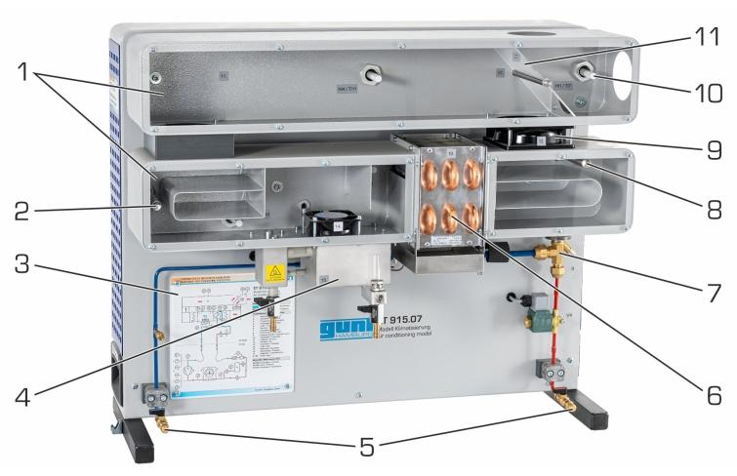 | Name of the equipment:  AC Test Rig  Make & Model:  Gunt Hamburg & ET 915 ET915.07  I-Stem Registration ID-  3224900  Category of Instrument  Educational training system  Types of Analysis / Testing  Heating and Cooling processes  Humidification and Dehumidification  Application:  Education Training in HVAC Systems  Thermodynamic Process Analysis  Description of Instrument  The GUNT Hamburg ET 915.07 Air Conditioning Model is an educational training system designed to simulate and analyse the operation of a full air conditioning system. It is part of the HIS training system for refrigeration and ac technology.
Booking Details

Book through I-STEM:  https://www.istem.gov.in/  Slot Booking Link  I-STEM Slot Booking link for External User | Booking available for  Internal & external  Requisition form for  Internal  External
Contact Details

Faculty In-charge:  Dr. T. J. Sarvoththama Jothi  Email ID:  tjsjothi@nitc.ac.in  Phone number:  0495 228 6419 | Technical Staff:  Abhilash A  abhilasha@nitc.ac.in  Dhaneesh D C  dhaneeshdc@nitc.ac.in  Athulkrishna K R athulkrishnakr@nitc.ac.in | Department  MED  Office Email ID  medoffice@nitc.ac.in  Location  Thermal Science Laboratory, Department of Mechanical Engineering  Lab Phone No  0495-2286449
Features, Working Principle and Specifications
Contact Details
Features of the equipment  - It features a complete air conditioning cycle with components for heating, cooling, humidifying, and dehumidifying air in a closed-loop system.  - The system supports interactive learning with fault simulation, h-x diagram plotting. | Unique features/Measurement capabilities, if any  - Integrated h-x Diagram Software Interface  - Fault Simulation Functionality
Instrument Technical Description and Major Specifications (This Specifications Limited to Major 5)  - Complete Air Conditioning Circuit  - Transparent Air Ducts  - Sensor-Equipped for Real Time Monitoring  - Airflow control & Mixing  - PC- Based Data Acquisition & Software Integration | Measurement/Sample specifications:
Type of Sample Required for Analysis / Testing (Quantity, Pre-Preparation, State etc.) Guidelines for Sample Submission – User Instructions

User Charges Rs. (GST Extra)

Test Details | Internal | External Academic Institutes | National R&D Lab | Industry
NA | NA | NA | NA | NA
NA | NA | NA | NA | NA

