Fuel Cell Experiment Test Rig
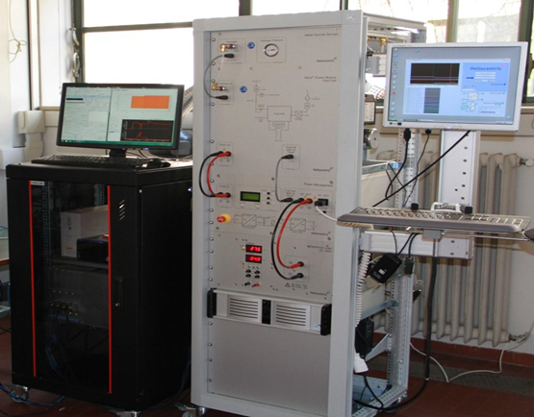 | Name of the equipment:  Fuel Cell Experiment Test Rig  Make & Model:  Heliocentris & EL 1500, Nexa®  I-Stem Registration ID-  3224910  Category of Instrument  Educational training system  Types of Analysis / Testing  Polarization Curve Analysis  Impedance Spectroscopy  Durability and Cycle testing  Application:  Educational Demonstrations  Research and Development  System Optimization  Description of Instrument  The Fuel Cell Test Rig is an advanced educational and research platform designed to study and analyse the performance characteristics of fuel cells under various operating conditions.
Booking Details

Book through I-STEM:  https://www.istem.gov.in/  Slot Booking Link  I-STEM Slot Booking link for External User | Booking available for  Requisition form for  Internal  External
Contact Details

Faculty In-charge:  Dr. Vinod Kumar Sharma  Email ID:  vinodks@nitc.ac.in  Phone number:  9981263331 | Technical Staff:  Abhilash A  abhilasha@nitc.ac.in  Dhaneesh D C  dhaneeshdc@nitc.ac.in  Athulkrishna K R athulkrishnakr@nitc.ac.in | Department  MED  Office Email ID  medoffice@nitc.ac.in  Location  Thermal Science Laboratory, Department of Mechanical Engineering  Lab Phone No  0495-2286449
Features, Working Principle and Specifications
Contact Details

Features of the equipment  - Comprehensive Measurement Capabilities  - Dynamic Load Testing  - Modular Design which enabling easy integration of additional components such as hydrogen generators, storage systems | Unique features/Measurement capabilities, if any  - Data Acquisition and Analysis  - Simulate real-world operating conditions by applying variable loads to the fuel cell.
Instrument Technical Description and Major Specifications (This Specifications Limited to Major 5)  - Proton Exchange Membrane (PEM) Fuel Cell.  - Typically, up to 1.5KW, depending on the configuration.  - Ranges from 50ºC to 80ºC  - Hydrogen supply  - Control Interface | Measurement/Sample specifications:  - Voltage and Current Monitoring  - Temperature sensing  - Pressure measurement
Type of Sample Required for Analysis / Testing (Quantity, Pre-Preparation, State etc.) Guidelines for Sample Submission – User Instructions

User Charges Rs. (GST Extra)

Test Details | Internal | External Academic Institutes | National R&D Lab | Industry
NA | NA | NA | NA | NA
NA | NA | NA | NA | NA

