Thermal Constant Analyzer  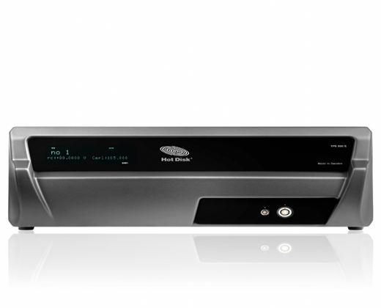 | Name of the equipment:  Thermal Constant Analyzer  Make & Model:  Sven Hultins gata 9A & Hot Disk TPS 500 S  I-Stem Registration ID-  3224904  Category of Instrument  Characterisation and Testing  Types of Analysis / Testing  Thermal property measurement (Thermal conductivity, Diffusivity and specific heat)  Application:  Material Research & Development  Characterizing thermal properties of new materials.  Description of Instrument  The Hot Disk Thermal Constant Analyzer is a versatile instrument that uses the transient plane source method to rapidly and accurately measure the thermal conductivity, diffusivity and specific heat capacity of various materials.
Booking Details

Book through I-STEM:  https://www.istem.gov.in/  Slot Booking Link  I-STEM Slot Booking link for External User | Booking available for  Internal and External Both  Requisition form for  Internals  Externals
Contact Details

Faculty In-charge:  Dr. T. J. Sarvoththama Jothi  Email ID:  tjsjothi@nitc.ac.in  Phone number:  0495 228 6419 | Technical Staff:  Abhilash A  abhilasha@nitc.ac.in  Dhaneesh D C  dhaneeshdc@nitc.ac.in  Athulkrishna K R athulkrishnakr@nitc.ac.in | Department  MED  Office Email ID  medoffice@nitc.ac.in  Location  Thermal Science Laboratory, Department of Mechanical Engineering  Lab Phone No  0495-2286449
Features, Working Principle and Specifications

Features of the equipment  - Transient Plane Source (TPS) Technique for fast, accurate and Non-destruction measurement  - Versatile Material Compatibility  - Small sample size requirement | Unique features/Measurement capabilities, if any  - Simultaneous Measurement of Multiple Thermal properties  - Ability to Measure Anisotropic Materials
Instrument Technical Description and Major Specifications (This Specifications Limited to Major 5)  - Thermal Conductivity: 0.03 to 100 W/m-K  - Diffusivity: 0.02 to 50 mm² /s  - Temperature: With TCU -50ºC to 300ºC  - Measurement time: 2.5 to 2560 seconds  - Measurement Accuracy better than 5% | Measurement/Sample specifications:  - Sample Type Compatibility: Solids, Liquids, Powders and thin films.  - No strict shape requirement- can be disk, slab, rod.  - Measurements depends on good sensor-sample contact.  - Sample is not damaged or altered after testing
Type of Sample Required for Analysis / Testing (Quantity, Pre-Preparation, State etc.) Guidelines for Sample Submission – User Instructions

- Quantity: 30ml minimum required for liquid sample. Please supply in a sealed container.
- Sample Type: Solid, Liquid, Powder and thin films
- Pre-preparation: In solid sample, its surface must be flat.
- User instructions: Submit two Identical Pieces (if solid), most test require the sensor to be sandwiched between two identical pieces.
- If the test must be conducted at non-ambient temperature, specify the required temperature.
- Submit a brief description of your material, expected thermal range.

User Charges Rs. (GST Extra)

Test Details | Internal | External Academic Institutes | National R&D Lab | Industry
Samples testing for room temperature | Rs.500 | 1000 + 18% GST | 2000 + 18% GST | 3000 + 18% GST
Samples testing for variable temperatures (only solid sample) | Rs.1000 | 2000 + 18% GST | 3000 + 18% GST | 4000 + 18% GST

