Combustion Laboratory Unit with oil Burner  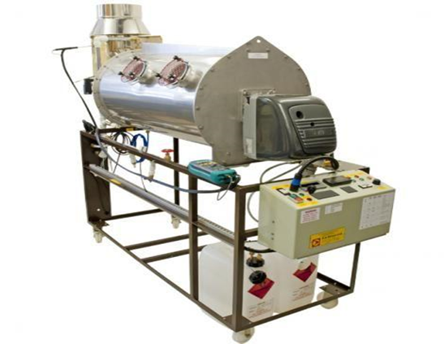 | Name of the equipment:  Combustion Laboratory Unit with oil Burner  Make & Model:  PA HILTON, UK & C492 & c492B  I-Stem Registration ID-  3224911  Category of Instrument  Advanced Educational training system  Types of Analysis / Testing  Combustion Efficiency Analysis  Air-Fuel Ratio and Excess Air calculation  Comparison of Fuel Types  Application:  Combustion Efficiency Studies  Flue Gas Analysis  Description of Instrument  The Combustion Laboratory Unit C492 by P.A. Hilton is an advanced training system designed to provide hands-on experience in combustion processes using both gas and oil burners. This unit is widely utilized in educational settings for studying combustion efficiency, burner operation and energy conversion.
Booking Details

Book through I-STEM:  https://www.istem.gov.in/  Slot Booking Link  I-STEM Slot Booking link for External User | Booking available for  Internal and External Both  Requisition form for  Internals  Externals
Contact Details
Faculty In-charge:  Dr. T. J. Sarvoththama Jothi  Email ID:  tjsjothi@nitc.ac.in  Phone number:  0495 228 6419 | Technical Staff:  Abhilash A  abhilasha@nitc.ac.in  Dhaneesh D C  dhaneeshdc@nitc.ac.in  Athulkrishna K R athulkrishnakr@nitc.ac.in | Department - MED  Office Email ID  medoffice@nitc.ac.in  Location  Thermal Science Laboratory, Department of Mechanical Engineering  Lab Phone No  0495-2286449

Features, Working Principle and Specifications

Features of the equipment  - Dual-Fuel Capability  - Water-Cooled stainless steel combustion chamber  - Integrated Flue Gas Analyzer | Unique features/Measurement capabilities, if any  - Real-Time visual flame analysis through quartz windows  - Built in safety systems
Instrument Technical Description and Major Specifications (This Specifications Limited to Major 5)  - Integrated Instrumentation  - Designed with safety, the unit includes flame monitoring sensors that shut off the fuel supply in the event of flame failure  - Optional High-Specification Gas Analyzer  - Special safety features  - Dual-Fuel Capability | Measurement/Sample specifications:  - Compatible Fuels: Kerosene, gas oil or similar light fuel oils.  - Compatible with natural gas of LPG (Propane/butane)
Type of Sample Required for Analysis / Testing (Quantity, Pre-Preparation, State etc.) Guidelines for Sample Submission – User Instructions

User Charges Rs. (GST Extra)

Test Details | Internal | External Academic Institutes | National R&D Lab | Industry
NA | NA | NA | NA | NA
NA | NA | NA | NA | NA

