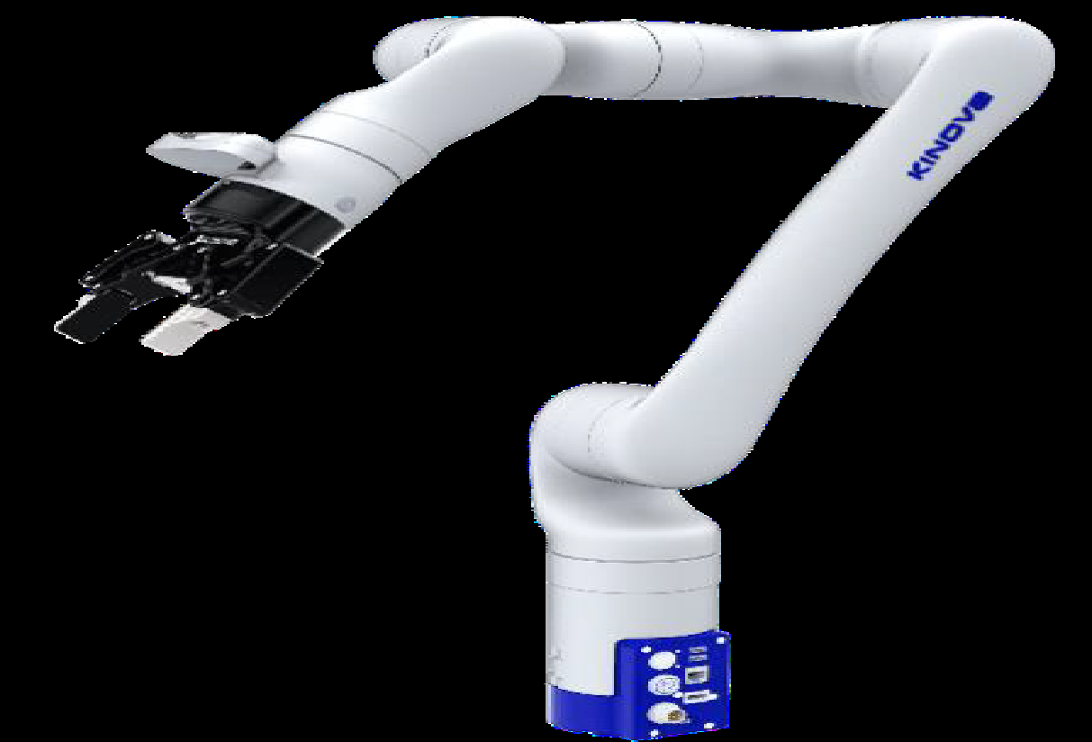 | KINOVA GEN3 ROBOT  Name of the equipment:  KINOVA GEN3 ROBOT  Make & Model:  KINOVA , CANADA GEN 3 & C-45652  I-Stem Registration ID-  3236734  Category of Instrument  (Advanced Manufacturing facility / Characterization and Testing / Computational Facility / Bioscience and Technology / Sample preparation)  Types of Analysis / Testing - NA  Application:  - Used for material handling.  - Robotic welding and machine vision.  - C NC machine tending and other FMS operation.  Description of Instrument  The KINOVA Gen3 is a versatile and reliable robot manipulator for industrial robotics training and education.
Booking Details

Book through I-STEM:  https://www.istem.gov.in/  Slot Booking Link  I-STEM Slot Booking link for External User | Booking available for  Internal and External Both  Requisition form for  Internals  Externals

Faculty In-charge:  Dr. Sudheer A P  Email ID:  apsudheer@nitc.ac.in  Phone number:  +91-9961450987 | Contact Details  Technical Staff:  Mr. Sasi K K  kksasi@nitc.ac.in  9447635438  Mr. Robin M D  robinmd@nitc.ac.in  8281045855 | Department  MED  Office Email ID  medoffice@nitc.ac.in  Location  Mechatronics/Robotics laboratory CAD/CAM Centre Building  Lab Phone No  ……………………………….

Features, Working Principle and Specifications

Features of the equipment  - Mimics human arm movement for enhanced flexibility.  - High accuracy for delicate task.  - Torque sensors in every joint.  - Collision Detection and instant stop. | Unique features/Measurement capabilities, if any  - Research and medical-grade precision  - Plug and play autonomy  - Advanced gripper option  - Real- time force and torque sensing  - Cloud and IoT ready
Instrument Technical Description and Major Specifications (This Specifications Limited to Major 5)  - 6 degree of freedom  - Operating radius of 891 mm  - Weight of instrument is 7.2 Kg and maximum Payload of 4 KG | Measurement/Sample specifications:  - NA
Type of Sample Required for Analysis / Testing (Quantity, Pre-Preparation, State etc.) Guidelines for Sample Submission – User Instructions

- NA

User Charges Rs. (GST Extra)

Internal | External Academic Institutes | National R&D Lab | Industry
1000/- per hour | 1000+ 18% GST per hour | 1000+ 18% GST per hour | 1000+ 18% GST per hour

