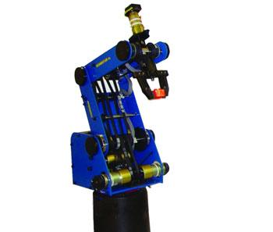 | Name of the equipment:  SCORBOT ER-4U ROBOT  SCORBOT ER-4U ROBOT  Make & Model:  INTELITEK, ER-4U & 160146421-006  I-Stem Registration ID-  3224930  Category of Instrument  (Advanced Manufacturing facility / Characterization and Testing / Computational Facility / Bioscience and Technology / Sample preparation)  Types of Analysis / Testing - NA  Application:  - Used in automated storage and retrieval system  - Automated workcell application such as robotic welding, machine vision and in CNC machine  Description of Instrument  The ScorBot ER-4U is a versatile and reliable system for industrial robotics training and education. The ScorBot ER-4U robot arm can be mounted on a tabletop, pedestal or linear slidebase. The robot’s speed and repeatability make it highly suited for both stand-alone operations and integrated use in automated workcell applications such as robotic welding, machine vision.
Booking Details

Book through I-STEM:  https://www.istem.gov.in/  Slot Booking Link  I-STEM Slot Booking link for External User |  | Booking available for  Internal and External Both  Requisition form for  Internals  Externals
Faculty In-charge:  Dr. Sudheer A P  Email ID:  apsudheer@nitc.ac.in  Phone number:  +91-9961450987 | Contact Details  Technical Staff:  Mr. Sasi K K  kksasi@nitc.ac.in  9447635438  Mr. Robin M D  robinmd@nitc.ac.in  8281045855 |  | Department - MED  Office Email ID  medoffice@nitc.ac.in  Location  Mechatronics/Robotics laboratory CAD/CAM Centre Building  Lab Phone No  ……………………………….

Features, Working Principle and Specifications

Features of the equipment  - 4 Degree of freedom  - Vertical articulate design  - Integrated teach pendant  - Support multiple Programming methods | Unique features/Measurement capabilities, if any  - Support third-party controllers ( Arduino & Raspberry pi..)  - Ideal for STEM/Robotics training
Instrument Technical Description and Major Specifications (This Specifications Limited to Major 5)  - Repeatability: ±0.5 mm  - Max Payload: 0.5 kg (1.1 lbs)  - Reach: Approx. 500 mm | Measurement/Sample specifications:  - NA
Type of Sample Required for Analysis / Testing (Quantity, Pre-Preparation, State etc.) Guidelines for Sample Submission – User Instructions

- NA

User Charges Rs. (GST Extra)

Internal | External Academic Institutes | National R&D Lab | Industry
600/- per hour | 600+18% GST per hour | 600+18% GST per hour | 600+18% GST per hour

