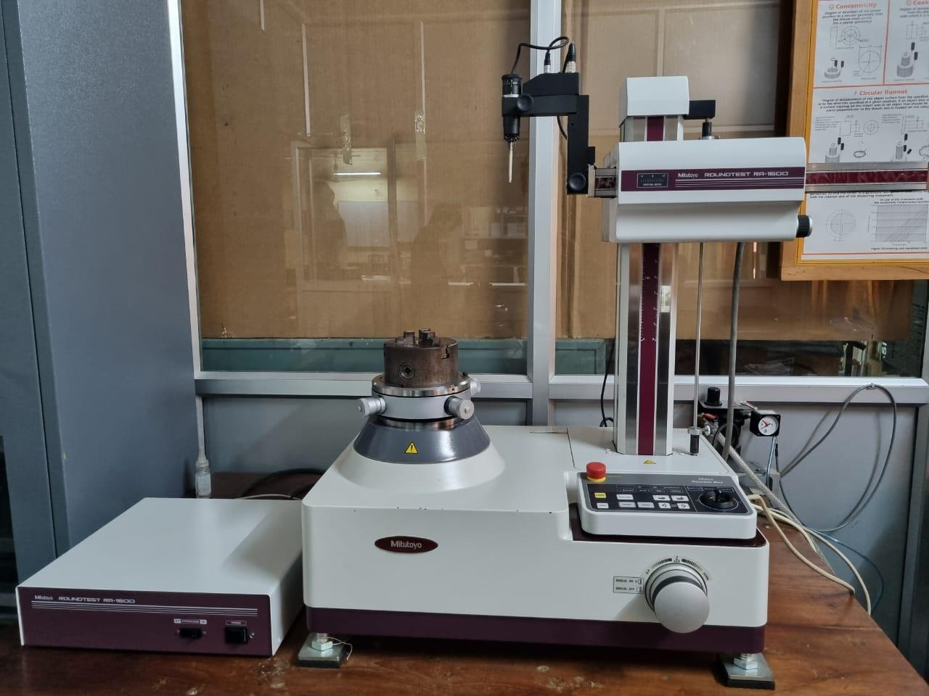 |  | Roundness Tester  Name of the equipment:  Roundness Tester  Make & Model:  Mitutoyo; RA-1600M  I-Stem Registration ID-  3224861  Category of Instrument  Characterization and Testing  Types of Analysis / Testing  To measure form errors  Description of Instrument  The Mitutoyo ROUNDTEST RA-1600M measures the roundness and cylindricity of a workpiece, ensuring its circularity and straightness.
Book through I-STEM:  https://www.istem.gov.in/  Slot Booking Link  I-STEM Slot Booking link for External User | Booking Details  Booking available for  Internal and External Both  Requisition form for  Internal  External

Contact Details

Faculty In-charge:  Dr. P. B. Dhanish  Email ID:  dhanish@nitc.ac.in  Phone number:  +91-9207024889 | Technical Staff:  Ishan Chandra (TA) ishanchandra@nitc.ac.in  Jishnu S (TE)  jishnus@nitc.ac.in | Department  MED  Office Email ID  medoffice@nitc.ac.in  Location  Metrology Lab, Room No. 113, Main Building, NIT Calicut

Specifications

Rotational accuracy: (0.02 +6H/10000) microns, H height (mm); Work piece max dia 560 mm, max height 300 mm, max weight 25 kg
User Charges Rs. (GST Extra)

Internal | External Academic Institutes | National R&D Lab | Industry
500/- per sample | 1000/- per sample + GST | 1000/- per sample +GST | 1500/- per sample +GST

