HIGH SPEED TEMPERATURE DATA ACQUISITION SYSTEM

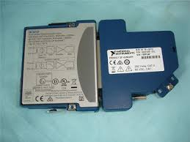  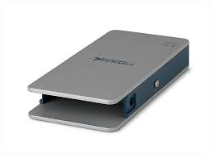  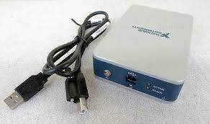 | Name of the equipment:  High speed temperature data acquisition system  Make & Model:  National Instruments,USA  NI CDAQ 9212  I-Stem Registration ID-  Category of Instrument  Thermal Systems Monitoring  Types of Analysis / Testing  Thermal Testing in R&D (Automotive, Aerospace, Electronics)  Application:  used for precise and high-speed temperature monitoring in applications such as battery testing, environmental chambers, industrial process control, and thermal profiling.  Description of Instrument  An 8-channel, high-accuracy, 24-bit thermocouple input module designed for high-speed temperature data acquisition in industrial and laboratory environments.
Booking Details
Contact Details
Book through I-STEM:  https://www.istem.gov.in/  Slot Booking Link  I-STEM Slot Booking link for External User | Booking available for  Internal and External Both  Requisition form for  Internal  External

Faculty In-charge:  Dr. Murali KP  Email ID:  kpmurali@nitc.ac.in  Phone number:  0495-2286414 | Technical Staff:  Sanal PR (TA SG I)  sanal@nitc.ac.in  Jithin Krishna M (TA)  jithinkrishnam@nitc.ac.in  Jijeesh k (ST)  jijeeshk@nitc.ac.in | Department  MED  Office Email ID  medoffice@nitc.ac.in  Location  Material Science Lab  Production Block  Lab Phone No  0495-2286450
Features, Working Principle and Specifications

Number of channels | 8 isolated thermocouple channels
ADC resolution | 24 bits
Type of ADC | Delta-Sigma
Sampling mode | Simultaneous
Voltage measurement range | ±78.125 mV
Temperature measurement ranges | Works over temperature ranges defined by NIST (J, K, T, E, N, B, R, and S thermocouple types)
Measurement sensitivity | For k-type thermocouple 0.05ºC
Measurement Accuracy | Isothermal terminal block up to 0.29 °C
Noise rejection | 50 Hz/60 Hz
Maximum sample rate | 95S/s/ch
Control Mode | PC Based -Dell Make

User Charges Rs. (GST Extra)

Internal | External Academic Institutes | National R&D Lab | Industry
100/- per hour | 300/- per hour + GST | 300/- per hour + GST | 300/- per hour + GST

