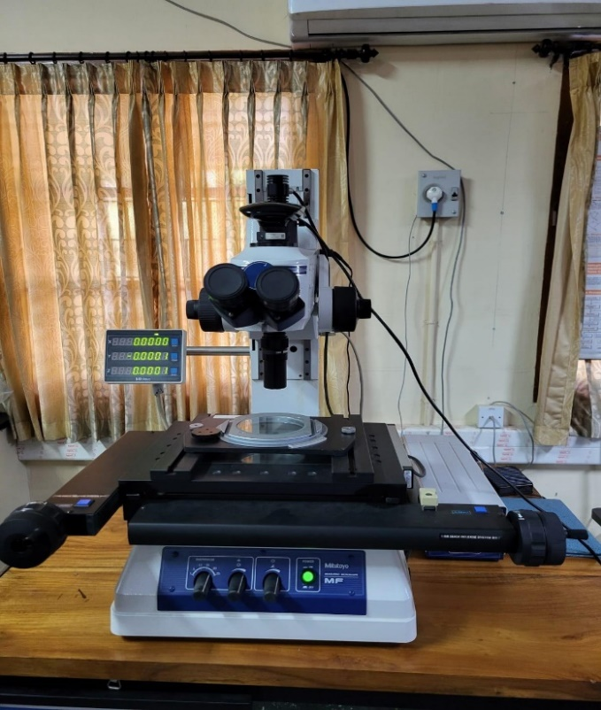 | Measuring Microscope  Name of the equipment:  Measuring Microscope  Make & Model:  Mitutoyo; MF-B2010D  I-Stem Registration ID-  3224862  Category of Instrument  Characterization and Testing  Types of Analysis / Testing  Linear measurements  Description of Instrument  The Mitutoyo MF-B2010D measuring microscope is a versatile instrument for high-accuracy measurements and observations.
Booking Details

Book through I-STEM:  https://www.istem.gov.in/  Slot Booking Link  I-STEM Slot Booking link for External User | Booking available for  Internal and External Both  Requisition form for  Internal  External
Contact Details

Faculty In-charge:  Dr. P. B. Dhanish  Email ID:  dhanish@nitc.ac.in  Phone number:  +91-9207024889 | Technical Staff:  Ishan Chandra (TA) ishanchandra@nitc.ac.in  Jishnu S (TE)  jishnus@nitc.ac.in | Department  MED  Office Email ID  medoffice@nitc.ac.in  Location  Metrology Lab, Room No. 113, Main Building, NIT Calicut

Specifications

Resolution: 0.1µm
Range: X axis. 0 to 200mm
Y axis. 0 to 100mm
Z axis. 0 to 150mm
Magnification : 3X,10X, 20X
Type of Sample Required for Analysis / Testing (Quantity, Pre-Preparation, State etc.) Guidelines for Sample Submission – User Instructions

Metals/ alloys/ composites etc.

User Charges Rs. (GST Extra)

Internal | External Academic Institutes | National R&D Lab | Industry
100/- per sample or reading | 200/- per sample or reading + GST | 200/- per sample or reading+ GST | 500/- per sample or reading+ GST

