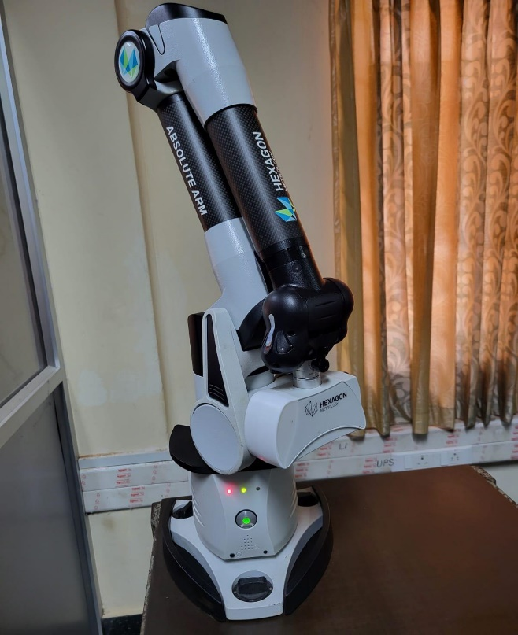 | Laser Scanner  Name of the equipment:  Laser Scanner  Make & Model:  Hexagon Metrology USA; HP-L-8.9  I-Stem Registration ID-  3224864  Category of Instrument  Characterization and Testing  Types of Analysis / Testing  To measure coordinate points and other form errors.  Description of Instrument  The HP-L-8.9 Laser Scanner is a cost-effective 3D scanning solution designed to enhance the capabilities of Hexagon's Absolute Arm portable coordinate measuring machine.
Booking Details

Book through I-STEM:  https://www.istem.gov.in/  Slot Booking Link  I-STEM Slot Booking link for External User | Booking available for  Internal and External Both  Requisition form for  Internal  External
Contact Details

Faculty In-charge:  Dr. P. B. Dhanish  Email ID:  dhanish@nitc.ac.in  Phone number:  +91-9207024889 | Technical Staff:  Ishan Chandra (TA) ishanchandra@nitc.ac.in  Jishnu S (TE)  jishnus@nitc.ac.in | Department  MED  Office Email ID  medoffice@nitc.ac.in  Location  Metrology Lab, Room No. 113, Main Building, NIT Calicut

Specifications

Accuracy: 0.04 mm
Acquisition rate: 45000 p/s
Type of Sample Required for Analysis / Testing (Quantity, Pre-Preparation, State etc.) Guidelines for Sample Submission – User Instructions

Sample within the dimensional specifications.

User Charges Rs. (GST Extra)

Internal | External Academic Institutes | National R&D Lab | Industry
500/- per sample | 1000/- per sample+ GST | 1000/- per sample+ GST | 1500/- per sample+ GST

