CNC VERTICAL MACHINING CENTER

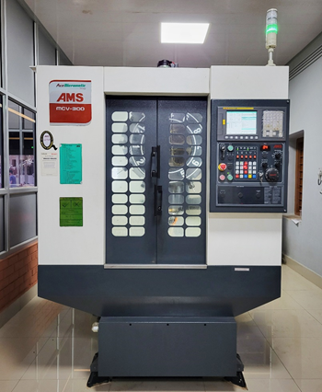 | Name of the equipment:  CNC Vertical Machining Center  Make & Model:  Ace Micromatic, Bangalore& MCV-300  I-Stem Registration ID-  3224873  Category of Instrument  Advanced Manufacturing facility  Types of Analysis / Testing  Machining  Application:  Precision component Manufacturing. Manufacturing of large quantities of standardized products.  Description of Instrument  It is a 3-Axis CNC Machining Centre and has vertically oriented spindle that approach work piece mounted on worktable from above and equipped with tool magazine system and automatic tool changer. This is the machine that handles complex machining operations.
Booking Details

Book through I-STEM:  https://www.istem.gov.in/  Slot Booking Link  I-STEM Slot Booking link for External User | Booking available for  Internal and External Both  Requisition form for  Internal  External
Contact Details

Faculty In-charge:  Dr. Muhammed Rashad  Email ID:  rashad@nitc.ac.in  Phone number:  +91-9744899126 | Technical Staff:  Mr.Manoj K.G  manoj@nitc.ac.in  Mr.Sreelal T  sreelal@nitc.ac.in | Department  MED  Office Email ID  medoffice@nitc.ac.in  Location  Machine Shop  Lab Phone No  0495 2286440
Features, Working Principle and Specifications

Features of the equipment  - Metal work pieces can be machined to the required shape and size. | Unique features/Measurement capabilities, if any
Instrument Technical Description and Major Specifications (This Specifications Limited to Major 5)  - CNC system: Fanuc 0i Mate  - Table size: 650 x 350mm  - Load on Table: 200 kgf  - Number of Tools: 12nos  - Tool shank type: BT-40 | Measurement/Sample specifications:  - work piece dimension: 500 x 200
Type of Sample Required for Analysis / Testing (Quantity, Pre-Preparation, State etc.) Guidelines for Sample Submission – User Instructions

- Work piece material: metal work pieces
- Minimum No of Days Required for work: Depends on work

User Charges Rs. (GST Extra)

Internal | External Academic Institutes | National R&D Lab | Industry
300/- per hour | 600/- per hour | 600/- per hour | 600/- per hour

