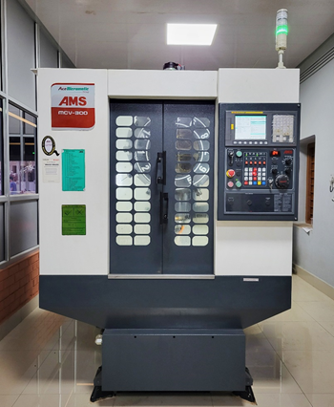 | CNC LATHE MACHINE  Name of the equipment:  CNC Lathe Machine  Make & Model:  Ace Micromatic, Bangalore& LT-16 300LM,  I-Stem Registration ID-  3224872  Category of Instrument  Advanced Manufacturing facility  Types of Analysis / Testing  Machining  Application:  Precision component Manufacturing. Manufacturing of large quantities of standardized products.  Description of Instrument  It is a 2-Axis CNC Lathe and has a horizontal spindle with a work holding device and the tool is located in a fixed position station turret. This machine that handles complex machining operations.
Booking Details

Book through I-STEM:  https://www.istem.gov.in/  Slot Booking Link  I-STEM Slot Booking link for External User | Booking available for  Internal and External Both  Requisition form for  Internals  Externals

Faculty In-charge:  Dr. Muhammed Rashad  Email ID:  rashad@nitc.ac.in  Phone number:  +91-9744899126 | Contact Details  Technical Staff:  Mr.Manoj K.G  manoj@nitc.ac.in  Mr.Abhinav K  abhinavk@nitc.ac.in | Department  MED  Office Email ID  medoffice@nitc.ac.in  Location  Machine Shop  Lab Phone No  0495 2286440

Features, Working Principle and Specifications

Features of the equipment  - Metal work pieces can be machined to the required shape and size. | Unique features/Measurement capabilities, if any
Instrument Technical Description and Major Specifications (This Specifications Limited to Major 5)  - CNC system: Fanuc 0i Mate  - Table size: 650 x 350mm  - Load on Table: 200 kgf  - Number of Tools: 12nos  - Tool shank type: BT-40 | Measurement/Sample specifications:  - work piece dimension: 500 x 200
Type of Sample Required for Analysis / Testing (Quantity, Pre-Preparation, State etc.) Guidelines for Sample Submission – User Instructions

- Work piece material: metal work pieces
- Minimum No of Days Required for work: Depends on work

User Charges Rs. (GST Extra)

Internal | External Academic Institutes | National R&D Lab | Industry
300/- per hour | 600/- per hour | 600/- per hour | 600/- per hour

