Advanced Control Education Kit

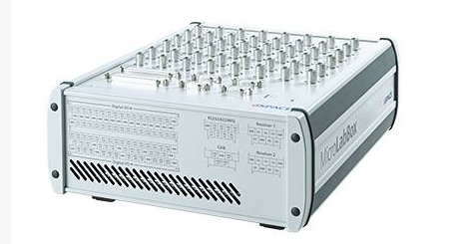 | Name of the equipment:  MicroLab Box DSpace  Make & Model:  DynaFusion Technologies & ACE_MLBX_1302T  I-Stem Registration ID-  3236736  Category of Instrument  Controller  Types of Analysis / Testing  Controlling and Testing  Application:  Controlling, Testing and Measuring Tool

Booking Details

Book through I-STEM:  https://www.istem.gov.in/  Slot Booking Link  I-STEM Slot Booking link for External User | Booking available for  Internal and External Both  Requisition form for  Internals  Externals
Contact Details

Faculty In-charge:  Dr.Ashesh Saha  Email ID:  ashesh@nitc.ac.in  Phone number:  +91-9451545350 | Technical Staff:  Shibin (Senior Technician) shibinr@nitc.ac.in | Department  MED  Office Email ID  medoffice@nitc.ac.in  Location  Room No. DB 118 Machine Dynamics Lab II  Lab Phone No  ……………………………….

Description and Technical Specifications

Description of Instrument: An ACE (Advanced Control Education) kit MicroLab Box is a bundled hardware and software package from dSPACE designed for educational and research purposes in the field of control systems. It provides a compact, versatile platform for developing, testing, and prototyping real-time control systems.

Instrument Technical Description and Major Specifications (This Specifications Limited to Major 5)

Type | Top Panel Variant with BNC Connectors
Sensor supply | 1 x 12 V, max. 3 W/250 mA (fixed)  1 x 2 ... 20 V, max. 1 W/200 mA (variable)
Memory | 1 GB DRAM  128 MB flash memory
Power supply | 100 ... 240 V AC, 50 ... 60 Hz
Power consumption | 125 W

User Charges Rs. (GST Extra)

Internal | External Academic Institutes | National R&D Lab | Industry
200/- per hour per person | 300 + 18%GST per hour per person | 300 + 18%GST per hour per person | 800 + 18%GST per hour per person

