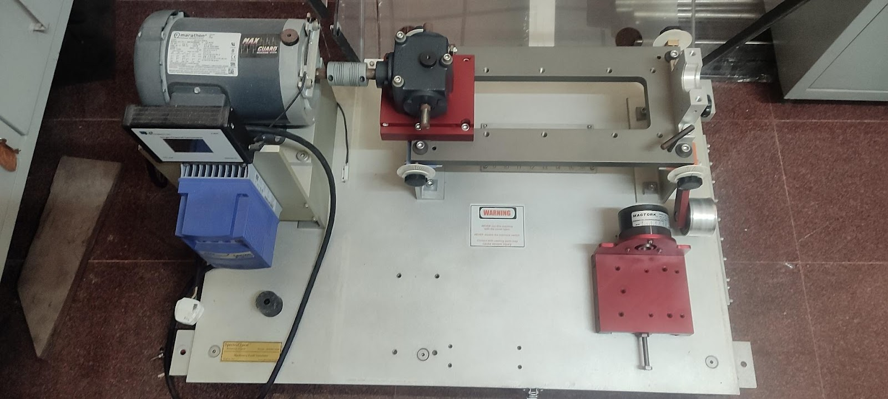 | Machinery Fault Simulator  Name of the equipment:  Machinery Fault Simulator  Make & Model:  Spectra Quest Inc USA & MFSS2010  I-Stem Registration ID-  3236735  Category of Instrument  Controller  Types of Analysis / Testing  Controlling and Testing  Application:  Controlling, Testing and Measuring Tool

Booking Details

Book through I-STEM:  https://www.istem.gov.in/  Slot Booking Link  I-STEM Slot Booking link for External User | Booking available for  Internal and External Both  Requisition form for  Internals  Externals
Contact Details

Faculty In-charge:  Dr.Ashesh Saha  Email ID:  ashesh@nitc.ac.in  Phone number:  +91-9451545350 | Technical Staff:  Shibin (Senior Technician) shibinr@nitc.ac.in | Department  MED  Office Email ID  medoffice@nitc.ac.in  Location  Room No. DB 118 Machine Dynamics Lab II  Lab Phone No  ……………………………….

Description and Technical Specifications

Description of Instrument: Machinery Fault Simulator is used for studying signatures of common machinery faults. The system reflects a modular design that provides versatility, operational simplicity and robustness. Each component of the simulator is machined to high tolerances so it can be operated without any significant conflicting vibrations so that user can introduce various faults either individually or jointly in a totally controlled environment.

Instrument Technical Description and Major Specifications (This Specifications Limited to Major 5)

RPM Range | 0 to 600 rpm
Shaft Diameter | ¾” diameter, TPG Steel
Rotors | Two 6” aluminium with 36 threaded holes
Instrumentation Connectors | 16 BNC connectors

User Charges Rs. (GST Extra)

Internal | External Academic Institutes | National R&D Lab | Industry
200/- per hour per sample (i.e. If the time taken to test a sample exceeds 1 hr then the user charge will be based on per hour) | 300 + 18%GST per hour per sample (i.e. If the time taken to test a sample exceeds 1 hr then the user charge will be based on per hour) | 300 + 18%GST per hour per sample (i.e. If the time taken to test a sample exceeds 1 hr then the user charge will be based on per hour) | 800 + 18%GST per hour per sample (i.e. If the time taken to test a sample exceeds 1 hr then the user charge will be based on per hour)

