Single cylinder automotive hybrid research engine with dual fuel setup and
Open ECU system

open ECU system

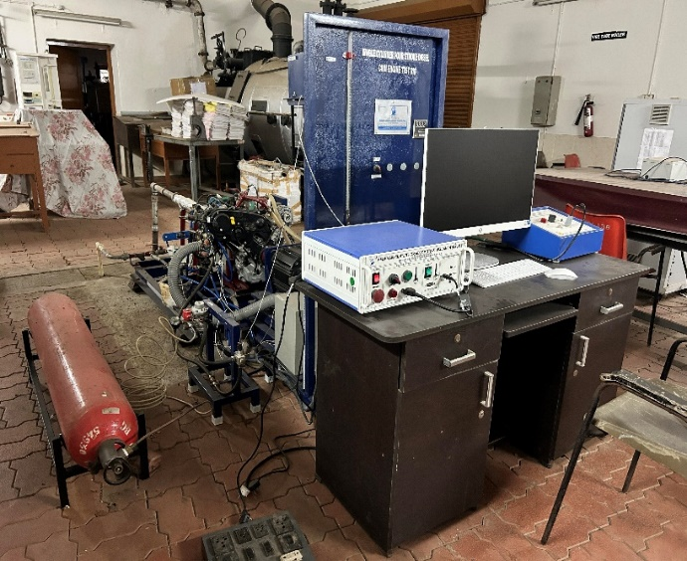 | Name of the equipment:  Single cylinder automotive hybrid research engine with dual fuel setup and open ECU system  Make & Model:  Mahindra, Jeeto (Engine No - UAK3A17253)  I-Stem Registration ID-  Category of Instrument  Heat Engines  Types of Analysis / Testing  Performance (Load Test), Combustion Analysis Charts (P-Ɵ, P-V etc), Heat Balance and Emission Test.  Application:  Diesel and hydrogen  Description of Instrument  The engine is a single cylinder, four stroke, water cooled with maximum power 15 HP output at 3600 RPM. This engine can be operated with diesel, diesel + hydrogen dual fuel mode and hybrid mode (engine + electric motor).
Booking Details

Book through I-STEM:  https://www.istem.gov.in/  Slot Booking Link  I-STEM Slot Booking link for External User |  | Booking available for  Internal and External Both  Requisition form for  Internal  External  Contact Details
Faculty In-charge:  Dr. Saleel Ismail  Email ID:  saleel@nitc.ac.in  Phone number:  9884691904 | Technical Staff:  Pradeep Kumar K K kkp69@nitc.ac.in  Dhaneesh DC  dhaneeshdc@nitc.ac.in  Athul Krishna K R  athulkrishnakr@nitc.ac.in  Vasu TC  tcv74@nitc.ac.in  Features, Working Principle and Specifications |  | Department  MED  Office Email ID  medoffice@nitc.ac.in  Location  Heat Engines Lab, Department of Mechanical Engineering  Lab Phone No  04952286456.
Features of the equipment  - The engine is a single cylinder, four stroke, water cooled with maximum power 15 HP output at 3600 RPM. |  | Features, Working Principle and Specifications  Unique features/Measurement capabilities, if any  - This engine can be operated with diesel, diesel + hydrogen dual fuel mode and hybrid mode (engine + electric motor).
Instrument Technical Description and Major Specifications (This Specifications Limited to Major 5)  Bore 93 mm  Stroke Length 92 mm  Displacement 625 cc  Max Power 15 HP @ 3600 rpm  Max Torque 35 Nm @ 2000 rpm |  | Measurement/Sample specifications:  - Diesel and hydrogen
Type of Sample Required for Analysis / Testing (Quantity, Pre-Preparation, State etc.) Guidelines for Sample Submission – User Instructions

- Quantity: As per the type of test.
- Sample should be in sealed condition with proper labelling.

User Charges Rs. (GST Extra)

Internal | External Academic Institutes | National R&D Lab | Industry
Rs. 500/ sample | Rs. 1000/ sample+GST | Rs. 3000/ sample+GST | Rs. 3000/ sample + GST

