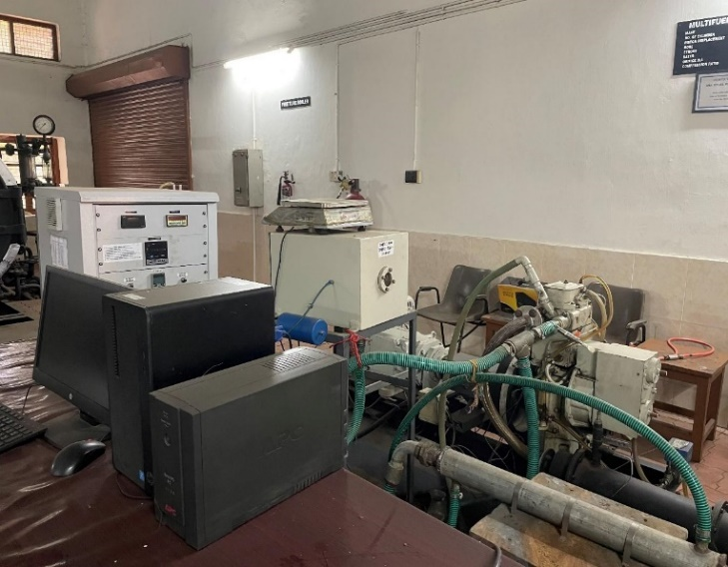 | Computerized Variable Compression Ratio Multifuel Engine Test Rig  Name of the equipment:  Computerized Variable Compression Ratio Multifuel Engine Test Rig  Make & Model:  Kirloskar, Tv1 (SR No- VE019)  I-Stem Registration ID-  Category of Instrument  Heat Engines  Types of Analysis / Testing  Performance (Load Test), Combustion Analysis Charts (P-Ɵ, P-V etc), Heat Balance and Emission Test for constant or variable Compression Ratio  Application:  Diesel and alternative liquid fuels (like bio-diesel) or hydrogen  Description of Instrument  The engine is a single cylinder, four stroke, water cooled with maximum 5 kW output at 1500 RPM at normal compression ratio. The compression ratio can be varied from 12:1 to 20:1 for diesel / bio-diesel operation.
Booking Details
Contact Details
Book through I-STEM:  https://www.istem.gov.in/  Slot Booking Link | Booking available for  Internal and External Both  Requisition form for  Internals  Externals

Faculty In-charge:  Dr. Saleel Ismail  Email ID:  saleel@nitc.ac.in  Phone number:  9884691904 | Technical Staff:  Pradeep Kumar K K kkp69@nitc.ac.in  Dhaneesh DC  dhaneeshdc@nitc.ac.in  Athul Krishna K R  athulkrishnakr@nitc.ac.in  Vasu TC  tcv74@nitc.ac.in | Department  MED  Office Email ID  medoffice@nitc.ac.in  Location  Heat Engines Lab, Department of Mechanical Engineering  Lab Phone No  04952286456.
Features, Working Principle and Specifications
Features of the equipment  - The engine is a single cylinder, four stroke, water cooled with maximum 5 kW output at 1500 RPM at normal compression ratio. | Unique features/Measurement capabilities, if any  - The compression ratio can be varied from 12:1 to 20:1 for diesel / bio-diesel operation.
Instrument Technical Description and Major Specifications (This Specifications Limited to Major 5)  Bore 87.5 mm  Stroke 110 mm  Displacement 661 cc  Normal Compression Ratio 17.5:1  Dynamometer A.C. Regenerative type | Measurement/Sample specifications:  - Diesel and alternative liquid fuels (like bio-diesel) or hydrogen
Type of Sample Required for Analysis / Testing (Quantity, Pre-Preparation, State etc.) Guidelines for Sample Submission – User Instructions

- Quantity: As per the type of test.
- Sample should be in sealed condition with proper labelling.

User Charges Rs. (GST Extra)

Internal | External Academic Institutes | National R&D Lab | Industry
Rs. 500/ sample | Rs. 1000/ sample + GST | Rs. 3000/ sample + GST | Rs. 3000/ sample + GST

