Booking Details
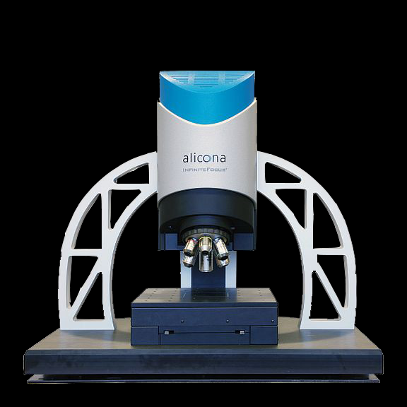 | 3D OPTICAL PROFILOMETER  Name of the equipment:  3D OPTICAL PROFILOMETER  Make & Model:  ALICONA Model- Infinite Focus G5  I-Stem Registration ID-  3224898  Category of Instrument  Characterization and Testing  Types of Analysis / Testing  Surface profile measurement  Application:  1. Surface roughness measurement (2D and 3D)  2. Area measurement after corrosion  3. Thickness measurement  4. Tool nose measurement and wear measurement  Description of Instrument  Capable of performing non-contact 3D surface roughness, micro geometry, form measurements, etc. Also, this instrument can generate, capture and display point cloud of high density, registered true colour information.
Contact Details
Book through I-STEM:  https://www.istem.gov.in/  Slot Booking Link  I-STEM Slot Booking link for External User | Booking available for  Internal and External Both  Requisition form for  Internals  Externals

Faculty In-charge:  Dr. Basil Kuriachen  Email ID:  bk@nitc.ac.in  Phone number:  +91-9947187133 | Technical Staff:  Harikrishnan K (TE) harikrishnank@nitc.ac.in  SHIBIN (ST)  shibinr@nitc.ac.in  SASI KK (TA)  kksasi@nitc.ac.in | Department  MED  Office Email ID  medoffice@nitc.ac.in  Location  FIST LAB, CAD/CAM CENTRE, Department of Mechanical Engineering  Lab Phone No  0495 228 6476

Features, Working Principle and Specifications

Features of the equipment  - High-Resolution 3D Surface Measurement  - Non-Contact Measurement  - Versatility in Sample Types  - Form and Roughness Evaluation  - Advanced Software Capabilities | Unique features/Measurement capabilities, if any  - Focus Variation Technology  - Automatic Stitching
Instrument Technical Description and Major Specifications (This Specifications Limited to Major 5)  - Travel range in XY 100 mm X 100 mm motorized  - Travel range in Z -100 mm motorized  - 6 Objectives 2.5X, 5X, 10X, 20X, 50X, 100X  - Min measurable radii 1 μm  - Finest lateral resolution 0.44 μm for 100x objective 3D rotation unit for capturing 3D data points | Measurement/Sample specifications:  - Metallic/composite/alloys etc.,  - Maximum size usually limited 100mm x 100mmx100mm
Type of Sample Required for Analysis / Testing (Quantity, Pre-Preparation, State etc.) Guidelines for Sample Submission – User Instructions

- Quantity: Maximum size usually limited 100mm x 100mmx100mm
- Sample Type: Metallic/composite/alloys etc.,
- Maximum No. of Samples Accepted at a Time- 2
- Minimum No of Days Required for Analysis – 1

User Charges Rs. (GST Extra)

Internal | External Academic Institutes | National R&D Lab | Industry
250/- per scan | 500+ 18%GST  Per scan | 500+ 18%GST  Per scan | 500+ 18%GST  Per scan

