5 AXIS CNC COORDINATE MEASURING MACHINE

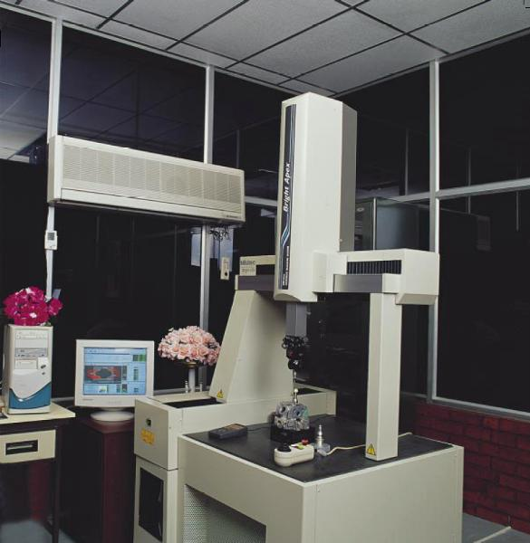 | Name of the equipment:  5 AXIS CNC COORDINATE MEASURING MACHINE  Make & Model:  Mitutoyo- Bright A 504  I-Stem Registration ID-  3224852  Category of Instrument  Characterization and Testing  Types of Analysis / Testing  coordinate measurement  Application:  Measurement errors in circularity, cylindricity, concentricity, straightness, coaxiality, flatness, parallelism, perpendicularity, angularity, runout etc.can be determined using this software. Measurement results are available in tabular/graphical form  Description of Instrument  The Mitutoyo Bright A 504 is a high-precision 5-axis CNC Coordinate Measuring Machine (CMM) designed for accurate dimensional inspection in industries such as aerospace, automotive, and precision manufacturing. It offers a measuring range of 500 mm × 400 mm × 400 mm along the X, Y, and Z axes, with a high resolution of 0.1 µm and accuracy in the range of ±3 to ±7.6 µm
Booking Details
Book through I-STEM:  https://www.istem.gov.in/  Slot Booking Link  I-STEM Slot Booking link for External User | Booking available for  Internal and External Both  Requisition form for  Internals  Externals

Faculty In-charge:  Dr Jos Mathew  Email ID:  josmat@nitc.ac.in  Phone number:  0495 2286405 | Contact Details  Technical Staff:  Mr. Unni Krishnan (TA) kishan@nitc.ac.in | Department - MED  Office Email ID  medoffice@nitc.ac.in  Location  PRODUCTION BLOCK, Department of Mechanical Engineering  Lab Phone No  0495 228 6476
Features, Working Principle and Specifications
Contact Details
Features of the equipment  - 5-Axis Probing System  - High Precision & Accuracy  - CNC Automation  - High-Speed Scanning  - Flexible Probing Options | Unique features/Measurement capabilities, if any  - Unlike traditional 3-axis CMMs, the 5-axis probe head allows rotational movement during measurement  - It significantly reduces inspection time, improves access to complex geometries, and enhances measurement flexibility and accuracy
Instrument Technical Description and Major Specifications (This Specifications Limited to Major 5)  - Working Area -638mmx860mm  - Probe System -HP10T AND HP20 of Renishaw, England  - Repeatability - 3μm  - Measuring Range X 505, Y 405, Z 405 | Measurement/Sample specifications:  - Metallic/composite/alloys etc.,
Type of Sample Required for Analysis / Testing (Quantity, Pre-Preparation, State etc.) Guidelines for Sample Submission – User Instructions

- Sample Type: Metallic/composite/alloys etc.,
- Maximum No. of Samples Accepted at a Time- 2
- Minimum No of Days Required for Analysis – 1

User Charges Rs. (GST Extra)

Internal | External Academic Institutes | National R&D Lab | Industry
300/- per hour | 300 + 18%GST  Rs. 354 | 300 + 18%GST  Rs. 354 | 300 + 18%GST  Rs. 354

