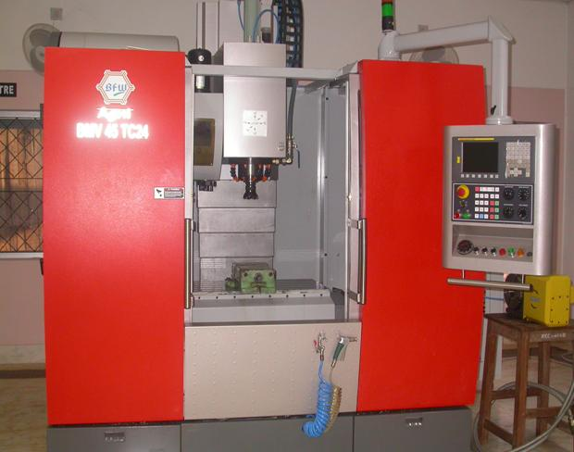 | CNC VERTICAL MACHINING CENTER  Name of the equipment:  CNC VERTICAL MACHINING CENTER  Make & Model:  Agni BMV45 TC24 4-axis vertical machining centre  I-Stem Registration ID-  3224889  Category of Instrument  Advanced Manufacturing  Types of Analysis / Testing  Machining  Application:  - Prototyping & Product Development  - Precision Component Manufacturing  Description of Instrument  CNC machining of complex geometries using codes written explicitly or generated by using Master cam software.
Booking Details

Book through I-STEM:  https://www.istem.gov.in/  Slot Booking Link  I-STEM Slot Booking link for External User | Booking available for  Internal and External Both  Requisition form for  Internals  Externals
Contact Details

Faculty In-charge:  Dr. Basil Kuriachen  Email ID:  bk@nitc.ac.in  Phone number:  +91-9947187133 | Technical Staff:  Mr. Unni Krishnan(TA )  kishan@nitc.ac.in | Department  MED  Office Email ID  medoffice@nitc.ac.in  Location  FIST LAB, CAD/CAM CENTRE, Department of Mechanical Engineering  Lab Phone No  0495 228 6476

Features, Working Principle and Specifications

Features of the equipment  - Vertical Spindle Orientation  - Automatic Tool Changer (ATC) – Allows for quick tool swaps (typically 16 to 30+ tools).  - Rotary Table (4th Axis Option) – Enables indexing for complex geometries. | Unique features/Measurement capabilities, if any  - Multi-Axis Capabilities (Beyond 3-Axis)  - High-Speed Machining (HSM) Capabilities  - Enhanced Chip & Coolant Management
Instrument Technical Description and Major Specifications (This Specifications Limited to Major 5)  - Three axes XYZ travel (X – 600mm, Y – 450mm, Z – 500mm)  - Clamping area 450 x 900 mm2  - Position accuracy +/- 0.005mm  - Max. Tool diameter 75 mm  - Max. Tool length 250 mm | Measurement/Sample specifications:  Metallic/composite/alloys etc
Type of Sample Required for Analysis / Testing (Quantity, Pre-Preparation, State etc.) Guidelines for Sample Submission – User Instructions

- Quantity:
- Sample Type: Metallic/composite/alloys etc
- Pre-preparation:
- Maximum No. of Samples Accepted at a Time- 2
- Minimum No of Days Required for Analysis – 1

User Charges Rs. (GST Extra)

Internal | External Academic Institutes | National R&D Lab | Industry
250/hour | 250 + 18%GST  Rs. 295 | 250 + 18%GST  Rs. 295 | 250 + 18%GST  Rs. 295

