Booking Details
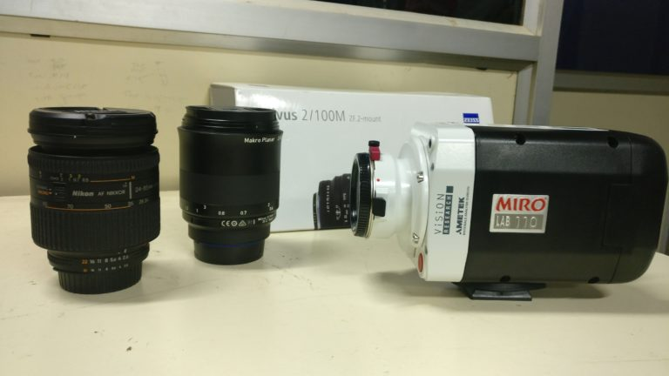  HIGH-SPEED CAMERA | Name of the equipment:  HIGH-SPEED CAMERA  Make & Model:  PHANTOM- MIRO LAB110  I-Stem Registration ID-  3224896  Category of Instrument  Characterization and Testing  Types of Analysis / Testing  High speed motion  Application:  studying liquid splashes, bubble formation, turbulent flows  Monitoring fast assembly lines, welding, laser cutting, and material testing.  Description of Instrument  Phantom Miro Lab 110 is a high-speed camera designed for capturing fast-moving events with exceptional clarity. Its compact size, high resolution, and fast frame rates make it suitable for a variety of scientific, industrial, and research applications.

Book through I-STEM:  https://www.istem.gov.in/  Slot Booking Link  I-STEM Slot Booking link for External User | Booking available for  Internal and External Both  Requisition form for  Internals  Externals

Faculty In-charge:  Dr. Basil Kuriachen  Email ID:  bk@nitc.ac.in  Phone number:  +91-9947187133 | Contact Details  Technical Staff:  Mr. Unni Krishnan(TA )  kishan@nitc.ac.in | Department- MED  Office Email ID  medoffice@nitc.ac.in  Location  FIST LAB, CAD/CAM CENTRE, Department of Mechanical Engineering  Lab Phone No  0495 228 6476

Features, Working Principle and Specifications

Features of the equipment  - High Resolution: Up to 1280 × 800 pixels at 1,480 fps.  - High-Speed Capture: Up to 148,000 fps at reduced resolutions.  - Compact & Lightweight: Ideal for lab and field use. | Unique features/Measurement capabilities, if any  - Global Shutter: Eliminates motion blur for crisp images.  - Triggering & Synchronization: Works with external devices for precise timing.
Instrument Technical Description and Major Specifications (This Specifications Limited to Major 5)  - Maximum Resolution -1280 X 800  - FPS at maximum resolution 1600 fps  Max. speed at a low resolution 128 X 8 up  to 400000 fps | Measurement/Sample specifications:
Type of Sample Required for Analysis / Testing (Quantity, Pre-Preparation, State etc.) Guidelines for Sample Submission – User Instructions

- Quantity:
- Sample Type: Any sample
- Pre-preparation:
- Maximum No. of Samples Accepted at a Time- 2
- Minimum No of Days Required for Analysis – 1

User Charges Rs. (GST Extra)

Internal | External Academic Institutes | National R&D Lab | Industry
150/hour | 300/hour+18% GST | 300/hour+18% GST | 300/hour+18% GST

