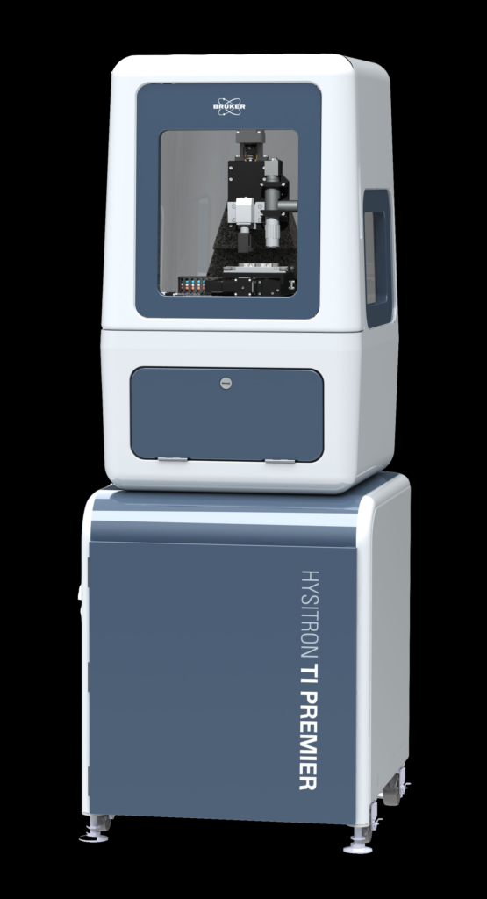  NANO INDENTER | Name of the equipment:  NANO INDENTER  Make & Model:  Hysitron TI Premier  I-Stem Registration ID-  3229300  Category of Instrument  Manufacturing technology  Types of Analysis / Testing  Testing of material properties  Application:  Nano Indentation, Nano Scratch, Measure reduced young’s modulus and hardness, etc.  Description of Instrument  This system performs indentation, scratch and wear studies capable of studying mechanical properties of thin films, soft samples, metals, etc.
Booking Details

Book through I-STEM:  https://www.istem.gov.in/  Slot Booking Link  I-STEM Slot Booking link for External User | Booking available for  Internal and External Both  Requisition form for  Internals  Externals
Contact Details

Faculty In-charge:  Dr. Basil Kuriachen  Email ID:  bk@nitc.ac.in  Phone number:  +91-9947187133 | Technical Staff:  Harikrishnan K (TE) harikrishnank@nitc.ac.in  SASI KK (TA)  kksasi@nitc.ac.in  SHIBIN (ST)  shibinr@nitc.ac.in | Department  MED  Office Email ID  medoffice@nitc.ac.in  Location  FIST LAB, CAD/CAM CENTRE, Department of Mechanical Engineering  Lab Phone No  0495 228 6476

Features, Working Principle and Specifications

Features of the equipment  - Observation of post-test deformation behavior, Custom-engineered enclosure with an integrated anti-vibration system to provide nanoscale characterization capabilities in non-ideal environments  - Intelligently designed software with enhanced automated testing routines and an intuitive user interface  - Easily adaptable system to meet specific research needs, from soft polymers to ceramic thin films. Etc | Unique features/Measurement capabilities, if any  - High-resolution in-situ SPM imaging that enables precise test positioning accuracy (±10 nm)  - Sensitive force and displacement noise floors (75 nN, 0.2 nm) for unprecedented accuracy
Instrument Technical Description and Major Specifications (This Specifications Limited to Major 5)  - Maximum force up to 10mN  - Minimum Contact Force <100nN  - Stage Travel 50mm x 150mm  - Z-travel -50mm | Measurement/Sample specifications:  - Maximum size usually limited 10mm x 10mmx10mm  - Surface roughness must be less than 500 nm. Porous material cannot be tested
Type of Sample Required for Analysis / Testing (Quantity, Pre-Preparation, State etc.) Guidelines for Sample Submission – User Instructions

- Quantity: Maximum size usually limited 10mm x 10mmx10mm
- Sample Type: Metallic/composite/alloys/biological sample etc.,
- Pre-preparation: Surface roughness must be less than 500 nm. Porous material cannot be tested.
- Maximum No. of Samples Accepted at a Time- 2
- Minimum No of Days Required for Analysis – 1

User Charges Rs. (GST Extra)

Internal | External Academic Institutes | National R&D Lab | Industry
2000/- per slot | 4000 + 18%GST  Per slot | 4000 + 18%GST  Per slot | 5000 + 18%GST Per slot
* 1 slot= 20 indentations or 3 hr

