Booking Details
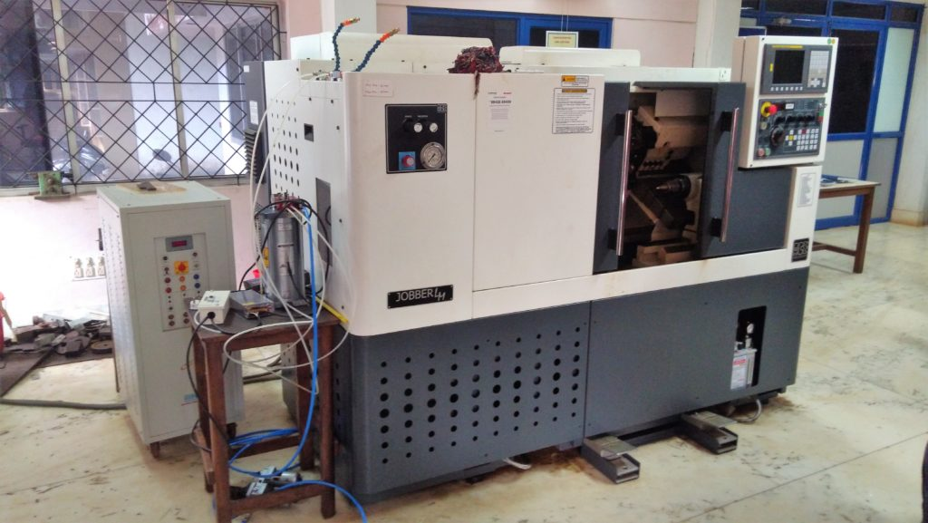 | CNC TURNING CENTER  Name of the equipment:  CNC TURNING CENTER  Make & Model:  Ace Micromatics- Jober LM  I-Stem Registration ID-  3224893  Category of Instrument  Advanced Manufacturing  Types of Analysis / Testing  Machining  Application:  - Prototyping & Product Development  - Precision Component Manufacturing  Description of Instrument  CNC machining of complex geometries using codes written explicitly or generated by using Master cam software.

Book through I-STEM:  https://www.istem.gov.in/  Slot Booking Link  I-STEM Slot Booking link for External User | Booking available for  Internal and External Both  Requisition form for  Internals  Externals
Contact Details

Faculty In-charge:  Dr. Basil Kuriachen  Email ID:  bk@nitc.ac.in  Phone number:  +91-9947187133 | Technical Staff:  Mr. Unni Krishnan(TA )  kishan@nitc.ac.in | Department  MED  Office Email ID  medoffice@nitc.ac.in  Location  FIST LAB, CAD/CAM CENTRE, Department of Mechanical Engineering  Lab Phone No  0495 228 6476

Features, Working Principle and Specifications

Features of the equipment  - Siemens/Mitsubishi CNC Control – User-friendly interface with G-code programming.  - Automatic Tool Turret – Typically 8–12 stations for quick tool changes  - Hydraulic or Servo Chuck – For secure workpiece clamping | Unique features/Measurement capabilities, if any  - Allows complex features like cross-holes, flats, and keyways in a single setup  - High-Speed Machining (HSM) Capabilities  - Enhanced Chip & Coolant Management
Instrument Technical Description and Major Specifications (This Specifications Limited to Major 5)  - OD Turning Tool Size 25×25  - X-axis Stroke 165mm  - Z-axis Stroke 400mm  Spindle Speed 3500rpm | Measurement/Sample specifications:  Metallic/composite/alloys etc
Type of Sample Required for Analysis / Testing (Quantity, Pre-Preparation, State etc.) Guidelines for Sample Submission – User Instructions

- Quantity:
- Sample Type: Metallic/composite/alloys etc
- Pre-preparation:
- Maximum No. of Samples Accepted at a Time- 2
- Minimum No of Days Required for Analysis – 1

User Charges Rs. (GST Extra)

Internal | External Academic Institutes | National R&D Lab | Industry
200/hour | 200 + 18%GST  Rs. 236 | 200 + 18%GST  Rs. 236 | 200 + 18%GST  Rs. 236

