Pin On Disc

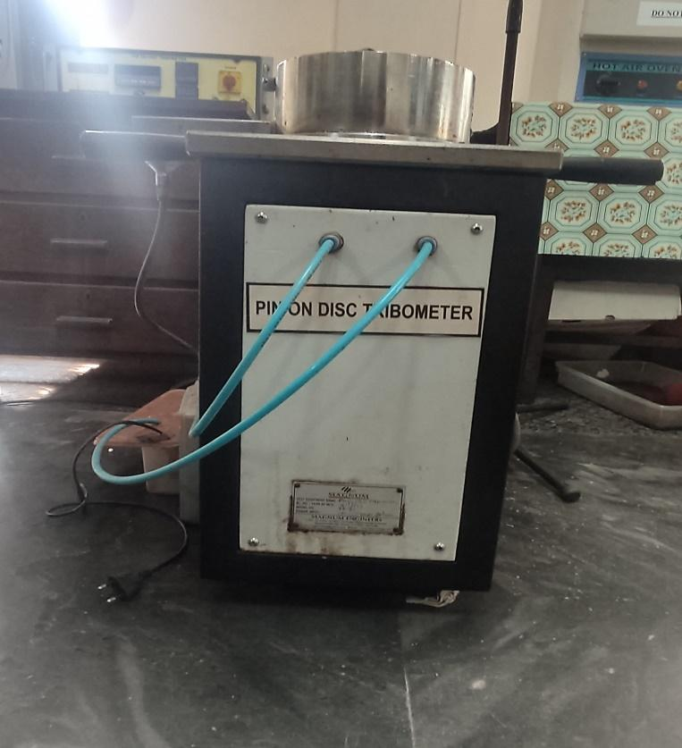 | Name of the equipment:  Pin On Disc Tribotester  Make & Model:  Magnum & TE-165 143/2014  I-Stem Registration ID-  3224913  Category of Instrument  Characterization and Testing Tool  Types of Analysis / Testing  Testing  Application:  Friction and Wear characteristics of Pin and Ball Samples
Booking Details

Book through I-STEM:  https://www.istem.gov.in/  Slot Booking Link  I-STEM Slot Booking link for External User | Booking available for  Internal and External Both  Requisition form for  Internals  Externals
Contact Details

Faculty In-charge:  Dr.Amit Kumar Singh  Email ID:  amitsingh@nitc.ac.in  Phone number:  +91-8949362395 | Technical Staff:  Shibin (Senior Technician) shibinr@nitc.ac.in  Hari Krishnan K (Technician)  harikrishnank@nitc.ac.in | Department  MED  Office Email ID  medoffice@nitc.ac.in  Location  Room No. 101 MSED Department Building  Lab Phone No  0495-2286485

Description and Technical Specifications

Description of Instrument: The apparatus facilitates the study of friction and wear characteristics in sliding contacts, sliding occurs between the stationary pin and a rotating disc. The normal load, rotational speed, temperature, humidity and wear are the variables to meet the test conditions.

Instrument Technical Description and Major Specifications (This Specifications Limited to Major 5)

Loads | Up to 200N
Speed | 100 to 2000 rpm
Specimen | Pin Size: ϕ3mm to 12mm
Wear Disc Size | ϕ165mm x 8mm thick

User Charges Rs. (GST Extra)

Internal | External Academic Institutes | National R&D Lab | Industry
100/- per hour per sample (i.e. If the time taken to test a sample exceeds 1 hr then the user charge will be based on per hour) | 500 + 18%GST per hour per sample (i.e. If the time taken to test a sample exceeds 1 hr then the user charge will be based on per hour) | 500 + 18%GST per hour per sample (i.e. If the time taken to test a sample exceeds 1 hr then the user charge will be based on per hour) | 1000 + 18%GST per hour per sample (i.e. If the time taken to test a sample exceeds 1 hr then the user charge will be based on per hour)

