High Frequency Reciprocating Rig

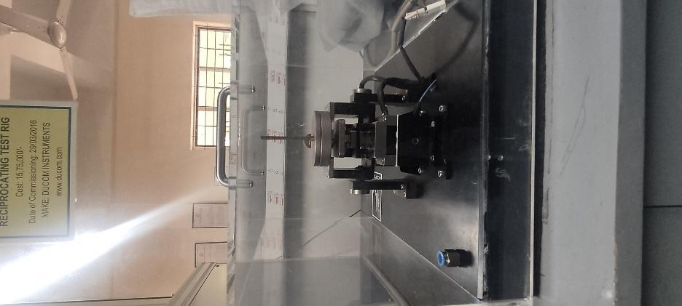 | Name of the equipment:  High Frequency Reciprocating Rig  Make & Model:  DUCOM & TR-282  I-Stem Registration ID-  3224915  Category of Instrument  Characterization and Testing Tool  Types of Analysis / Testing  Testing  Application:  Friction and Wear characteristics of Ball Samples

Booking Details

Contact Details
Book through I-STEM:  https://www.istem.gov.in/  Slot Booking Link  I-STEM Slot Booking link for External User | Booking available for  Internal and External Both  Requisition form for  Internals  Externals

Faculty In-charge:  Dr.Amit Kumar Singh  Email ID:  amitsingh@nitc.ac.in  Phone number:  +91-8949362395 | Technical Staff:  Shibin (Senior Technician) shibinr@nitc.ac.in | Department  MED  Office Email ID  medoffice@nitc.ac.in  Location  Room No. 101 MSED Department Building  Lab Phone No  0495-2286485

Description and Technical Specifications

Description of Instrument: It is an equipment used to find the Coefficient of Friction of lubricants. Here the spherical ball clamped in a holder which is reciprocating to & fro along a cylindrical disc which is fixed at the bottom holder filled with lubricant.
Instrument Technical Description and Major Specifications (This Specifications Limited to Major 5)

Top Specimen Ball | ϕ6mm
Bottom Specimen Plate | ϕ10 x 3mm
Frequency Range | 10-60Hz
Load | 1 to 10N

User Charges Rs. (GST Extra)

Internal | External Academic Institutes | National R&D Lab | Industry
100/- per hour per sample (i.e. If the time taken to test a sample exceeds 1 hr then the user charge will be based on per hour) | 500 + 18%GST per hour per sample (i.e. If the time taken to test a sample exceeds 1 hr then the user charge will be based on per hour) | 500 + 18%GST per hour per sample (i.e. If the time taken to test a sample exceeds 1 hr then the user charge will be based on per hour) | 1000 + 18%GST per hour per sample (i.e. If the time taken to test a sample exceeds 1 hr then the user charge will be based on per hour)

