Four Ball Tester

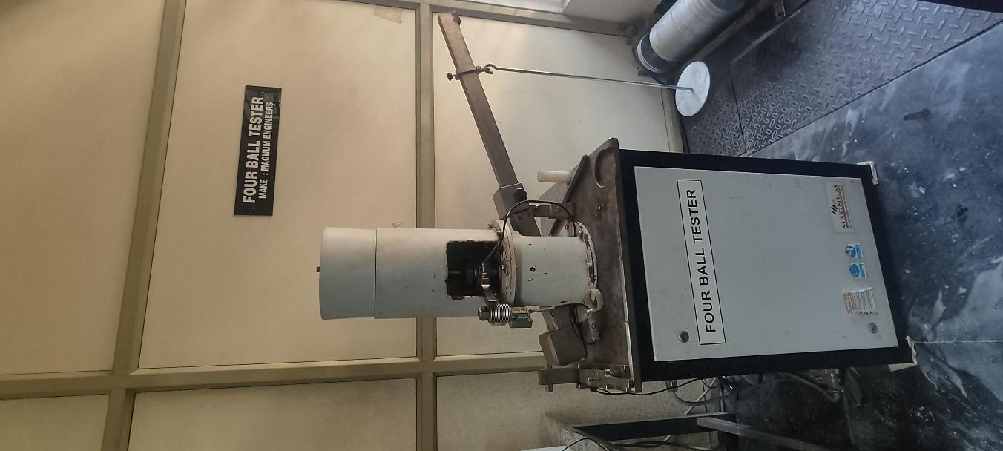 | Name of the equipment:  Four Ball Tester  Make & Model:  Magnum & TE-4B-L 144/2014  I-Stem Registration ID-  3224913  Category of Instrument  Characterization Tool  Types of Analysis / Testing  Testing  Application:  Determining the Coefficient of Friction of lubricants.

Booking Details

Book through I-STEM:  https://www.istem.gov.in/  Slot Booking Link  I-STEM Slot Booking link for External User | Booking available for  Internal and External Both  Requisition form for  Internals  Externals
Contact Details

Faculty In-charge:  Dr.Amit Kumar Singh  Email ID:  amitsingh@nitc.ac.in  Phone number:  +91-8949362395 | Technical Staff:  Eldho P Varghese (TA SG II) epv@nitc.ac.in  Shibin (Senior Technician) shibinr@nitc.ac.in | Department  MED  Office Email ID  medoffice@nitc.ac.in  Location  Room No. 101 MSED Department Building  Lab Phone No  0495-2286485

Description and Technical Specifications

Description of Instrument: This instrument is used to measure the Coefficient of Friction and Performance of lubricants by measuring the scar diameter.
Instrument Technical Description and Major Specifications (This Specifications Limited to Major 5)

Speed | 100 to 2000 rpm
Normal Load | 0.5 to 800kg
Leverage Ratio | 13:1
Temperature | Up to 100 ͦ C

User Charges Rs. (GST Extra)

Internal | External Academic Institutes | National R&D Lab | Industry
100/- per hour per sample (i.e. If the time taken to test a sample exceeds 1 hr then the user charge will be based on per hour) | 500 + 18%GST per sample per hour (i.e. If the time taken to test a sample exceeds 1 hr then the user charge will be based on per hour) | 500 + 18%GST per hour per sample (i.e. If the time taken to test a sample exceeds 1 hr then the user charge will be based on per hour) | 1000 + 18%GST per hour per sample (i.e. If the time taken to test a sample exceeds 1 hr then the user charge will be based on per hour)

