Linear Reciprocating Tribometer

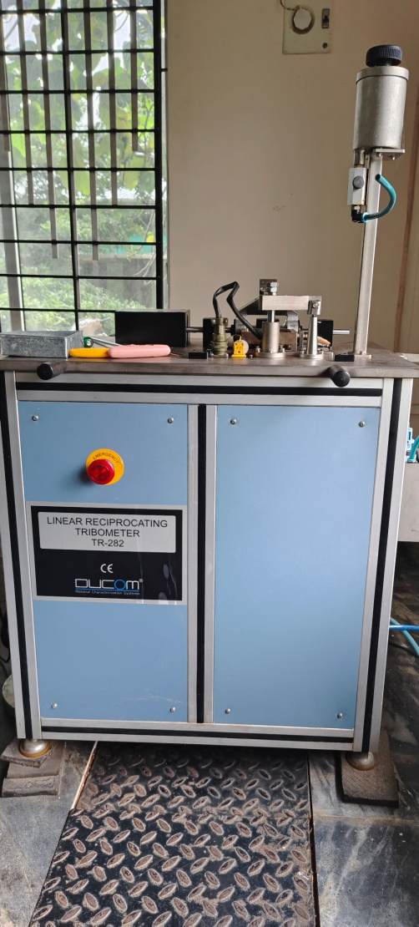 | Name of the equipment:  Linear Reciprocating Tribometer  Make & Model:  Ducom TR 282  I-Stem Registration ID-  3224926  Category of Instrument  Characterization and Testing Tool  Types of Analysis / Testing  Testing  Application:  Friction and Wear characteristics of Ball/ pin/ cylindrical samples

Booking Details

Book through I-STEM:  https://www.istem.gov.in/  Slot Booking Link  I-STEM Slot Booking link for External User | Booking available for  Internal and External Both  Requisition form for  Internals  Externals
Contact Details

Faculty In-charge:  Dr.Amit Kumar Singh  Email ID:  amitsingh@nitc.ac.in  Phone number:  +91-8949362395 | Technical Staff:  Shibin (Senior Technician) shibinr@nitc.ac.in  Robin (Lab Attendant) robinmd@nitc.ac.in | Department  MED  Office Email ID  medoffice@nitc.ac.in  Location  Room No. 101 MSED Department Building  Lab Phone No  0495-2286485

Description and Technical Specifications
Instrument Technical Description and Major Specifications (This Specifications Limited to Major 5)
Description of Instrument: It is an equipment used to find the Coefficient of Friction. Here the top specimen clamped in a holder which is reciprocating to & fro along a plate (bottom specimen) which is fixed at the bottom holder.

Top Specimen's | Ball: ϕ3x15, ϕ6x15, ϕ10x15  Pin: ϕ3, ϕ6, ϕ10  Cylinder: ϕ3x15, ϕ6x15, ϕ10x15
Bottom Specimen Plate | 40*40*6mm
Frequency range | 1 to 50 Hz
Load | 5 to 250N

User Charges Rs. (GST Extra)

Internal | External Academic Institutes | National R&D Lab | Industry
100/- per hour per sample (i.e. If the time taken to test a sample exceeds 1 hr then the user charge will be based on per hour) | 500 + 18%GST per hour per sample (i.e. If the time taken to test a sample exceeds 1 hr then the user charge will be based on per hour) | 500 + 18%GST per hour per sample (i.e. If the time taken to test a sample exceeds 1 hr then the user charge will be based on per hour) | 1000 + 18%GST per hour per sample (i.e. If the time taken to test a sample exceeds 1 hr then the user charge will be based on per hour)

