Rheometer

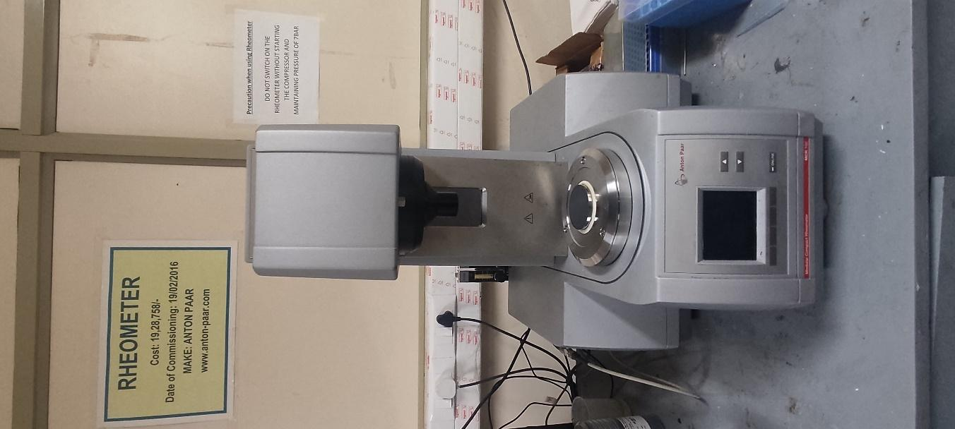 | Name of the equipment:  Rheometer  Make & Model:  Anton Paar & MCR 102 & MRD170/T  I-Stem Registration ID-  3224914  Category of Instrument  Characterization and Testing Tool  Types of Analysis / Testing  Testing  Application:  Friction and Wear characteristics of Ball Samples

Booking Details

Book through I-STEM:  https://www.istem.gov.in/  Slot Booking Link  I-STEM Slot Booking link for External User | Booking available for  Internal and External Both  Requisition form for  Internals  Externals
Contact Details

Faculty In-charge:  Dr.Amit Kumar Singh  Email ID:  amitsingh@nitc.ac.in  Phone number:  +91-8949362395 | Technical Staff:  Shibin (Senior Technician) shibinr@nitc.ac.in  Muhammed Rasheed K (TA)  muhammedrasheed@nitc.ac.in | Department  MED  Office Email ID  medoffice@nitc.ac.in  Location  Room No. 101 MSED Department Building  Lab Phone No  0495-2286485

Description and Technical Specifications

Description of Instrument: This instrument is used to measure the way in which a viscous fluid flows in response to applied forces.
Instrument Technical Description and Major Specifications (This Specifications Limited to Major 5)

Min Torque Rotation | 5nNm
Max Torque | 200nNm
Max Speed | 314rad/s
Normal Force Range | 0.01 to 50N

User Charges Rs. (GST Extra)

Internal | External Academic Institutes | National R&D Lab | Industry
100/- per hour per sample (i.e. If the time taken to test a sample exceeds 1 hr then the user charge will be based on per hour) | 500 + 18%GST per hour per sample (i.e. If the time taken to test a sample exceeds 1 hr then the user charge will be based on per hour) | 500 + 18%GST per hour per sample (i.e. If the time taken to test a sample exceeds 1 hr then the user charge will be based on per hour) | 1000 + 18%GST per hour per sample (i.e. If the time taken to test a sample exceeds 1 hr then the user charge will be based on per hour)

