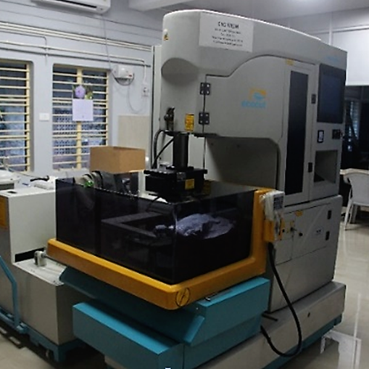 | WIRE ELECTRIC DISCHARGE MACHINE  Name of the equipment:  Wire Electric Discharge Machine  Make & Model:  Electronica, ECOCUT-11  I-Stem Registration ID-  3224894  Category of Instrument  Production Engineering  Types of Analysis / Testing  Metal Cutting  Application:  Precision cutting of hard materials, cutting of complicated shapes, Cutting of small and delicate parts  Description of Instrument  Capable to perform non-contact 3D contouring, cutting die-making with a travelling electrically conductive wire as the tool electrode
Booking Details

Book through I-STEM:  https://www.istem.gov.in/  Slot Booking Link  I-STEM Slot Booking link for External User | Booking available for  Internal and External Both  Requisition form for  Internal  External
Contact Details

Faculty In-charge:  Dr. Vikash Kumar  Email ID:  vikash@nitc.ac.in  Phone number:  +91-8638366093 | Technical Staff:  Sanal PR (TA SG I)  sanal@nitc.ac.in  Jithin Krishna M (TA)  jithinkrishnam@nitc.ac.in  Jijeesh k (ST)  jijeeshk@nitc.ac.in | Department  MED  Office Email ID  medoffice@nitc.ac.in  Location  Production Engineering Lab  Production Block  Lab Phone No  0495-2286450

Features, Working Principle and Specifications

Instrument Technical Description and Major Specifications:
Max Table size : 370 x 600 mm
Main table traverse (X,Y) : 250, 350 mm
Max work piece height : 200 mm
Max work piece weight : 300 kg
Max taper cutting angle : +5ᵒ/100 mm
Dry run speed : 80 mm/min
Wire diameter : 0.25 mm
Min resolution for X,Y,U,V : 0.001 mm
Max work piece height : 250mm
Type of sample Required: Conducting Samples only
User Charges Rs. (GST Extra)

Internal | External Academic Institutes | National R&D Lab | Industry
200/- per hour | 250/- per hour + GST | 250/- per hour + GST | 250/- per hour + GST

