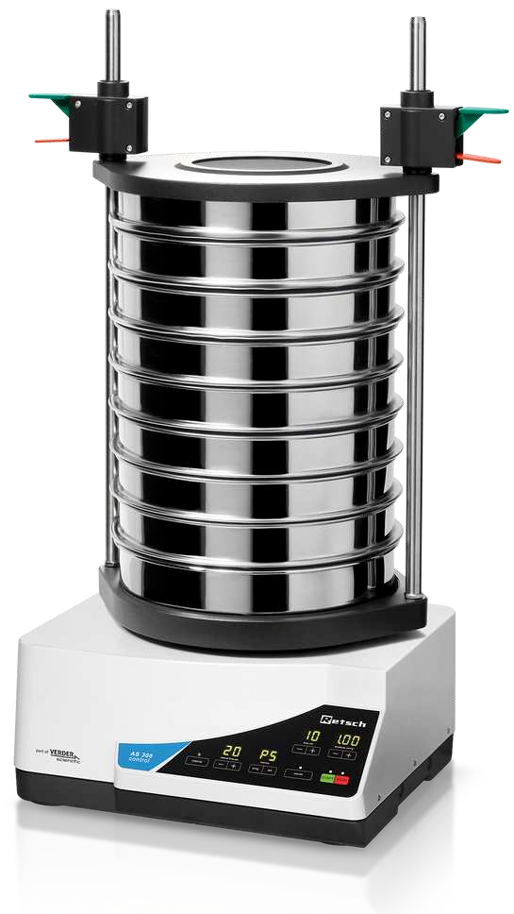  VIBRATORY SIEVE SHAKER | Name of the equipment:  Vibratory Sieve Shaker  Make & Model  Retsch, Germany AS 300 CONTROL  I-Stem Registration ID-  Category of Instrument:  Particle Size Analysis  Types of Analysis / Testing:  Granulometric (sieve) analysis  Application:  Separation and classification of particles based on size  Description of Instrument  The Vibratory Sieve Shaker uses controlled vibrations to separate particles through a stack of sieves, enabling accurate determination of particle size distribution in powders and granular materials.
Booking Details

Book through I-STEM:  https://www.istem.gov.in/  Slot Booking Link  I-STEM Slot Booking link for External User | Booking available for  Internal and External Both  Requisition form for  Internal  External
Contact Details

Faculty In-charge:  Dr. Murali KP  Email ID:  kpmurali@nitc.ac.in  Phone number:  0495-2286414 | Technical Staff:  Sanal PR (TA SG I)  sanal@nitc.ac.in  Jithin Krishna M (TA)  jithinkrishnam@nitc.ac.in  Jijeesh k (ST)  jijeeshk@nitc.ac.in | Department  MED  Office Email ID  medoffice@nitc.ac.in  Location  Material Science Lab  Production Block  Lab Phone No  0495-2286450

Features, Working Principle and Specifications

- Feed material: powders, bulk materials, suspensions
- Measuring range*: 20 µm - 40 mm
- Sieving motion: throwing motion with angular momentum
- Max. batch / feed capacity :6 kg
- Max. number of fractions: 11 / 17
- Max. mass of sieve stack :10 kg
- Amplitude: digital, 0.20 - > 2.20 mm
- Controlled amplitude: Yes
- Sieve acceleration :1.0 - > 10.0 g
- Time display: digital, 1 - 99 min
- Interval operation: 1 - 99 s
- Storable SOPs: 99
- Suitable for dry sieving: Yes
- Suitable for wet sieving: Yes
- Serial interface: Yes
- Including test certificate / can be calibrated: Yes
- Suitable sieve diameters: 100 mm / 200 mm / 203 mm (8") / 305 mm / 315 mm
- Max. height of sieve stack: 510 mm
- Clamping devices: standard, "comfort", each for wet and dry sieving
- Protection code: IP 21
- W x H x D: 417 x 220 x 384 mm
- Net weight: ~ 42 kg
Type of Sample Required for Analysis / Testing (Quantity, Pre-Preparation, State etc.) Guidelines for Sample Submission – User Instructions

- Sample Type: powdered samples
- Maximum No. of Samples Accepted at a Time- 1
- Minimum No of Days Required for Analysis – 2 Days

User Charges Rs. (GST Extra)

Internal | External Academic Institutes | National R&D Lab | Industry
300/- per hour | 600/- per hour + GST | 600/- per hour + GST | 600/- per hour + GST

