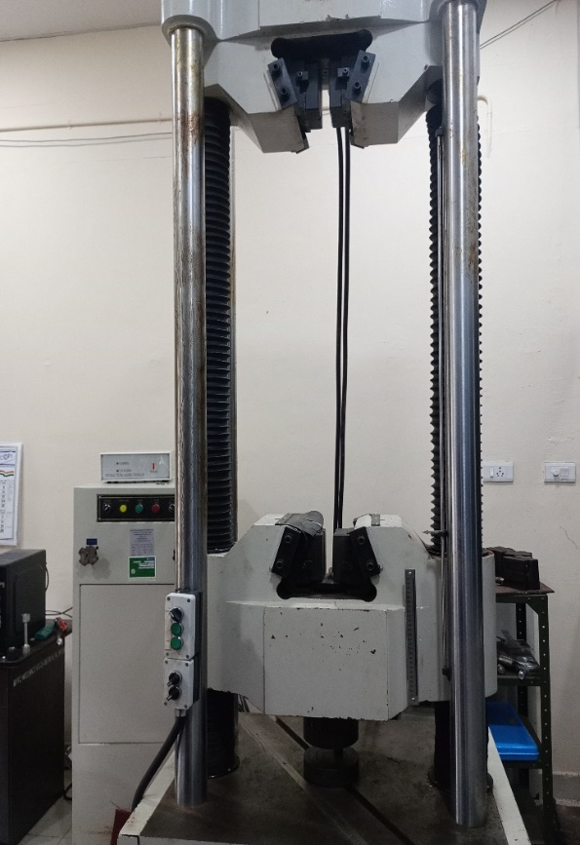  COMPUTER CONTROLLED HYDRAULIC SERVO 1000KN UNIVERSAL TESTING MACHINE | Name of the equipment:  Computer controlled Hydraulic Servo 1000KN Universal Testing Machine  Make & Model:  JINAN WAW1000E  I-Stem Registration ID-  3224877  Category of Instrument  Material Science  Application:  Mechanical properties testing (Tensile, compression, bending  Description of Instrument  Computer-controlled 1000kN hydraulic servo universal testing machine for versatile material testing (tension, compression, bending, etc.)
Booking Details

Book through I-STEM:  https://www.istem.gov.in/  Slot Booking Link  I-STEM Slot Booking link for External User | Booking available for  Internal and External Both  Requisition form for  Internals  Externals
Contact Details

Faculty In-charge:  Dr. Murali KP  Email ID:  kpmurali@nitc.ac.in  Phone number:  0495-2286414 | Technical Staff:  Sanal PR (TA SG I)  sanal@nitc.ac.in  Jithin Krishna M (TA)  jithinkrishnam@nitc.ac.in  Jijeesh k (ST)  jijeeshk@nitc.ac.in | Department  MED  Office Email ID  medoffice@nitc.ac.in  Location  Material Science Lab  Production Block  Lab Phone No  0495-2286450

Features, Working Principle and Specifications

Instrument Technical Description and Major Specifications:
Max. load: 1000kN
Load range: 0-100kN, 0-200kN, 0-500kN & 0-1000kN
Control Mode & precision: Load rate, stress rate, displacement rate, strain rate control, load hold mode (short duration) & 1%
Displacement resolution: 0.01mm
Piston speed: 0.5 – 80 mm/mi
Type of sample Required: As per Standard
User Charges Rs. (GST Extra)

Internal | External Academic Institutes | National R&D Lab | Industry
350/- per sample | 1000/- per sample + GST | 1000/- per sample + GST | 2400/- per sample + GST

