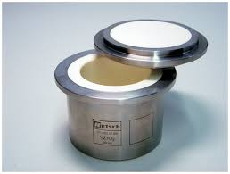  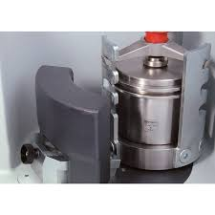  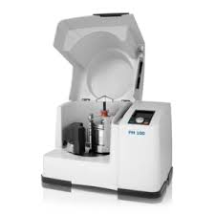  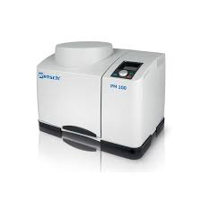 | PLANETARY BALL MILL  Name of the equipment:  Planetary Ball Mill  Make & Model:  Retsch, Germany PM 100  I-Stem Registration ID-  3224880  Category of Instrument  Mechanical Alloying / Comminution  Types of Analysis / Testing  Particle size reduction  Application:  Milling hard, medium-hard, soft, brittle, or fibrous materials  Description of Instrument  The PM 100 reduces materials to sub-micron sizes through high-energy impact and friction, ideal for sample preparation and nanomaterial synthesis.
Booking Details

Book through I-STEM:  https://www.istem.gov.in/  Slot Booking Link  I-STEM Slot Booking link for External User | Booking available for  Internal and External Both  Requisition form for  Internals  Externals
Contact Details

Faculty In-charge:  Dr. Murali KP  Email ID:  kpmurali@nitc.ac.in  Phone number:  0495-2286414 | Technical Staff:  Sanal PR (TA SG I)  sanal@nitc.ac.in  Jithin Krishna M (TA)  jithinkrishnam@nitc.ac.in  Jijeesh k (ST)  jijeeshk@nitc.ac.in | Department  MED  Office Email ID  medoffice@nitc.ac.in  Location  Material Science Lab  Production Block  Lab Phone No  0495-2286450
Features, Working Principle and Specifications

Planetary Ball Mill
Feed material | soft, hard, brittle, fibrous - dry or wet
Size reduction principle | impact, friction
Material feed size* | < 10 mm
Final fineness* | < 1 µm, for colloidal grinding < 0.1 µm
No. of grinding stations | 1
Speed ratio | 1 : -2
Sun wheel speed | 100 - 650 min⁻¹
Effective sun wheel diameter | 141 mm
G-force | 33.3 g
Type of grinding jars | "comfort", optional areation covers, safety closure devices
Material of grinding tools | zirconium oxide
Grinding jar sizes | 500 ml
Setting of grinding time | digital, 00:00:01 to 99:59:59
Interval operation | yes, with direction reversal
Interval time | 00:00:01 to 99:59:59
Pause time | 00:00:01 to 99:59:59
Drive power | 750 W
Electrical supply data | different voltages
Power connection | 1-phase
Power consumption | ~ 1250W (VA)
W x H x D closed | 640 x 480 (780) x 420 mm
Net weight | ~ 86 kg
Standards | CE

Type of Sample Required for Analysis / Testing (Quantity, Pre-Preparation, State etc.) Guidelines for Sample Submission – User Instructions

- Sample Type: Metals, Alloys & other Materials
- Type of Samples to be Analysed - Metallic
- Maximum No. of Samples Accepted at a Time- 1
- Minimum No of Days Required for Analysis – 2 Days

User Charges Rs. (GST Extra)

Internal | External Academic Institutes | National R&D Lab | Industry
300/- per hour | 600/- per hour + GST | 600/- per hour + GST | 600/- per hour + GST

