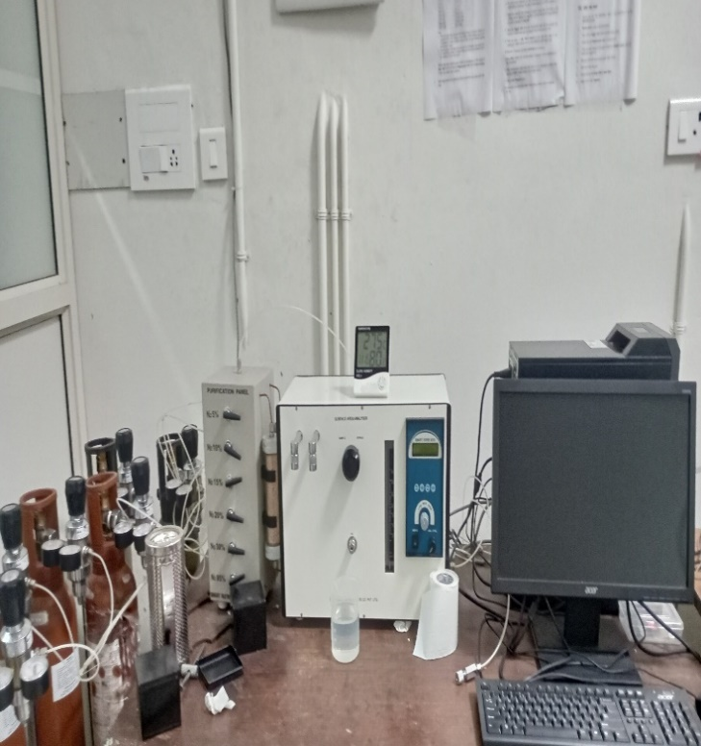 | MULTI-POINT BET SURFACE AREA ANALYSER  Name of the equipment:  Multi-point BET Surface area Analyzer  Make & Model:  Smart SORB-93  I-Stem Registration ID-  3224875  Category of Instrument  Ceramic Lab  Application:  For inspecting the surface area and pore volume of  - Catalysts for automotive, fertilizers and petrochemical industries  - Carbon powder for rubber, adsorbents (gas separation and water purification), gas masks, inks, laser printers etc  - Minerals such as alumina, clays, pigments, phosphates, silica, zirconia etc  - abrasives, adsorbents, biomaterials, ceramics, cement, etc  Description of Instrument  BET surface area analyzer is one of the most used methods to measure and analyze the surface area of porous materials and nanoparticles. This physical characterization technique provides quantitative data on the specific surface area and pore volume of the solid materials. The method is suitable for a wide range of solid matrices, from catalyst powders to monolithic materials.

Booking Details

Book through I-STEM:  https://www.istem.gov.in/  Slot Booking Link  I-STEM Slot Booking link for External User | Booking available for  Internal and External Both  Requisition form for  Internal  External

Contact Details
Faculty In-charge:  Dr. Muhammed Rashad K  Email ID:  rashad@nitc.ac.in  Phone number: | Technical Staff:  Sanal PR (TA SG I)  sanal@nitc.ac.in  Jithin Krishna M (TA)  jithinkrishnam@nitc.ac.in  Jijeesh k (ST)  jijeeshk@nitc.ac.in  Features, Working Principle and Specifications | Department  MED  Office Email ID  medoffice@nitc.ac.in  Location  Ceramic Lab  Production Block  Lab Phone No  0495-2286450

Instrument Technical Description and Major Specifications:
Smart Sorb 93, Surface Area Analyser is based on the dynamic BET principle. Nitrogen gas is used for adsorption. The dynamic flow method uses a highly sensitive thermal conductivity detector to measure the change in the concentration of an adsorbate/carrier gas mixture during the adsorption or desorption process. It determines the surface area at a single point and it can be enhanced for measuring multi-point surface area and total pore volume analysis with different gas mixture percentage
- Surface Area range - 0.1 m²/gm to 1500 m²/gm - Normal. Extendable up to 2500 m²/gm.
- Accuracy - Typically better than ± 5%
- Reproducibility - Typically better than ± 3%
- Regeneration System Temperature Range: Ambient to 300°C
- Sample holder capacity - 7 ml

Application of Instrument:
For inspecting the surface area and pore volume of
  - Catalysts for automotive, fertilizers and petrochemical industries
  - Carbon powder for rubber, adsorbents (gas separation and water purification), gas masks, inks, laser printers etc
  - Minerals such as alumina, clays, pigments, phosphates, silica, zirconia etc
  - abrasives, adsorbents, biomaterials, ceramics, cement, etc

Type of sample Required:
Type of Sample: Powders of particle size less than 2 mm
Instruction to the users: Before doing the analysis, users may share the information about the expected range of surface area for their samples with the instrument operator.
User Charges Rs. (GST Extra)

Internal | External Academic Institutes | National R&D Lab | Industry
200/- per sample | 500/- per sample + GST | 500/- per sample + GST | 500/- per sample + GST

