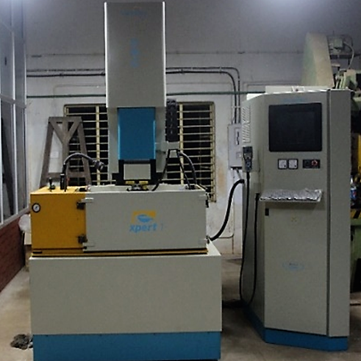  CNC DIE SINKING EDM | Name of the equipment:  CNC Die Sinking EDM  Make & Model:  Electronica  I-Stem Registration ID-  3224899  Category of Instrument  Production Engineering  Application:  Tool die making, Injection Moulding, Precision component manufacturing, Blind cavities, Blind keyways, Internal splines  Description of Instrument  CNC Die Sinking EDM machine is a precision tool that uses electric sparks to erode material from a workpiece, creating complex shapes and intricate designs in metal dies
Booking Details

Book through I-STEM:  https://www.istem.gov.in/  Slot Booking Link  I-STEM Slot Booking link for External User |  | Booking available for  Internal and External Both  Requisition form for  Internal  External
 |  | Contact Details
Faculty In-charge:  Dr. Vikash Kumar  Email ID:  vikash@nitc.ac.in  Phone number:  +91-8638366093 | Technical Staff:  Sanal PR (TA SG I)  sanal@nitc.ac.in  Jithin Krishna M (TA)  jithinkrishnam@nitc.ac.in  Jijeesh k (ST)  jijeeshk@nitc.ac.in |  | Department  MED  Office Email ID  medoffice@nitc.ac.in  Location  Production Engineering Lab  Production Block  Lab Phone No  0495-2286450

Features, Working Principle and Specifications

Instrument Technical Description and Major Specifications:
Longitudinal travel (x) - 400mm
Transverse travel (y) - 300mm
Max permitted load on the table - 1000kg
Max electrode weight - 50kg or more without c axis 25kg or more with c axis
Max work piece height - 250mm
Type of sample Required: Conducting Samples only

User Charges Rs. (GST Extra)

Internal | External Academic Institutes | National R&D Lab | Industry
200/- per hour | 250/- per hour + GST | 250/- per hour + GST | 250/- per hour + GST

