GPU Server
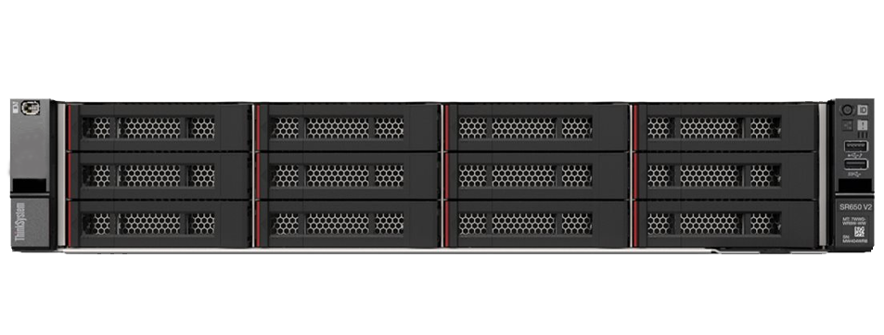 | Name of the equipment:  GPU Server  Make & Model:  Lenovo Think System SR650  I- Stem Registration ID:  3245579  Source of funding:  Plan fund 2021-22  Location:  ITL 305  Description of Instrument:  A powerful and scalable 2U rack server designed for performance-intensive workloads such as virtualization, databases, analytics, and enterprise applications. Ideal for growing businesses and modern data centers.
Booking Details

Book through I-STEM:  https://www.istem.gov.in/  Slot Booking Link  I-STEM Slot Booking link for External User | Booking available for  Internal and External Both  Requisition form for  Internals  Externals
Contact Details

Faculty In charge:  Dr Jayaraj P B  Email:  jayarajpb@nitc.ac.in  Phone No:  9633701066 | Technical Staff:  Mr.Rahul N K  Email ID:  rahulnk@nitc.ac.in  Phone No:  8547321384 | Department:  CSED  Email ID:  csedoffice@nitc.ac.in

Features and specifications
Rack Server
Processor - 64 bit Processor from Intel Xeon Silver 4310 2.10 GHz.
RAM - 128 GB,or more ECC DDR4, 3200MHz scalable up to 4TB
Storage - 4 TB HDD
GPU Support - NVIDIA A100 , 80GB
OS - Ubuntu 22.04

Unique features/Measurement capabilities, if any:
GPU Support- NVIDIA A100 80GB
User Charges Rs. (Inclusive of GST)

Internal | External Academic Institutes | National R&D Lab | Industry
20 Rs per hour/GPU | 50 Rs per hour/GPU | 100 Rs per hour/GPU | 200 Rs per hour/GPU

