Rack Server
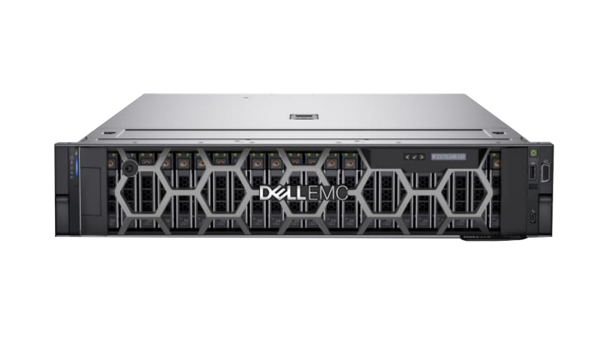 | Name of the equipment:  RACK Server  Make & Model:  Dell PowerEdge R750  I-Stem Registration ID:  3245580  Source of funding:  Plan fund 2022-23  Location:  ITL 305  Description of Instrument:  The Dell PowerEdge R750 is a 2U, dual-socket rack server designed for performance, scalability and versatility.
Booking Details

Book through I-STEM:  https://www.istem.gov.in/  Slot Booking Link  I-STEM Slot Booking link for External User | Booking available for  Internal and External Both  Requisition form for  Internals  Externals
Contact Details

Faculty In charge:  Dr Gopakumar G  Email:  gopakumarg@nitc.ac.in  Phone No:  9446032724 | Technical Staff:  Mr. Brijalal V S  Email ID:  brijalalvs@nitc.ac.in  Phone No:  9567062569 | Department:  CSED  Email ID:  csedoffice@nitc.ac.in
Features and specifications

Rack Server
Processor - Intel Xeon Gold 5318Y 2.1g
RAM - 128 GB and scalable up to 1TB
Storage - 4.8 TB
GPU Support - NVIDIA A40 48GB
OS - Ubuntu 22.10

Unique features/Measurement capabilities, if any:
GPU Support - NVIDIA A40 48GB
User Charges Rs. (Inclusive of GST)

Internal | External Academic Institutes | National R&D Lab | Industry
20 Rs per hour/GPU | 50 Rs per hour/GPU | 100 Rs per hour/GPU | 200 Rs per hour/GPU

