DYNAMIC SHEAR RHEOMETERS (DSR)

DYNAMIC SHEAR RHEOMETERS (DSR)

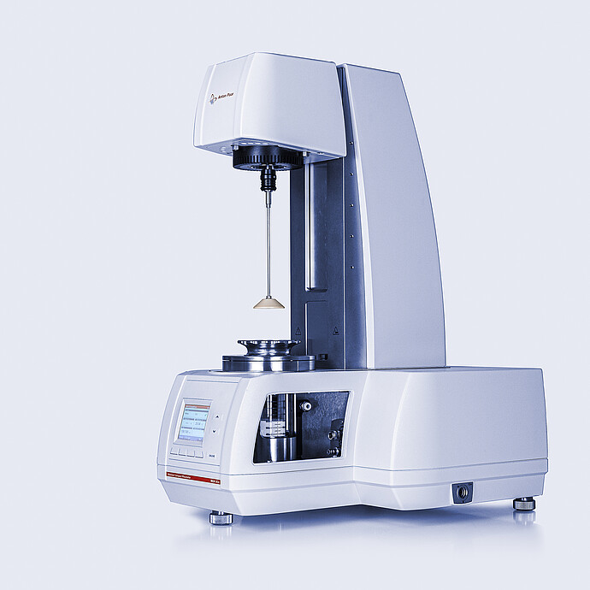 | Name of the equipment:  Dynamic Shear Rheometers (DSR)  Make & Model:  ANTON PAAR - MCR-102  I-Stem Registration ID-  ……………………..  Category of Instrument  Characterization and Testing  Types of Analysis / Testing  It can perform Complex Shear Modulus, Viscosity determination, Superpave performance grading, and Multiple stress creep recovery (MSCR).  Application:  - Quality control and routine measurements in asphalt test labs  - Research and development of asphalt and bitumen products  - Standard asphalt tests according to international standards (AASHTO, ASTM, DIN EN, etc.)  Description of Instrument  The SmartPave 102 is a dynamic shear rheometer (DSR) that is designed to analyze unmodified and modified asphalt binder and bitumen in a wide temperature range.
Booking Details
Book through I-STEM:  https://www.istem.gov.in/  Slot Booking Link  I-STEM Slot Booking link for External User | Booking available for  Internal and External Both  Requisition form for  Internals  Externals
Contact Details
Faculty In-charge:  Dr. M. Sivakumar  Email ID:  sivakumarm@nitc.ac.in  Phone number:  04952286232 | Technical staffs:  Chandni P R  chandnipr@nitc.ac.in  Ajin Das C K  ajindasck@nitc.ac.in  Abhiraj A R  abhirajar@nitc.ac.in | Department  CED  Office Email ID  cedoffice@nitc.ac.in  Location  Pavement Engineering Laboratory  Lab Phone No  0495-2286243
Features, Working Principle and Specifications
Features of the equipment  - High-precision Peltier temperature control  - EC motor for sensitive and precise movements  - QuickConnect system for easy and fast system changes  - TruRay lighting concept for a clear view of the sample and measurement surface | Unique features/Measurement capabilities, if any  - Temperature range of -50 °C to +220 °C  - Unrivalled accuracy and convenience  - Automatic and fast temperature calibration and verification routine.
Instrument Technical Description and Major Specifications (This Specifications Limited to Major 5)  - Temperature range: -50 °C to +220 °C  - Meets international standards  - Complex Shear Modulus |G| [Pa]*  - Viscosity determination of asphalt binder  - Upgradeable to all standard rheological tests | Measurement/Sample specifications:  - Asphalt binder  - Bitumen  - Modified asphalt binder
The SmartPave 102e requires 10-20g of dry and solid asphalt binder, bitumen, modified asphalt binder, or ground tire rubber (GTR) modified asphalt binders for analysis/testing.
Type of Sample Required for Analysis / Testing (Quantity, Pre-Preparation, State etc.) Guidelines for Sample Submission – User Instructions

Internal | External Academic Institutes | National R&D Lab | Industry
User Charges Rs. (GST Extra)

