THE INFRA-RED TRAFFIC LOGGER (TIRTL)

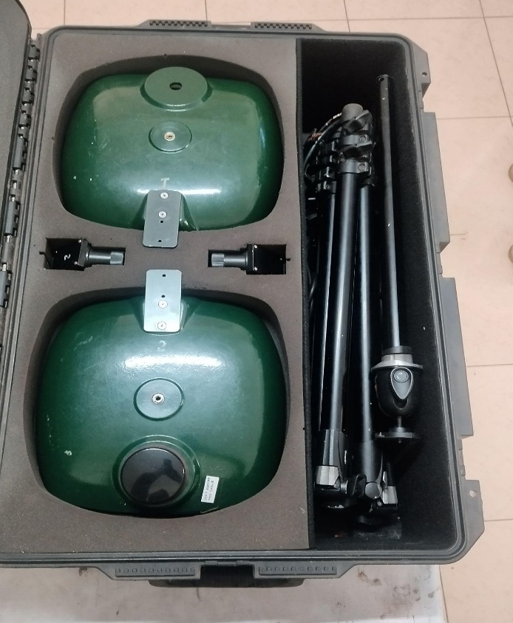 | Name of the equipment:  The Infra-Red Traffic Logger (TIRTL)  Make & Model:  CEOS International, RX1223F  I-Stem Registration ID-  …………………..  Category of Instrument  Characterization and Testing  Types of Analysis / Testing  Multi-purpose traffic sensor  Application:  Traffic Data Collection and Analysis Real-Time Traffic Management and Enforcement  Description of Instrument  The TIRTL (The Infra-Red Traffic Logger) is a non-invasive, multi-purpose traffic sensor that utilizes infrared light beam technology to detect and analyze vehicles.
Booking Details

Book through I-STEM:  https://www.istem.gov.in/  Slot Booking Link  I-STEM Slot Booking link for External User | Booking available for  Internal and External Both  Requisition form for  Internals  Externals
Contact Details

Faculty In-charge:  Dr. M. Sivakumar  Email ID:  sivakumarm@nitc.ac.in  Phone number:  04952286232 | Technical staffs:  Chandni P R  chandnipr@nitc.ac.in  Ajin Das C K  ajindasck@nitc.ac.in  Abhiraj A R  abhirajar@nitc.ac.in | Department  CED  Office Email ID  cedoffice@nitc.ac.in  Location  Transportain Lab  Lab Phone No  0495-2286243

Features, Working Principle and Specifications

Features of the equipment  - Non-invasive: Infrared beam detection, no road cutting.  - Multi-purpose: Counts, classifies, measures speed, identifies lanes, and more (red light, heavy vehicle, etc.).  - Precise: Uses overlapping infrared beams and accurate timing.  - Smart: On-board processing with configurable classification.  - Real-time & Logging: Streams and stores data. | Unique features/Measurement capabilities, if any  - Dual IR Beams for Detailed Wheel Analysis: Provides more data than single-beam systems.  - Precise Trajectory Analysis: Can infer wheel width and lateral position.  - Robust Lane Identification: Uses parallel and crossed beams.  - High Accuracy: Reliable counting, classification, and speed measurement in diverse conditions.
Instrument Technical Description and Major Specifications (This Specifications Limited to Major 5)  Detection: Dual IR beams forming 4 pathways.  Measurements:  - Speed: 5-250 km/h, ±0.5% accuracy.  - Classification: Axle-based, >98% accuracy (20+ classes in India).  - Volume: >99.9% accuracy  Data & Communication:  - Output: Plain text.  - Interfaces: RS-232, Ethernet.  - Remote (Optional): GSM, etc.  Environment & Physical:  - Temp: -20°C to +70°C (typical).  - Power: Low voltage DC.  - Enclosure: Weatherproof (IP65+).  Installation: Pole-mounted, straightforward alignment. |  | Measurement/Sample specifications:  - Speed: km/h, 5-250 range, ±0.5% accuracy. Handles low speeds well.  - Classification: IRC-aligned scheme (2-wheelers, 3-wheelers, cars, buses, trucks, etc.), 10-20+ classes, >95% accuracy, adapted for local vehicles.  - Volume: Vehicles/time, >99% accuracy, by class.  - Lane ID: For multi-lane roads.  - Time: IST timestamp with milliseconds.  Sample Data: Includes date, time, lane, speed (km/h), class code, and description.

Type of Sample Required for Analysis / Testing (Quantity, Pre-Preparation, State etc.) Guidelines for Sample Submission – User Instructions
Classified Traffic Volume Count/Speed
- Minimum No of Days Required for Analysis – 1 week
User Charges Rs. (GST Extra)

Internal | External Academic Institutes | National R&D Lab | Industry
2500/- per test | 4000/- per test | 5000/- per test | 10000/- per test

