REPEATED LOAD TEST SET-UP

REPEATED LOAD TEST SET-UP

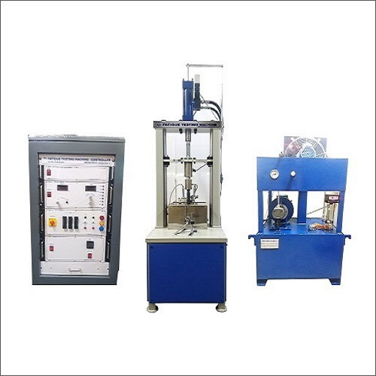 | Name of the equipment:  REPEATED LOAD TEST SET-UP  Make & Model:  SPRANKTRONOICS  I-Stem Registration ID-  3220870  Category of Instrument  Characterization and Testing  Types of Analysis / Testing  Fatigue Test  Application:  Determine material fatigue and evaluate structural performance  Description of Instrument  The Repeated Load Fatigue Testing Machine is a device used for testing the fatigue of materials such as concrete, bitumen, and soil.
Booking Details

Book through I-STEM:  https://www.istem.gov.in/  Slot Booking Link  I-STEM Slot Booking link for External User | Booking available for  Internal and External Both  Requisition form for  Internals  Externals
Contact Details

Faculty In-charge:  Dr. M. Sivakumar  Email ID:  sivakumarm@nitc.ac.in  Phone number:  0495-2286232 | Technical Staff:  Abhiraj A R  abhirajar@nitc.ac.in  Ajin Das C K  ajindasck@nitc.ac.in  Chandni P R  chandnipr@nitc.ac.in | Department  CED  Office Email ID  cedoffice@nitc.ac.in  Location  Pavement Engineering Laboratory  Lab Phone No.  0495-2286243
Features of the equipment  - Controlled and repeated loads  - Measurement of deformation and strain  - Monitoring of material or structural response  - Simulation of various loading conditions | Unique features/Measurement capabilities, if any  - Deformation and strain measurement  - Load control (cyclic and dynamic loading)  - Material response monitoring
Instrument Technical Description and Major Specifications (This Specifications Limited to Major 5)  - Load Range: 0-5T  - Frequency Range: 1-10Hz  - Hydraulic Actuation: Haver Sine Wave Static Ramp Control  - Auto Computer Control: Load and deformation control  - Rate of Load Frequency Operation: Maximum 5 cycles/second  - Servo Control: Total system is servo-controlled | Measurement/Sample specifications:  - Material Type: Various materials such as soils, flexible pavements, and more.  - Sample Size: Varies depending on the test setup and application.
Type of Sample Required for Analysis / Testing (Quantity, Pre-Preparation, State etc.) Guidelines for Sample Submission – User Instructions
Features, Working Principle and Specifications

- Sample Type: Representative samples of the material or structure to be tested.
- Sample Size: Typically, 1-5 samples, depending on the test setup and application.
- Preparation: Samples should be in a stable, undisturbed state.

User Charges Rs. (GST Extra)

Internal | External Academic Institutes | National R&D Lab | Industry
500/- per hour | 500/- per hour | 1500/- per hour | 3000/- per hour

