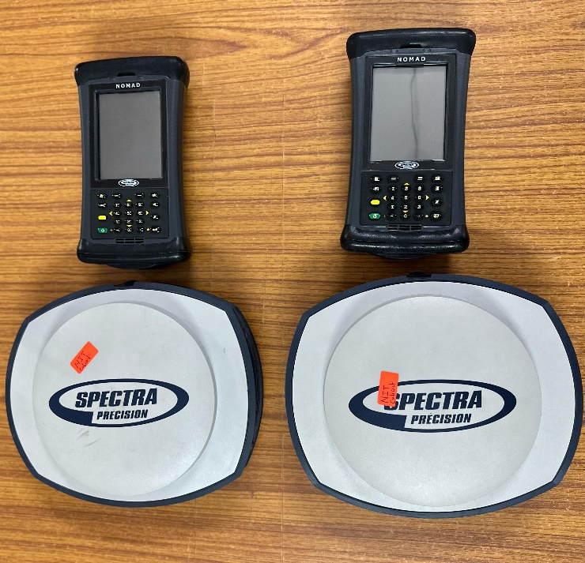 | SP80 GNSS receiver  Name of the equipment:  SP80 GNSS receiver  Make & Model:  make:Spectra precision model: SP80  I-Stem Registration ID-  Category of Instrument  High-Precision GNSS Receiver  Types of Analysis / Testing  High Precision Positioning and Surveying Analysis  Application:  Land boundary mapping, site planning.  Description of Instrument  The sp80 dgps is a high accuracy gnss receiver for professional surveying
Booking Details

Book through I-STEM:  https://www.istem.gov.in/  Slot Booking Link  I-STEM Slot Booking link for External User | Booking available for  Internal and External Both  Requisition form for  Internals  Externals
Contact Details

Faculty In-charge:  Dr. AGILAN V  Email ID:  agilan@nitc.ac.in  Phone number:  04952286251 | Technical Staff:  Mithun sai das  mithunsaidas@nitc.ac.in  Sridhara K  sridharak@nitc.ac.in | Department  CED  Office Email ID  cedoffice@nitc.ac.in  Location  Room No. 107, Main building  Lab Phone No  04952286244

Features, Working Principle and Specifications

Features of the equipment  - High-Precision GNSS: Provides centimeter-level accuracy  - Real-Time Kinematic (RTK) Corrections  - Can be used globally with proper reference stations  - Multiple Connectivity Options: Supports Bluetooth, Wi-Fi, and cellular | Unique features/Measurement capabilities, if any  - Patented Z-Blade technology  - 240-channel 6G ASIC)  - Patented SBAS ranging  - Patented Strobe™ Correlator for reduced GNSS multi-path
Instrument Technical Description and Major Specifications (This Specifications Limited to Major 5)  - Physical Characteristics:Size 22.2 x 19.4 x 7.5 cm Weight 1.17 kg  - 240 GNSS channels  - Recording Interval:0.05-999 seconds  - Supported data formats: ATOM, CMR, CMR+, RTCM 2.1, 2.2, 2.3, 3.0, 3.1 and 3.2 (including MSM), CMRx and sCMRx (rover only) | Measurement/Sample specifications:  - Up to 20 Hz real-time raw data (code & carrier and position output)  - NMEA 0183 messages output  - Real-Time Kinematic Position (Horizontal Accuracy: 8 mm + 1 ppm,Vertical Accuracy: 15 mm + 1 ppm )
Type of Sample Required for Analysis / Testing (Quantity, Pre-Preparation, State etc.) Guidelines for Sample Submission – User Instructions

  - Testing Requirements: Specify any particular tests or scenarios. (For GNSS receiver, this might include specific environmental conditions, accuracy checks, or data logging tests or duration of use.
  - User instructions: power on the device, connect it to a data controller via Bluetooth or Wi-Fi, and configure it as a base or rover for data collection. Ensure good satellite visibility, charged batteries, for optimal performance.
  - Battery Duration: The receiver is designed to operate for about 10 hours with both batteries fully charged, assuming GNSS is on
User Charges Rs. (GST Extra)

Internal | External Academic Institutes | National R&D Lab | Industry
50000/day | 60000/day | 60000/day | 75000/day

