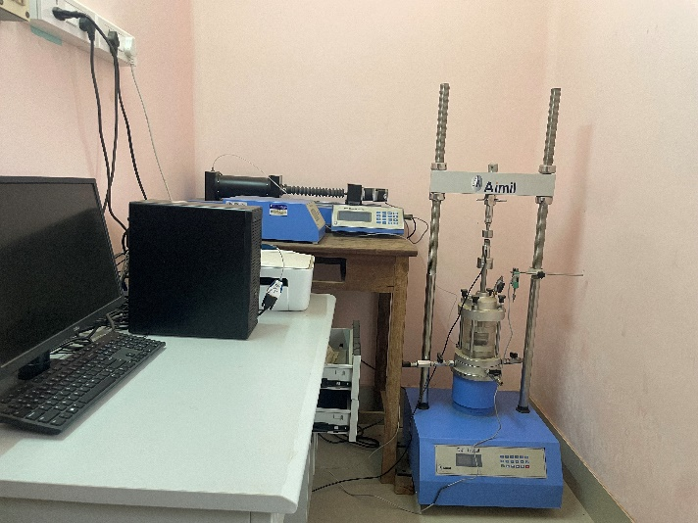  Constant Rate of Strain (CRS) consolidation test equipment | Name of the equipment:  Constant Rate of Strain (CRS) consolidation test  Make & Model:  AIMIL  I-Stem Registration ID-  ……………………..  Category of Instrument  Geotechnical Engineering  Types of Analysis / Testing  Soil Sample  Application:  Consolidation properties of soil samples under various conditions.  Description of Instrument  Measures the magnitude and rate-of-consolidation of saturated cohesive soils using axial strain-controlled conditions, when the soil specimen is restrained laterally and drained axially to one surface.
Booking Details
Contact Details
Book through I-STEM:  https://www.istem.gov.in/  Slot Booking Link  I-STEM Slot Booking link for External User | Booking available for  Internal and External Both  Requisition form for  Internals  Externals

Faculty In-charge:  Dr. Anjana Bhasi,  Email ID:  anjanabhasi@nitc.ac.in,  Phone number:  +91-7353245331 | Technical Staff:  Nayana P  nayanap@nitc.ac.in  Lini Ignatius C  liniignatiusc@nitc.ac.in  Ajith Augusthy ajithaugusthy@nitc.ac.in | Department  CED  Office Email ID  cedoffice@nitc.ac.in  Location  Geotechnical Lab, Department of Civil Engineering  Lab Phone No  0495-2286245

Features, Working Principle and Specifications

Features of the equipment  - Controlled saturation  - Axial Loading device  - Chamber pressure measuring device  - LVDT deformation measuring device  - Porous disc | Unique features/Measurement capabilities, if any  - Load Frame with Control Electronics  - Lab Software and Data Acquisition System
Instrument Technical Description and Major Specifications (This Specifications Limited to Major 5)  - Adjustable rate of loading  - Saturation can be controlled  - LVDT 0.01 – 50mm  - Porous stone 90mm & 60mm | Measurement/Sample specifications:  - Sample size 60mm dia and 20mm thickness
Type of Sample Required for Analysis / Testing (Quantity, Pre-Preparation, State etc.) Guidelines for Sample Submission – User Instructions

- All soil sample (Clay and Silt) minimum 100g
User Charges Rs. (GST Extra)

Internal | External Academic Institutes | National R&D Lab | Industry
2000/- per sample | 9000/- per sample | 9000/- per sample | 15000/- per sample

