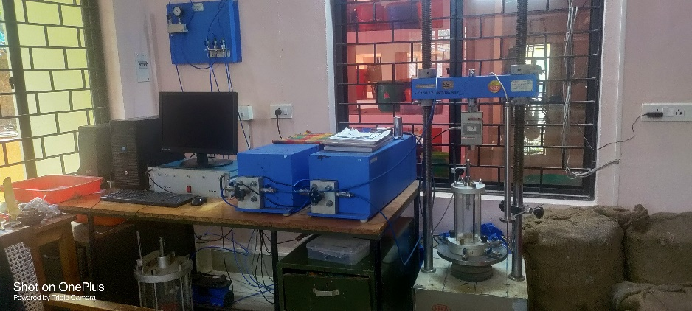  Computerised Static Triaxial equipment | Name of the equipment:  Computer Controlled Triaxial  Make & Model:  HEICO Model: HS26.635 & 1502184  I-Stem Registration ID-  ……………………..  Category of Instrument  Geotechnical Engineering  Types of Analysis / Testing  Soil sample  Application:  To get shear strength of soil.  Description of Instrument  Static triaxial testing CU & UU tests
Booking Details

Book through I-STEM:  https://www.istem.gov.in/  Slot Booking Link  I-STEM Slot Booking link for External User | Booking available for  Internal and External Both  Requisition form for  Internals  Externals
Contact Details

Faculty In-charge:  Dr.Seethalakshmi  Email ID:  seetha@nitc.ac.in  Phone number:  +91-9442259922 | Technical Staff:  Nayana P  nayanap@nitc.ac.in  Lini Ignatius C  liniignatiusc@nitc.ac.in  Ajith Augusthy ajithaugusthy@nitc.ac.in | Department  CED  Office Email ID  cedoffice@nitc.ac.in  Location  Geotechnical Lab, Department of Civil Engineering  Lab Phone No  0495-2286245

Features, Working Principle and Specifications

Features of the equipment  - Used for conducting Unconsolidated Undrained (UU), Consolidated Undrained (CU), and Consolidated Drained (CD) triaxial tests on soil specimens under static condition  - Allows testing under different confining pressures (σ₃) and axial loading conditions while maintaining controlled strain rates. | Unique features/Measurement capabilities, if any  - Load Frame with Control Electronics  - Lab Software and Data Acquisition System  - Pressure Volume Controllers for measuring change in Volume & Constant Pressure
Instrument Technical Description and Major Specifications (This Specifications Limited to Major 5)  - Load upto 50kN  - LVDT displacement 0.01mm-50mm  - Load cell 50kN  - Pressure Sensor 0.01kg/cm2 to 10kg/cm2  - Universal Load Cell | Measurement/Sample specifications:  - 38mm, 50mm and 75mm dia
Type of Sample Required for Analysis / Testing (Quantity, Pre-Preparation, State etc.) Guidelines for Sample Submission – User Instructions

- All soil sample (Clay, Silt, Sand, etc) minimum 1 Kg

User Charges Rs. (GST Extra)

Internal | External Academic Institutes | National R&D Lab | Industry
1500/- per sample | 3000/- per sample | 3000/- per sample | 5000/- per sample

