Universal Testing machine 1000 KN

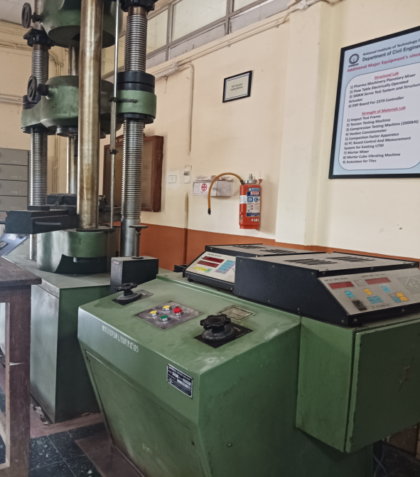 | Name of the equipment:  Universal Testing machine 1000 KN  Make & Model:  Bluestar. & UTE 2001  I-Stem Registration ID-  3220833  Category of Instrument  Characterization and Testing  Types of Analysis / Testing  Shear , Flexure etc  Application:  It has to be planned based on the need  Description of Instrument  This machine is set to perform shear & flexure tests.

Booking Details

Book through I-STEM: https://www.istem.gov.in/ Slot Booking Link I-STEM Slot Booking link for External User Booking available for Internal and External Both Requisition form for Internals Externals | Book through I-STEM: Internal and External Both Slot Booking Link Internals Externals Booking available for Internal and External Both Requisition form for Internals Externals
Contact Details

Faculty In-charge:  Dr. Muhamed Safeer Pandikkadavath  Email ID:  msafeerpk@nitc.ac.in  Phone number:  9895599785 | Technical Staff:  Noushad K K (TA) noushadkk@nitc.ac.in  Jeyeshkumar (TA)  jeyesh@nitc.ac.in  Nithya B S (TA) nithyabs@nitc.ac.in |  | Department  CED  Office Email ID  cedoffice@nitc.ac.in  Location  SM Lab, Department of Civil engineering  Lab Phone No  0495-2286840
Features of the equipment  - Rigid and stable frame suitable for testing structural elements such as beams, columns, and reinforcement bars.  - Provides support for both instructional laboratory experiments and research-based analysis.  - Capable of applying large loads uniformly and accurately.  - Simple hydraulic operation with manual controls for ease of use.  - Suitable for various loading configurations depending on the structural element under test. |  | Unique features/Measurement capabilities, if any  - Specially designed for testing full-scale or scaled-down structural members (beams, columns, bars).  - Accurate load application and measurement up to 100 Tonne capacity.  - Useful for observing structural failure modes and validating theoretical models in classroom or research settings.
Instrument Technical Description and Major Specifications (This Specifications Limited to Major 5)  - 100 Tonne capacity machine designed to test reinforced concrete beams, columns, and steel bars under different loading conditions.  - Make & Origin:  - Make: Bluestar.  Type of Sample Required for Analysis / Testing (Quantity, Pre-Preparation, State etc.) Guidelines for Sample Submission – User Instructions |  | Measurement/Sample specifications:  - Universal testing machine for concrete typically have a load capacity upto 1000 KN.
Features, Working Principle and Specifications
Features, Working Principle and Specifications

- Samples may be prepared as per standard IS codes., If you are unsure about the sample suitability or testing feasibility, you are encouraged to visit the laboratory in advance and discuss your requirements with the lab in-charge or technical staff. This will help ensure proper preparation and avoid delays in testing.
User Charges Rs. (GST Extra)

Internal | External Academic Institutes | National R&D Lab | Industry
500/- per hour | 1500/- per hour | 2500/- per hour | 3000/- per hour

