Digital Universal Testing machine 200 KN

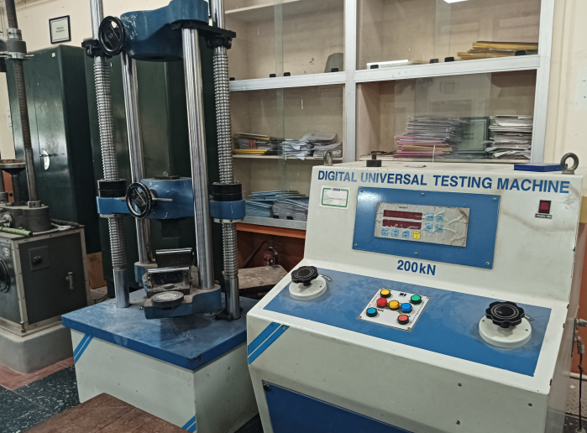  Booking Details | Name of the equipment:  Digital Universal Testing machine 200 KN  Make & Model:  EIE Instruments. & UTM -2011  I-Stem Registration ID-  3220835  Category of Instrument  Characterization and Testing  Types of Analysis / Testing  Compression, tension etc  Application:  It has to be planned based on the need  Description of Instrument  This machine is designed to perform compression, tension & flexure tests.
Book through I-STEM: https://www.istem.gov.in/ Slot Booking Link I-STEM Slot Booking link for External User Booking available for Internal and External Both Requisition form for Internals Externals |  | Book through I-STEM: Internal and External Both Slot Booking Link Internals Externals Booking available for Internal and External Both Requisition form for Internals Externals
Contact Details

Faculty In-charge:  Dr. Muhamed Safeer Pandikkadavath  Email ID:  msafeerpk@nitc.ac.in  Phone number:  9895599785 | Technical Staff:  Noushad K K (TA) noushadkk@nitc.ac.in  Jeyeshkumar (TA)  jeyesh@nitc.ac.in  Nithya B S (TA)  nithyabs@nitc.ac.in | Department  CED  Office Email ID  cedoffice@nitc.ac.in  Location  SM Lab, Department of Civil engineering  Lab Phone No  0495-2286840

Features, Working Principle and Specifications
Features of the equipment  - Digital Universal Testing Machine (UTM) capable of performing tension, compression, and bending tests.  - User-friendly digital interface for real-time display of load, displacement, and test status.  - Rigid two-column frame design suitable for accurate load application and specimen alignment.  - Suitable for both academic laboratory experiments and advanced research.  - Versatile grips and attachments for different specimen types. | Unique features/Measurement capabilities, if any  - Capable of testing steel bars (tension test), concrete specimens (compression), and concrete beams (bending) using interchangeable fixtures.  - Digital load measurement with high precision and repeatability.  - Supports automatic data logging and report generation for analysis and documentation.  - Provides load vs. displacement curve for structural interpretation.
Instrument Technical Description and Major Specifications (This Specifications Limited to Major 5)  - Measurement / Sample Specifications:  Suitable for steel bars, and RCC beams.  - Maximum Load Capacity:  200 kN (20 Tonne).  - Machine Type:  Fully Digital Universal Testing Machine with hydraulic loading and electronic control.  - Make & Origin:  Make: EIE Instruments.  Type of Sample Required for Analysis / Testing (Quantity, Pre-Preparation, State etc.) Guidelines for Sample Submission – User Instructions | Measurement/Sample specifications:  - Steel bars (typically 8 mm to 16mm dia) for tensile testing.  - Concrete beams for flexural/bending tests.  - Tests performed as per IS code standards with support for custom research setups.  - Load capacity up to 200 kN, suitable for small to medium-sized structural components.

- Steel reinforcement bars, concrete cubes/cylinders, and beam specimens.
- Samples should ideally conform to standard IS code sizes, or be pre-approved for research-specific dimensions.
Quantity: Typically, 3 specimens per test type for statistical reliability.
User Charges Rs. (GST Extra)

Internal | External Academic Institutes | National R&D Lab | Industry
500/- per hour | 1500/- per hour | 2500/- per hour | 3000/- per hour

