Booking Details
Compression and transverse testing machine 300 T
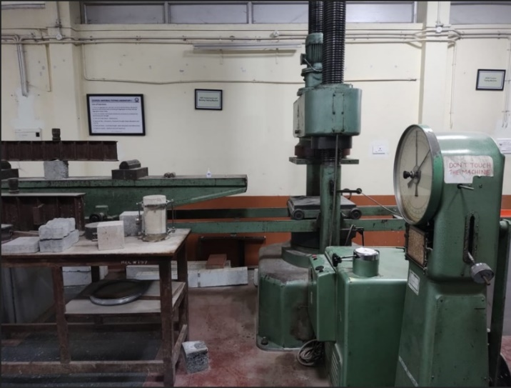 | Name of the equipment:  Compression and transverse testing machine 300 T  Make & Model:  UTM -100 ,VEB WERKSTOFFPROFMASCHINEN LEIPZIG,1966  I-Stem Registration ID-  3220831  Category of Instrument  Characterization and Testing  Types of Analysis / Testing  Compression, bending etc  Application:  It has to be planned based on the need  Description of Instrument  This machine is designed to evaluate the mechanical properties of materials mainly compression, bending tests of concrete specimen

Book through I-STEM: https://www.istem.gov.in/ Slot Booking Link I-STEM Slot Booking link for External User Booking available for Internal and External Both Requisition form for Internals Externals | Book through I-STEM: Internal and External Both Slot Booking Link Internals Externals Booking available for Internal and External Both Requisition form for Internals Externals
Contact Details

Faculty In-charge:  Dr. Muhamed Safeer Pandikkadavath  Email ID:  msafeerpk@nitc.ac.in  Phone number:  9895599785 | Technical Staff:  Noushad K K (TA) noushadkk@nitc.ac.in  Jeyeshkumar (TA)  jeyesh@nitc.ac.in  Nithya B S (TA) nithyabs@nitc.ac.in | Department  CED  Office Email ID  cedoffice@nitc.ac.in  Location  SM Lab, Department of Civil engineering  Lab Phone No  04952286840

Features, Working Principle and Specifications
Features of the equipment  - Easy crosshead movement on dual support pillars to adjust the gap for specimen placement, enabling convenient operation as per test requirements.  - Used to determine compressive, flexural, and crushing strength of cement, concrete, stone, and other construction materials.  - Supports a wide range of experiments for Undergraduate, Postgraduate students, and research scholars.  - Strong and durable build quality suitable for long-term laboratory and field usage.  - Designed for both instructional and research-based applications. | Unique features/Measurement capabilities, if any  - Hydraulically operated Compression and Bending Testing Machine.  - Capable of performing both compression and flexural strength tests with a single setup.  - High-capacity machine with robust design, imported from Germany.  - Long-standing operation since 1969, showcasing durability and consistent performance.
Instrument Technical Description and Major Specifications  - 300 Tonne capacity machine capable of testing cement, concrete, stone, and similar construction materials in both compression and bending modes. | Measurement/Sample specifications:  - Universal testing machine for concrete typically have a load capacity upto 1000 KN.
Type of Sample Required for Analysis / Testing (Quantity, Pre-Preparation, State etc.) Guidelines for Sample Submission – User Instructions

If you are unsure about the sample suitability or testing feasibility, you are encouraged to visit the laboratory in advance and discuss your requirements with the lab in-charge or technical staff. This will help ensure proper preparation and avoid delays in testing.
User Charges Rs. (GST Extra)

Internal | External Academic Institutes | National R&D Lab | Industry
500/- per hour | 1500/- per hour | 2500/- per hour | 3000/- per hour

